AGROFORESTRY

This topic entails the following:
- Definition of agro forestry
- Importance of agro forestry
- Forms of agro forestry
- Importance of trees
- Selection f trees to plant
- Routine management practices on trees
- Methods of tree harvesting.

The following relevant questions and their answers in this topic will greatly motivate and help the user to comprehend and understand the required concepts and practices.

1. State two reasons for seed treatment of tree species before planting
2. State four ways by which Re-afforestation help in land reclamation
3. List four advantages of agro-forestry
4. The illustrations below are techniques of harvesting agroforestry trees. Study them carefully and
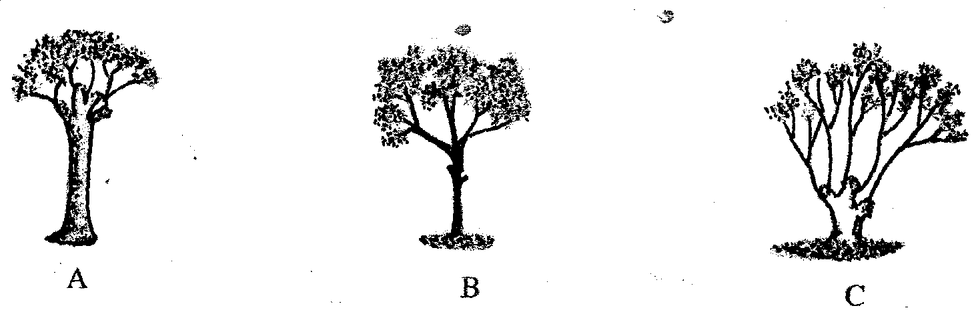
then answer the questions below:-

(a) Identify the harvesting techniques represented by techniques A and B
(b) Give an example of a tree species suitable for technique B and C as a method of harvesting
5. State four factors considered when choosing trees for Agroforestry
6. (a) Five characteristics of trees used in agroforestry are;
(b) The benefits of agroforestry are:
7. Name four forms of agro- forestry
8. Give four characteristics that good agro-forestry tree should posses

AGROFORESTRY
1. two reasons for seed treatment of tree species before planting
- Break dormancy
Control pests and diseases
2. four ways by which Re-afforestation help in land reclamation
- Add organic matter from falling leaves
- Recycles soil erosion
- Control soil erosion
- Improve drainage of swampy areas
Play part in hydrological cycle
3. four advantages of agro forestry
- Source of wood fuel (energy)
- Source of income
- Conserve environment/reduce soil erosion/improve water catmint
- Source of food /fruits
- Medicine/value
- Aesthetic value
- Feed for livestock
- Labour saving
5. (a) A – Pollarding technique (½mk)
B – Coppicing (½mk)
(b) An example of a tree species suitable for technique B and C as a method of harvesting B
(i) Calliandra calothyrus
(ii) Markahmia lutea
(iii) Psidum guajava
(iv) Croton macrostachyus ( ½ x 1 = ½mk)
C (i) - Grevillea robusta
- Calliandra calothyrsus
- Croton cacrostachyus ( ½ x 1= ½mk)
6. -Deep rooted
- Nitrogen fixing/ leguminous
- Fast growing
Good in by product production
7. (a) Five characteristics of trees used in agroforestry are;
- Fast growth rate
- Nitrogen fixing/leguminous
- Good in by product use timber, fruits etc
- Deep rooted
- Nutritious and palatable
- easily coppiced
- Non-competitive ability with main crop (5x1=5mks)
(b) The benefits of agroforestry are:
- Provides food
- Source of energy/fuel
- Fodder for livestock
- Aesthetic value
- Provides shelter
- Income generation
- Soil and water conservation
- Balancing of atmospheric gases (8x1=8mks)
8. four forms of agro- forestry
- Alley cropping
- Woodlots
- Multi-storey
- Source of wood fuel
- Source of income
- Labour saving
- Aesthetic value
- Reduces the carbon dioxide reducing the depletion of Ozone layer
Used as a method of soil and water conservation
9. - Border//edge grow
- Source of wood fuel
- Source of income
- Labour saving
- Aesthetic value
- Reduces the carbon dioxide reducing the depletion of Ozone layer
- Used as a method of soil and water conservation
10. - fast growth
-Deep rooted
-Nitrogen fixing
-Good by-products
- Friendly to crops/not affent crop

