Name: …………………………………………………………… Adm. No …......…................................

School: ………………………………………………….....……. Date: …………………………………

AGRICULTURE
TIME: 2 hourS

TERM 2 MID TERM 2 EXAMINATION -2022

FORM 2
AGRICULTURE
INSTRUCTIONS TO CANDIDATES:

- Answers all questions in the spaces provided.

1. What determines the colour of a particular soil? (1mk)
……………………………………………………………………………………………………
2. Give three reasons why soil is important in crop production. (3mks)
……………………………………………………………………………………………………
……………………………………………………………………………………………………
……………………………………………………………………………………………………
3. State four physical agents of weathering. (4mks)
……………………………………………………………………………………………………
……………………………………………………………………………………………………
……………………………………………………………………………………………………
……………………………………………………………………………………………………
4. List four tools used for laying concrete blocks when constructing a wall. (4mks)
……………………………………………………………………………………………………
……………………………………………………………………………………………………
……………………………………………………………………………………………………
……………………………………………………………………………………………………
5. Differentiate between the following :-

i) Seeded and seedling bed. (2mk)
……………………………………………………………………………………………………
……………………………………………………………………………………………………
ii) Tilth and tillage. (2mks)
……………………………………………………………………………………………………
……………………………………………………………………………………………………
6. State four climatic factors that influence crop production. (4mks)
……………………………………………………………………………………………………
……………………………………………………………………………………………………
……………………………………………………………………………………………………
……………………………………………………………………………………………………
7. Name four types of water pumps. (4mks)
……………………………………………………………………………………………………
……………………………………………………………………………………………………
……………………………………………………………………………………………………
……………………………………………………………………………………………………
8. Name two breeds of dairy goats kept in Kenya. (2mks)

……………………………………………………………………………………………………
……………………………………………………………………………………………………
9. List down at least five characteristics of a typical beef cattle. (5mks)
…………………………………………………………………………………………………
……………………………………………………………………………………………………
……………………………………………………………………………………………………
……………………………………………………………………………………………………
……………………………………………………………………………………………………

10. a) Identify the tools labeled A,B,C and D (2mks)
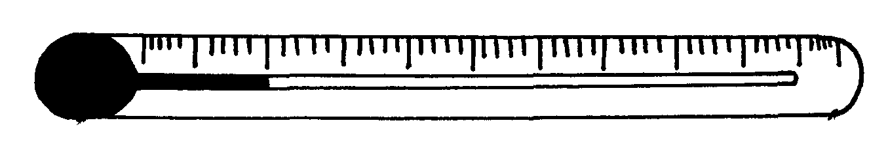
A
C

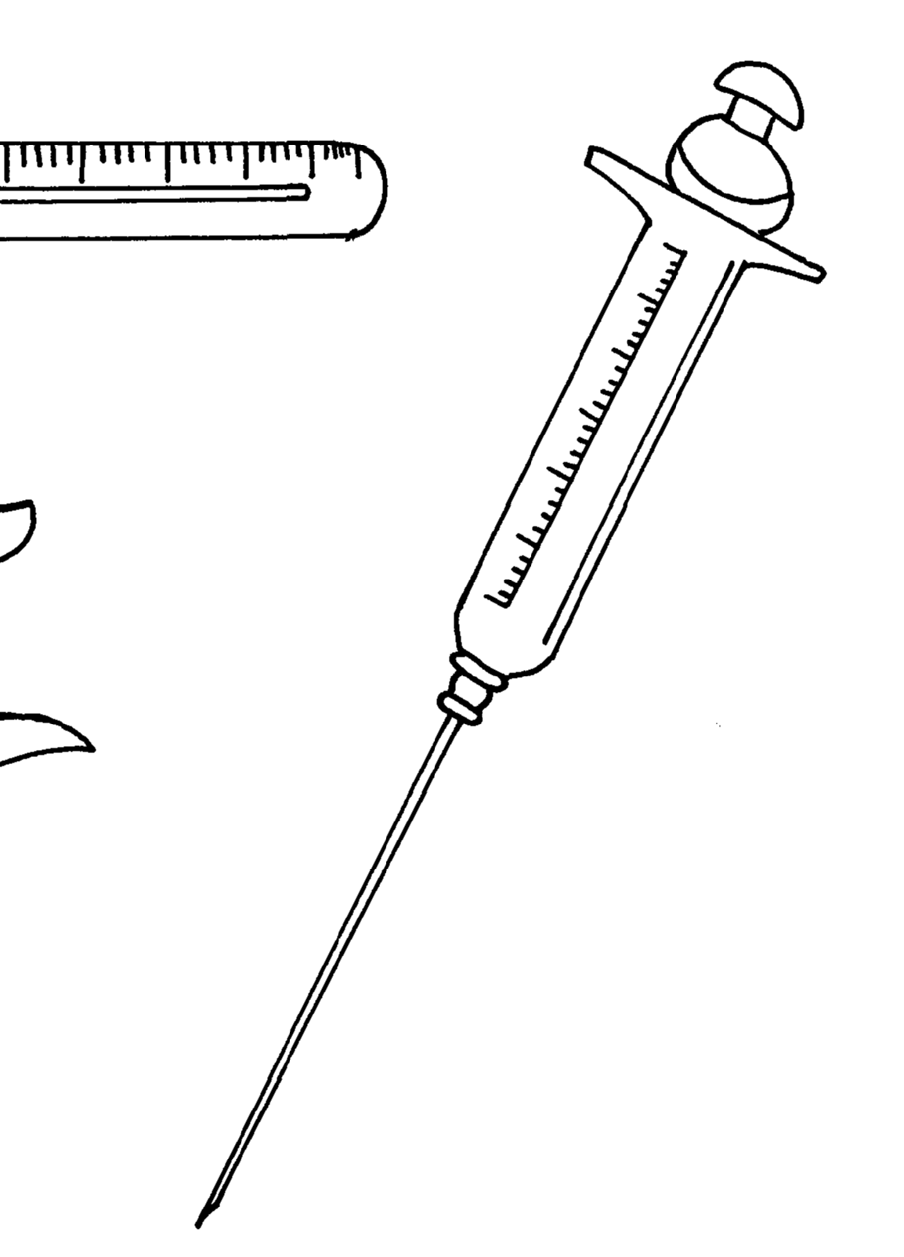
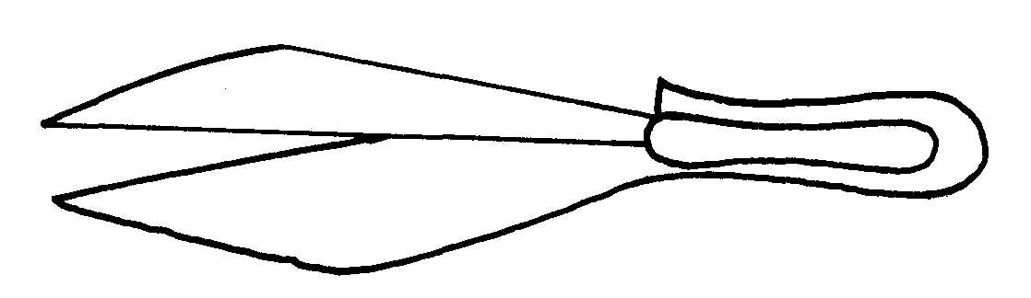

D
B

b) Give one use of each of the tools illustrated in (a) above. 2mks)
……………………………………………………………………………………………………
……………………………………………………………………………………………………
c) Name the part of the animal where specimen A is placed when in use. (1mk)
……………………………………………………………………………………………………
11. Name three types of grafting (3mks)
……………………………………………………………………………………………………
……………………………………………………………………………………………………
……………………………………………………………………………………………………
12. Give four advantages of agroferestry. (4mks)
……………………………………………………………………………………………………
……………………………………………………………………………………………………
……………………………………………………………………………………………………
……………………………………………………………………………………………………
13. Mention four reasons for carrying out testing of a soil sample. (4mks)
……………………………………………………………………………………………………
……………………………………………………………………………………………………
……………………………………………………………………………………………………
……………………………………………………………………………………………………
14. State any four post – harvest practices. (4mks)
……………………………………………………………………………………………………
……………………………………………………………………………………………………
……………………………………………………………………………………………………
……………………………………………………………………………………………………
15. i) What is organic farming? (1mk)
……………………………………………………………………………………………………
ii) State four importance of organic farming (4mks)
……………………………………………………………………………………………………
……………………………………………………………………………………………………
……………………………………………………………………………………………………
……………………………………………………………………………………………………
16. Name two categories of plant nutrients. (2mks)
……………………………………………………………………………………………………
……………………………………………………………………………………………………
17. Mention four roles of nitrogen in plants. (4mks)
……………………………………………………………………………………………………
……………………………………………………………………………………………………
……………………………………………………………………………………………………
……………………………………………………………………………………………………

18. State three characteristics of dairy cattle. (3 marks)

……………………………………………………………………………………………………
………………………………………………………………………………………………
…………………………………………………………………………………………………
19. State the importance of using certified seeds for planting. (4mks)
……………………………………………………………………………………………………
……………………………………………………………………………………………………
……………………………………………………………………………………………………
……………………………………………………………………………………………………
20. State four fact ors considered in determining the depth of planting. (4mks)
……………………………………………………………………………………………………
……………………………………………………………………………………………………
……………………………………………………………………………………………………
……………………………………………………………………………………………………
21. The diagram below shows a soil sampling method.
3
4
7
6
5
2
8
1
13
10
9
14
12
11

(i) Identity the method. (1mk)
……………………………………………………………………………………………………
(ii) State four activities that are carried out during soil sampling in the field. (4mks)
……………………………………………………………………………………………………
……………………………………………………………………………………………………
……………………………………………………………………………………………………
……………………………………………………………………………………………………
(iii) What information should the sample have before being taken to the laboratory. (3mks)
……………………………………………………………………………………………………
……………………………………………………………………………………………………
……………………………………………………………………………………………………
22. Outline two positive effects of wind on crop production. (2mks)
……………………………………………………………………………………………………
……………………………………………………………………………………………………

23. State four agricultural practices that pollute water. (4mks)
……………………………………………………………………………………………………
……………………………………………………………………………………………………
……………………………………………………………………………………………………
……………………………………………………………………………………………………
24. Mention any four methods used in draining land during land reclamation. (4mks)
……………………………………………………………………………………………………
……………………………………………………………………………………………………
……………………………………………………………………………………………………
……………………………………………………………………………………………………
25. i) What is opportunity cost? (1mk)
……………………………………………………………………………………………………
……………………………………………………………………………………………………
ii) State four types of farm records. (4mks)
……………………………………………………………………………………………………
……………………………………………………………………………………………………
26. Outline four factors that affect rooting of cuttings. (4mks)
……………………………………………………………………………………………………
……………………………………………………………………………………………………
……………………………………………………………………………………………………
……………………………………………………………………………………………………

