

**443/2 - AGRICULTURE - Paper 2**

**2022 TRIAL 2 JULY INTERNAL EXAMINATION**

**MARKING SCHEME**

|  |  |  |  |
| --- | --- | --- | --- |
| **SECTION** | **QUESTION** | **MAXIMUM**  **SCORE** | **CANDIDATE**  **SCORE** |
| **A** | **1-16** | **30** |  |
| **B** | **17-20** | **20** |  |
| **C** |  | **20** |  |
|  |  | **20** |  |
|  | **TOTAL SCORE** | **90** |  |

**SECTION A: (30MARKS)**

***Answer all questions from this section on the spaces provided.***

1(a) Give **two** qualities of milk of the Friesian breed of cattle. (1 mark)

• ***Has low butter fat content of about 3.5%.***

• ***Highest milk producing breed.***

b) Name **three** components of a truss. (1½

marks)

• ***Tie or beam***

• ***Two rafters***

• ***Struts***

• ***Raffer batter***

2. Give **two** reasons why Jersey breed of cattle is well suited to semi-arid conditions. (1 mark)

• ***It has little pasture requirements.***

• ***An excellent grazer in poor posture.***

3(a) State the effect of an incubator with internal humidity of 100%. (½

mark)

• ***Lowers hatchability and leads to production of bigger chick which looks marshy.***

b) State the use soluble grit to layer birds? (½

mark)

• ***Encourage strong shelled eggs and efficient digestion.***

4. Give **two** uses of a wood float. (1 mark)

• ***For phastering to create a level surface of floors and walls.***

5. Give **three** conditions may lead to culling of a breeding boar? (1½

marks)

• ***Poor health***

• ***Old age***

• ***Poor production***

• ***Have physical deformities***

• ***To avoid inbreeding***

• ***Have heredity defects***

6. Identify **two** practices carried out during sap displacement in timber preservation. (1 mark)

• ***Fleshy cut posts are packed in containers filled with wood preservative. The preservative is drawn up through the wood grains as the sap dries out.***

7(a) State **three** characteristics of the Galla goat (1½

marks)

• ***Ability to adapt to hot conditions.***

• ***White coloured body.***

• ***Very good quality meat.***

b) Name the **two** breeds of camels. (1 mark)

• ***Dromedary***

• ***Bacterian***

8(a) List **three** sources of water to livestock. (1½

marks)

• ***Rivers, streams, dams***

• ***Springs, well, boreholes***

• ***Rain water***

b) Maize germ, a livestock feed has a starch equivalent of 30%. Explain

(1mark)

• ***100kg of the feed will produce a net energy equivalent to the energy produce by 30kg of pure statch****.*

9(a) State **four** ways in which fleas cause economic losses to the farmer. (2mark)

• ***Cause irritation which leads to scratching.***

• ***Stick fast fleas cause wounds on the point of attach.***

• ***Lower quality***

• ***Lower price***

• ***Leads to mortality rates.***

b) List **three** limitations of water as a source of power in the farm. (1½

marks)

• ***Most rivers are small and seasonal.***

• ***It is expensive to harness the power.***

• ***Most farms do not have access to large quantities of moving water.***

10. Tabulate **two** features that differentiate between dairy and beef cattle. (2 marks)

|  |  |
| --- | --- |
| ***Dairy*** | ***Beef*** |
| ***Wedge or triangular shaped*** | ***Blocky in shape*** |
| ***Selective grazing*** | ***Reduced selective grazing*** |
| ***Large udder*** | ***Small udder*** |

11. Define the following terms as used in livestock production. (1½

marks)

a) Digestibility

• ***The portion of food retained in an animal’s body after taking care of losses through urine,***

***faces and gases, expressed as a percentage.***

b) Prolificacy

• ***Ability to give birth to many young once.***

c) Malpresentation

• ***Abnormal calving where the forelegs don’t come out first.***

12. Give **three** methods of selecting livestock for breeding

(1½marks)

• ***Mass selection***

• ***Progeny testing***

• ***Contemporary comparison***

13. Why should bees be fed on sugar syrup? (1mark)

• ***When flowers are not available to maintain the colony.***

14. State **four** conditions that would encourage hens to eat eggs in poultry production

(1½mark)

• ***Bright light***

• ***Overcrowding***

• ***Pests attack***

• ***Lack of calcium minerals***

15. Distinguish between tupping and serving. (1mark)

• ***Tupping – mating in sheep and goats.***

• ***Serving – mating in cattle and pigs.***

16. What is the advantage of using forage harvesters compared to a mower? (1mark)

• ***They are designed for harvesting and chopping forage materials to appropriate sizes.***

17. Give **three** maintenance practices of ox ploughs. (1½marks)

• ***The land wheel bearing should be lubricated.***

• ***Worn out shares be replaced.***

• ***Blunt shares should be sharpened by hammering.***

18. State **four** disadvantages of using live fence on the farm

(2marks)

• ***They take many years to grow.***

• ***Can be hiding places for rodents and thieves.***

• ***Require regular trimming.***

19(a) Give **two** pre disposing factors of mastitis. (1mark)

• ***Age***

• ***Udder attachment***

• ***Stage go lactation period.***

• ***Incomplete milking***

b) Using letter **X** identify **three** areas infested with a three- host tick in the picture below. (1½marks)

**X**

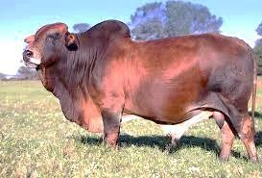

X

X

**SECTION B: (20MARKS)**

***ANSWER ALL QUESTIONS FROM THIS SECTION ON SPACES PROVIDED***

20. Study the structure of a goat pen below and then answer the questions that follow.

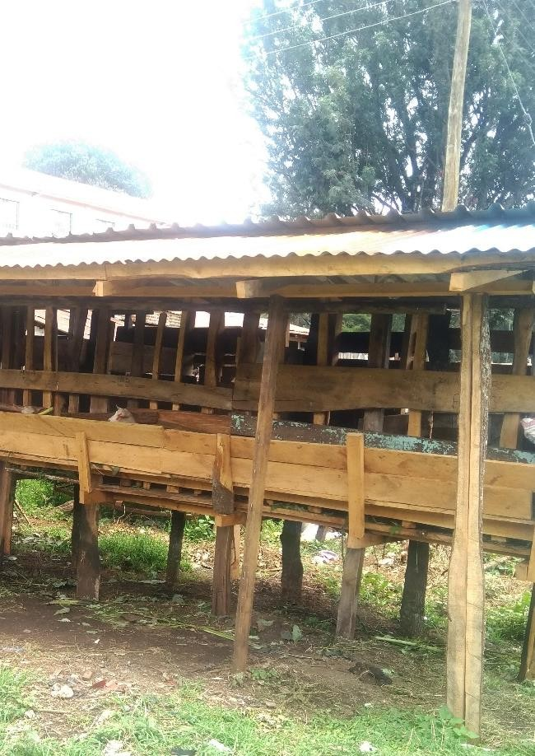

**K- FOOD TRUPH/FOR**

**PRIVISON OF FOODS**

**H**

**N**

a) Specify the measurements between **H** and **N**. (½mark)

• ***(N-H) – (60-90CM High)***

Give a reason for your answer in a) above. (½mark)

• ***Raised for proper drainage and easy cleaning.***

b) State the function of part **K**. (1mark)

• ***Used to place feed in***

c) Which type of floor is recommended for the pen shown in the picture above

(½mark)

• Slated floor

Give a reason for your answer in (c) above

(½mark)

• ***to facilitate passage of droppings and urine***

d) List **two** reasons for housing the calves singly. (1mark)

• ***To prevent licking each other as this may form fur balls in the stomach***

21(a) Identify the equipment **X** and **Y** below.

(1mark)

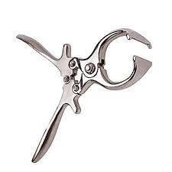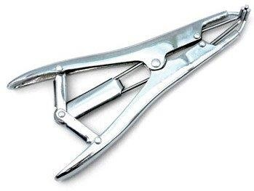

**X** -***Burdizzo* Y** -***Elastrator***

b) State the functions of each of the equipment. (2marks)

**i. X used for castrating bulls rams and billies**

ii. **Y used to expand the rubber ring while docking castrating and dehorning**

c) i) Name the tool used to castrate a piglet. (½mark)

(1mark)

- **Scalpel**

ii) Give **two** reasons for castrating a male piglet.

- **To control inbreeding**

- **Fattens faster**

- **Controls breeding diseases**

22(a) Identify the parasites below. (1mark)

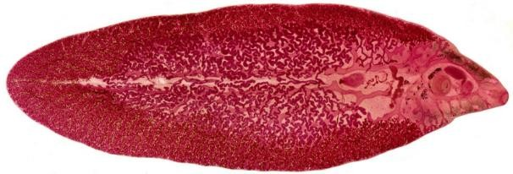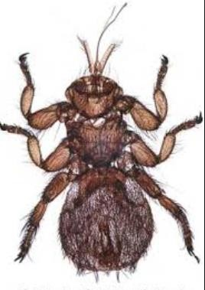

**U W**

b) Name **two** species of parasite **U**. (1mark)

**i. Fasciola gigantica ii. Fasciola hepatica**

c) Why is it difficult to control parasite **U**?

(1mark)

- **It has an intermediate host**

d) State the livestock commonly affected by parasite **W**? (½mark)

- **Sheep**

e) A farmer wanted to mix 270kg of livestock feed containing 30% DCP by using Sorghum meal with 12%DCP and Soya bean meal containing 36% DCP. Calculate the quantities of each feedstuff he would have in the ration.

(2marks)

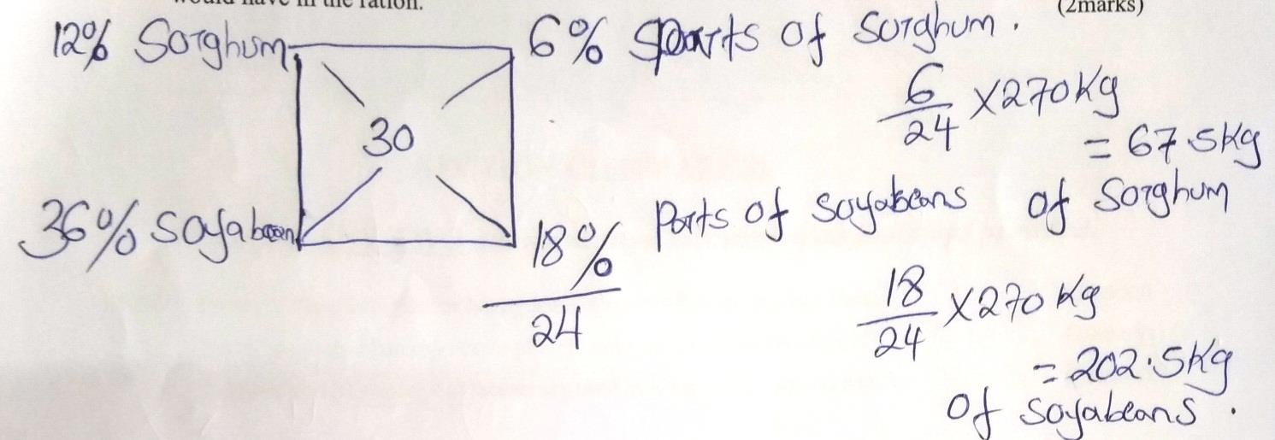

23(a) Using ***x*** draw the behaviour of the chicks expected in the following conditions in a brooder.(2marks)

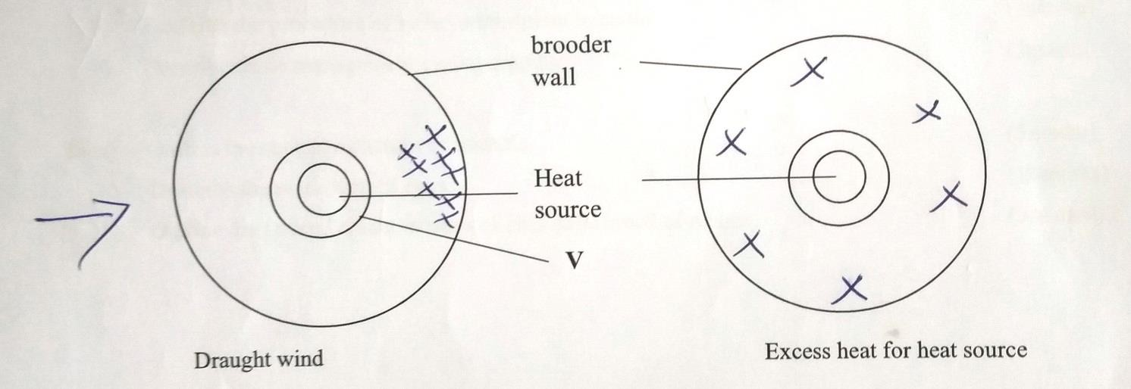

b) What is the role of the part labelled **V**? (½

mark)

• ***to prevent the chicks from going to close to the heat source***

c) i) Identify the goat breed below. (1mark)

• ***Saanen***

ii) On the diagram name parts 1-3. (1½

marks)

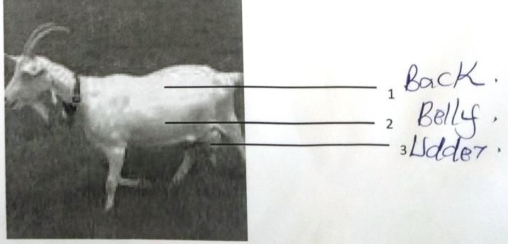

d) List two features that are used to identify the goat breed

(1mark)

• ***White in colour***

• ***Upright ears and forward facing***

**SECTION C: (40MARKS)**

***Answer*  ANY TWO *questions from this section on foolscaps provided*.**

24(a) Describe the procedure for honey harvesting in a Kenya Top Bar Hive. (5marks)

• ***Honey is harvested early in the morning as late in the evening when bees are less active.***

***When harvesting honey, the following steps are followed.***

• ***Approach the hive quietly and blow smoke around the hive and later through the entrance holes using a smoker. The smoke makes the bees to start eating honey this becoming heavy an inactive.***

• ***Lower the hive to the ground.***

• ***Cut the combs from each top bar three centimetres from the surface and put them in a clean container rubbing off the bees using a twig.***

***The 3cm of the comb left is for attachment of new combs.***

• ***Place back the bars and do not disturb the broad.***

• ***Return the hive to its position.***

b) Name ten parts of an ox- drawn plough and state the function of each.

(10marks)

• ***Beam. This is the component onto which all other parts of the plough are attached. It also adds weight to the plough for better penetration.***

• ***The handles. There are two handles, one on each side of the rear part plough. Handles enable the operator to see the implements in the direction when ploughing.***

• ***The mouldboard. It invert the furrow slices***

• ***Shore. It cuts the furrow slice horizontally.***

• ***Landslide. The landslide presses against the wall of the unploughed land and therefore helps ot stabilize the plough.***

• ***Land wheel. This is a wheel which is adjusted to regulate the ploughing depth.***

• ***Draft rod. This is a metal bar which is attached to the main beam of the plough. At the front end of the draft rod there is a chain which connects it to the yoke.***

c) Explain how physiological factors are used as a sign of ill or good health. (5marks)

• ***fatique***

• ***weakness***

• ***pregnancy***

25(a) Describe the process of milk let down in a cow. (6marks)

• ***It involves the active participation of the lactating cow; and occurs after the animals is stimulated by a suckling calf by any other stimuli; such as washing of the udder with warm water/feeding, familiar noises;***

• ***The pituitary gland is stimulated to produce oxytocin harmone;***

• ***Oxytocin is transported by blood to the mammary glands;***

• ***Oxytocin causes the contraction of the upper regions of the udder; which forces the milk into the gland astern.***

b) Describe the procedure of embryo transplant in cattle. (9marks)

• ***Female is injected with hormones; to make her produce more ova than a normal rate;***

• ***Ova are harvested form a high quality dairy cow;***

• ***The ova are fertilized in a test tube; with semen from a high quality bull.***

• ***The embryos that develop are stored in cold temperature to wait for implanting.***

• ***Implantation is done to other female animals; and hence called foster mother.***

• ***The embryo that develops when born produces a calf with superior characteristics***

c) Describe cattle management during dipping

(5marks)

• ***Assemble the cattle near the plange dip/***

• ***Allow the cattle to drink water to minimize drinking of the dip wash solution.***

• ***Assemble the cattle in the collection yard.***

• ***Guide the cattle to the dip starting with young animals then older ones;***

• ***Allow the cattle to stand in the drainage race to drain off the dipwash;***

• ***Pregnant and sick animals should not be dipped.***

26(a) Outline the control measures of mastitis. (5marks)

• ***Ensure complete and thorough milking is done;***

• ***After milking dip each teat in a teat dip containing antiseptics***

• ***Use a clean towel when drying the udder for each cow;***

• ***Use a strip cup to check for infected cows and quarters;***

• ***Remove sharp objects/treat wounds on teats***

• ***Control parasites such as ticks by using appropriate acaricides;***

• ***Infected animals should be milked last.***

• ***Treat infected animals using a teat cannula with an antibiotic***;

b) Describe the marketing of eggs. (10marks)

• ***Propect/carry out research for a market for eggs produced;***

• ***Sort the eggs according to colour; and size.***

• ***Standadise the sorted eggs into some colour and size;***

• ***Pack the eggs in crates of 6; or 30 eggs;***

• ***Transport the eggs with the egg trays arranged in stacks;***

• ***Sell the eggs through retailing; and through a cooperative; and directly to consumers;***

• ***Sale of egg should be done twice a week; to ensure supply of fresh egg;***

c) Outline the general characteristics of chinchilla breed of rabbits. (5marks)

• ***Grey and blue in colour.***

• ***Have an average weight of 4.5kg – 5kg.***

• ***Well-muscled / around back/muscular legs.***

• ***Ear area straight and stand erect.***

• ***Kept for meat and for production***

• ***Good breeders producing litter of between 6 – 9 kindlings.***

• ***Have good mothering ability.***