443/1 - AGRICULTURE - Paper 1

MARKING SCHEME

SECTION | QUESTION | MAXIMUM  SCORE | CANDIDATE  SCORE
A | 1-16 | 30
B | 17-20 | 20
C |  | 20
 |  | 20
 | TOTAL SCORE | 90

SECTION A (30marks)
Answer all questions in this section in the spaces provided
1. List four reasons for early land preparation.
(2mks)

i. To allow time for weeds to dry.

ii. To allow time for exposed pests to die. iii. To allow time for subsequent operations.

iv. To allow time for compaction of soil.

2. State four disadvantages of clean weeding in a maize field.
(2mks)

i. Exposes soil to agents of erosion.

ii. Exposes soil to heat leading to loss of nutrients through vitalization. iii. Loses water through evaporation.

iv. Creates suitable conditions for weed seeds to germinate.

3. State four factors that determine the choice of a method of irrigation used in a farm.
(2mks)

i. Availability of capital. ii. Topography of land

iii. Availability of water. iv. Type of soil.

v. Type of crop to be irrigated.

4. Name two sources of credit for a group of farmers registered as a cooperative. (1mk)

i. Co-operative societies

ii. Crop boards

iii. Commercial banks iv. Agricultural finance cooperation.

v. Settlement fund trusties.

vi. Insurance companies/ traders

5. State four characteristics of well decomposed farm yard manure.
(2mks)

i. Free from bad odour.

ii. Does not have original material or debrils. iii. Light in weight.

iv. Dark brown in colour.

v. Crumby and not stickey.

6. Name two types of labour records.
(1mk)

i. Muster roll.

ii. Labour utilization record.

7. State two uses of a sales book.
(1mk)

i. Records all details of produce sold from the farm on which payment has not been received.

ii. Records all firms which owes money to the farm.

8. Name three methods of training crops.
(1½mks)

i. Stalking

ii. Propping iii. Trellising

9. Name three diseases that affect tomatoes in the field.
(1½mks)

i. Late blight

ii. Early blight

iii. Blossom end rot iv. Bacterial wilt

10. State four reasons for resettlement and settlement in Kenya.
(2mks)

i. To diversity agricultural production. ii. To check rural to urban migration.

iii. To ease population pressure iv. To reclaim arable land not in use.

v. To provide land to people affected by natural calamities.

- State four aspects of biological weed control.
(2mks)
  - Agent should be selective.
  - Should not affected poisoned by week to be controlled. iii. Should be economical to implement /mital.
iv. Should be easy t eradicate.

- State four symptoms of attack by the bean fly in bean production.
(2mks)

i. Holes in stem/tunnels in stem. ii. Stem swells at the base.

iii. Cracking of stem at the base iv. Stunted growth.

13. Give three reasons for flooding when growing paddy rice.
(1½mks)

i. Weed control against non acquatie weeds

ii. Control of crowing pests such as army worms iii. Maintain high humidity required for growth of rice. iv. Prevent denitrification.

14. State four precautions observed when harvesting cotton.
(2mks)

i. Should be done during dry conditions

ii. Gunny / sisal bags should not be used. iii. Twigs/stems leaves should not be picked with lint.

iv. Separate containers should be used to faut at white lint (safi) and stan(Fiti).

15. (a) State two disadvantages of tractor hire services.
(2mks)

i. Not available when needed

ii. Some farmers may be overcharged.

(b) Give four sources of tractor hire services.
(2mks)

i. Government tractor hire services

ii. Private contractors. iii. Individual farmers

iv. Cooperative societies with tractors

16. State four functions of the National Agricultural Commodity Association.
(2mks)

i. Bargain for better prices for farm produce.

ii. Ensure timely and adequate supply of farm imputs.

iii. Bargain for reasonable and affordable prices of farm imputs.

17. (a) What is meant by the term Agroforestry?
(½mk)

i. A variety of land use practices that combine tree growing, pasture and crop production practices.

(b) State four management practices carried out during intensive hedgerow agroforestry. (2mks) i. Pruning

ii. Weeding

iii. Pest control iv. Disease control

v. protection
SECTION B (20marks)
Attempt all questions in this section
18. Identify the following methods of propagation. (1½marks)
C

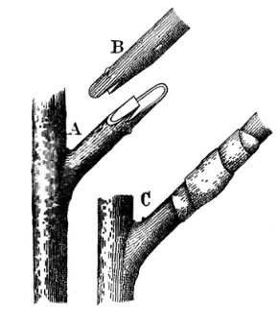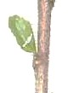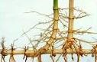

U

S Side grafting T Budding V stem cutting
a) State three factors contribute to the success of method S?
(1½mk)

i. Scion and root stock should be compatible.

ii. Should be free from moisture.

iii. Should be free from air.

b) Name parts labelled B and C. (1mk)
B Scion

C Root stock.

c) State two importance of part U in the diagram labelled T?
(1mk)

i. Provides / develops to form a shoot.

ii. Diseased or damaged part of plant can be repaired.

iii. Used to establish several compatible species on one root stock.
d)Name two crops propagated by use of method V.
(1mk)

i. Citrus fruits

ii. Mango
19. Maina’s farm requires the following items on credit from Kenya farmers association on 30th March 2020
10bags of Unga feeds Bran
18bags of DSP Chapa meli
24kg of Rose Coco Bean seeds simlaw seed
KFA sells the items as follows
Item | Company | Price | Quantity in store
Bran 90kgs/bag | Brookhouse farm supplies | Kshs. 1000/bag | 200 bags
Bran 90kgs/bag | Unga feeds Bran | Kshs. 1200/bag | 150 bags
Bran 90kgs/bag | EA MAIZE Millers | Kshs. 1230/bag | 400 bags
DSP 50kgs each | Chapa meli | Kshs. 1500/bag | 120 bags
DSP 50kgs each | Nauru international | Kshs, 1500/bag | 140 bags
DSP 50kgs each | Boatmil industries | Kshs. 1500/bag | 150 bags
Bean seeds Rose coco | Kenya Seed | Ksh330 / 2kgs packets | 100 - 2kgs packets
Bean seeds Rose coco | Western Seed | Ksh290 / 2kgs packets | 400 - 2kgs packets
Bean seeds Rose coco | Simlaw Seed | Ksh300 /2kgs packets | 120 - 2kgs packets
a) Prepare a purchase order that KFA made to Maina’s farm.
(3mks)
PURCHASE ORDER MAINA’S FARM P.O BOX……….
NAIROBI

TO: KENYA FARMERS DATE: 30/03/2020

ASSOCIATION

Please supply the following.

Item No | Particulars | Quantity
2 | Bran Unga feeds | 10 bags
4 | D.S.P – chapa meli | 18 bags
9 | Rose coco Bean seeds (simlaw) | 24 kg

Ordered by:……………………………………………….

Authourised by:………………………………………..
20. Below is an illustration of a method of frame formation in tea. Answer the questions that follow.
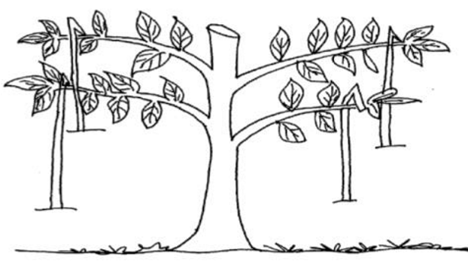
a) Identify the above method.
(1mk)

i. Pegging method using individual hooked pegs.

b) Describe the procedure followed in (a) above
(4mks)

i. A young tea plant is allowed to grow for one year ro reach a height of 25 – 30cm.

ii. Cutting back is done to 15cm above the ground. iii. Slide branches are allowed to grow to 60 – 75 cm. iv. Hooked pegs are used to force plant to grow at an angle of 30⁰ + 45⁰.

v. The tips are nipped off.

c) Apart from the above method name one other method of frame formation (1mk) i. Formative pruning.

21. Give a reason why the following practises are important when making silage
a) Wilting crop for 6-12 hours
(1mk)

i. To reduce the moisture content which lowers the silo lensiling temperature. ii. Improve the guilty of collage

iii. Reduce produce effluent.

b) Compacting the ensiled materials every 10cm-12cm
(1mk)

i. To raise the ensiling temperature.

ii. To remove air that causes butyric fermentation.

c) Checking the temperature regularly
(1mk)

i. To prevent high or low temperature that leads to poor decomposition.

ii. Avoid gaseous losses.

d) Ensuring that the soil over the silo maintains a hump shape after covering
(1mk)

To allow rain water to drain off the silo.

SECTION C (40 marks)
Answer any two questions from this section in the spaces provided after question 22.
22. A farmer in Rongai division wishes to change from arable farming to dairy goat production. In arable farming he has been spending kshs.400 on weeding maize and Ksh 200 on weeding cabbages. He spends Ksh 500 and Ksh 300 on harvesting maize and cabbages respectively. He buys the following inputs; DAP fertilizer at Ksh.1000, cabbage seeds for Ksh 400, maize seeds for Ksh 600. Pesticides cost ksh800. He also spends Ksh. 300 on shelling of maize.
The change in enterprise will have the following implications; He will buy 5 dairy goats at ksh.2, 000 each; pay milk man ksh.3, 000; control diseases at a cost of ksh.1500. Fencing of the farm will be done at a cost of ksh.1, 500.The revenue he gets when growing maize is ksh.10, 000 and cabbages is ksh.4, 000. In dairy goat production, he will get Ksh 20,000 from sale of milk and Ksh 1000 from sale of manure.
a) Prepare a partial budget and advise the farmer whether the change is worthwhile or not.(12mks)

Partial Budget for
Rongai farm

31st Dec 2020

Debit |  |  | Credit
Extra cost Dairy goats | Ksh | Cts | Extra Revenue Dairy goats | Ksh | Cts
5 dairy goats | 10,000 | 00 | Sale of milk | 20,000 | 00
Labour | 3,000 | 00 | Sale of  manure | 1,000 | 00
Treatment | 1,500 | 00
Fencing | 1,500 | 00
Total | 16,000 | 00 | Total | 21,000 | 00
Revenue forgone |  |  | Cost saved
Sale of maize | 10,000 | 00 | Weeding maize and cabbage | 600 | 00
Sale of cabbages | 4,000 | 00 | Harvesting maize and cabbage | 800 | 00
Total | 14,000 | 00 | D.A.P fertilizer | 1,000 | 00
 |  |  | Pesticide | 800 | 00
 |  |  | Shelling maize | 300 | 00
 |  |  | Total | 4,500 | 00
Total Debit | 30,000 | 00 | Total credit | 25,500 | 00

(Extra revenue + cost saved) = (Extra cost + revenue forgone)

Credit Debit

25,500 – 30,000 = 4500

It is not worthwhile to change from arable farming to goat farming.

b) Explain four factors that determine the choice of a farming enterprise (8 mks)

i. Size of farm – large farm can hold many enterprises while a small farm holds few enterprises.

ii. Environmental factors – include climate, type of soil and topography which determine type of plants to grow

iii. Farmers choice and preference – has a psychological effect encouraging production of certain enterprises.

iv. Current trends in labour market.

23 a) Explain five roles of Agricultural based women self-help groups in Kenya. (5 mks)

i. Loaning members to finance their projects

ii. Enlighten members on new methods of farming and improve technology. iii. Assist in marketing agricultural produce. iv. Buy farm inputs in bulk.

v. Collectively assist members in farming tastes. vi. Guarantee members for loans

vii. Gather information in intense projects. viii. Acts as agents of community change.
b) The inventory of Awilo’s Farm as at 31st December 2020 was as follows In Ksh:
Cash in hand 5,000
Layers 27,000
Dairy cattle 125,000
Maize in store 6,000
Calves 29,000 Buildings 70,000
Land 200,000
Machinery 75,000
On the same day, the following information was obtained from the sales record.
Bank loan 160,000
Egg sale on credit 20,000 Milk sales on credit 25,000 Vegetable sales on credit 10,000 Fertilizer purchased on credit 15,000
Wages payable 8,200
Taxes payable 8000
Interest payable on loan 4,000
- Prepare a balance sheet (8mks)

Balance sheet for Awilos farm
As at 31st December 2020-12-07
Liabilities | Ksh | Cts | Assets | Ksh | Cts
Bank loan | 160,000 | 00 | Cash in hand | 5,000 | 00
Fertilizer purchased on credit | 15,000 | 00 | Layers | 27,000 | 00
Wages payable | 8,200 | 00 | Dairy cattle | 125,000 | 00
Taxes payable | 9,000 | 00 | Maize in store | 6,000 | 00
Interest on loan | 4,000 | 00 | Calves | 29,000 | 00
Total liabilities | 195,000 | 00 | Buildings | 70,000 | 00
 |  |  | Land | 200,000 | 00
 |  |  | Machinery | 75,000 | 00
 |  |  | Eggs sold on credit | 20,000 | 00
Capital | 371,800 | 00 | Vegetables sold on credit | 10,000 | 00
Total balance | 576,000 | 00 | Total assets | 576,000 | 00

- State with a reason if Awilo’s farm solvent or insolvent (1mk)

i. Awilo’s farm is solvent because the assets total to 567,000 against the liabilities 195,200 hence a capital of 371,600
c) State five ways through which agricultural practices pollute water bodies. (5mks)
25. The tables below show the weekly demand and supply for wheat.
Price (Ksh.) | Quantity demand (kg) |  | Price (Ksh.) | Quantity supplied (kg)
200 | 250 |  | 200 | 2500
180 | 350 |  | 180 | 2250
160 | 550 |  | 160 | 2000
140 | 900 |  | 140 | 1700
120 | 1300 |  | 120 | 1300
100 | 1850 |  | 100 | 800
80 | 2500 |  | 80 | 100

a. (i) Draw a demand and supply curve on the graph attached (7 mks)

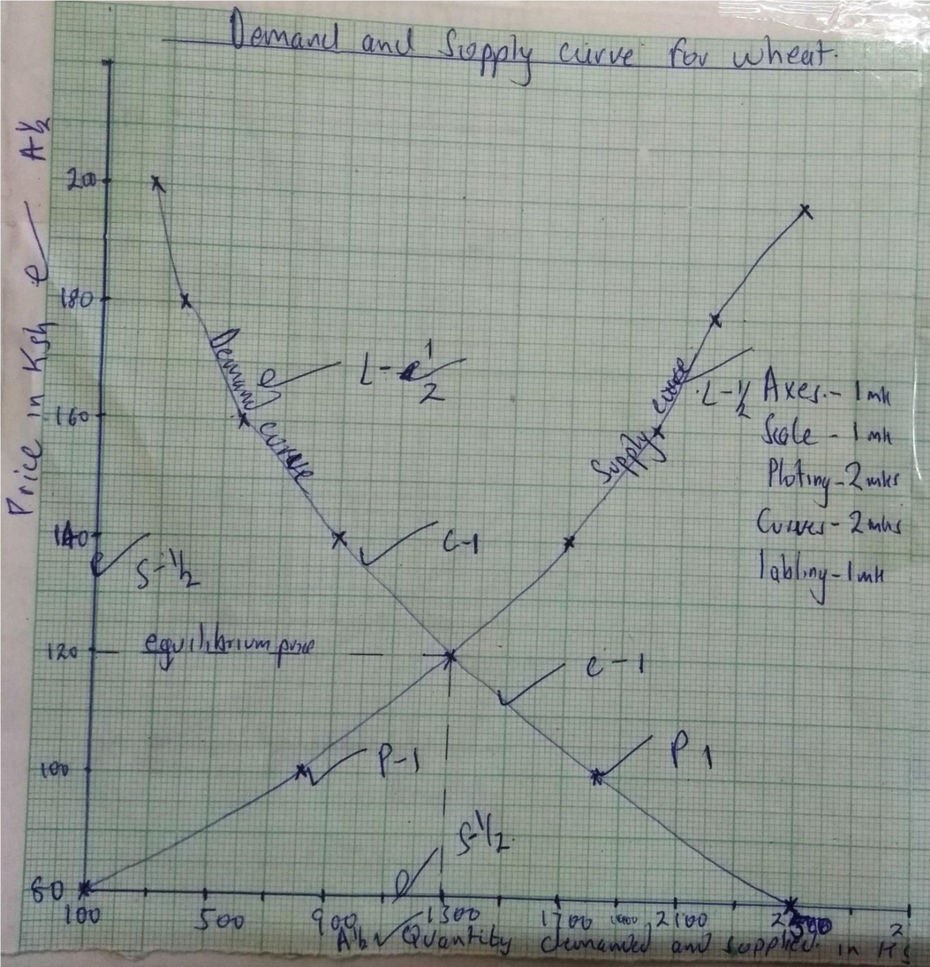

(ii) Determine the equilibrium price for the wheat (1mk)

120ksh
(iii) Calculate the elasticity of demand for
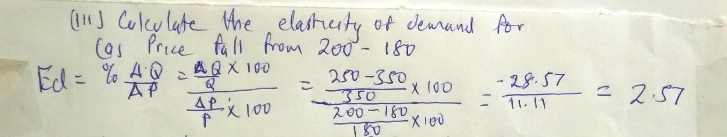

b. (i) If the price increased from kshs.140 to kshs.160 (2mks)
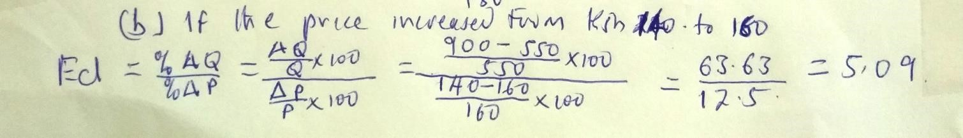
(ii) Find the quantity demanded at equilibrium price. (2mks)

1300kg

c. Explain two factors that affect the demand of tomatoes other than price. (2mks)

i. Income

ii. Population

iii. Preferences and force iv. Prices of related goods

v. Advertisement

vi. Beliefs and customs

b) Describe four characteristics of variable inputs (4mks)

i. Change in quantity required with level of production ii. Added to fixed inputs for production iii. Allocated to specific resources iv. Used to calculate gross margin

