FORM FOUR TERM 2 , 2022
AGRICULTURE PAPER II)
(MARKING SCHEME
TIME:2 ½ HRS
SECTION A: (30 MARKS)
Answer all questions in this section in the spaces provided.
1. Name three meat breeds of sheep. (3 x ½ marks)
- Dorper.
- Blackhead Persian.
- Red Maasai Sheep.
2. | List two methods of identifying pigs. | (2 x ½ )
Ear notching.
- Ear tagging.
- Differentiate between oestrus cycle and heat period. (mark as whole 1mark)
Oestrus cycle is the period between two successive heat periods in animals while heat period is the time When a female animal is ready to accept mating to take place.
- State three qualities of marketable eggs. ((Any 3 x ½ )1½mks) - Smooth shell
  - Oval shape
  - Medium weight - Hard shell
  - Clean eggs
  - Free from cracks
- Name any four notifiable diseases in livestock. (Any 4 x ½ ) (2mks)
    - New castle
    - Rinderpest
    - Anthrax
    - Gumboro
    - Foot and mouth.
- State four factors that affect maintenance ration required by an animal. ( 4 x ½ ) (2mks)
    - Body size/weight of the animal
    - Age of the animal i.e. young animal require more than old animal.
    - Animal’s activities.
    - Level of production where higher produces need more for maintenance their low produces.
- Give a reason why ruminant animals are able to digest grass. (1 mark )
- They have micro-organisms/bacteria in the rumen which help to breakdown cellulose.
- Give the difference in meaning of the following terms as used in livestock health. (a) Quarantine and Isolation Quarantine.
Laws by the government banning movement of livestock and their products into and out of an area during the period of an outbreak of a notifiable or highly contagious and infectious disease.
Isolation.
Separating and confining a sick animal from the rest of the herd to prevent spread of a highly contagious disease
(Mark as a whole)
(b) Zoonotic and notifiable diseases (1 mark)
Zoonotic A disease that can be transmitted from livestock to humans and vice versa
Notifiable - highly contagious and infectious disease whose outbreak should be reported to the authority.
(Mark as a whole)
- Give four reasons for feeding calves with colostrum. (4 x ½ ) (2 marks)
  - Highly digestible
  - Highly nutritive
  - Highly laxative/purgative cleans the system
  - Contain antibodies
- Differentiate between cropping and harvesting in fish production. (1 mark)
Cropping is the removal of fish of marketable size from the pond while harvesting is the removal of all the fish from the pond.
- State four major routes of administering vaccines in day old chicks. (4 x ½ ) - Nostrils
  - Mouth
  - Eyes
  - Under the skin (sub cutaneous)
- Give two reasons for feeding bees (Any 2 x ½ ) (1mk)
  - When there are new colonies
  - During drought conditions
  - To encourage multiplication
- Name the vectors for each of the following livestock diseases. (2 marks)
  - East coast fever… Brown ear tick ( Rhipicephalus appendiculatus)
  - Rift valley fever… Culex mosquito/Aedes mosquito
  - Trypanosomiasis… Tsetse fly
  - Nairobi sheep disease Brown ear tick ( Rhipicephalus appendiculatus
- (a) Name the tools used in ( 2 marks)
(i) Cutting curves on thin wood Coping saw
(ii)Measuring the inner diameter of a circular object/surface Inside calipers
(iii)Cutting thin sheets of metal Tinsnips
(iv)Tightening wires during fencing Wire strainer
b) State two care and maintenance practices of masonry tools and equipment. (1 mark)
- Tools should be cleaned after use (Any 2 x ½ )
- Part like hack-saw blades should be replaced regularly
- Handles should be replaced when broken
- All moving parts like nuts and wheels should be lubricated regularly to reduce friction - When cutting metal, a coolant oil should be used to increase grip
- State two ways in which proper feeding contributes to disease control in livestock.
(2 x ½ ) - It helps in preventing nutritional deficiency diseases. - It increases ability to resist diseases.
- Outline four factors which would be considered when culling layers.
(Any 4 x ½ ) (2 marks) - Poor layers/producers
  - cannibals
  - Old chicken
  - Combs, wattles & vents become shriveled
  - Having dull feathers
  - Egg eaters
  - Breast bones become hard
  - Body and vent changes colour from white to yellow
  - Width between pelvic bones becomes narrow 2-3 fingers can’t fit in between
- a. What is parasitism? (½ mark)
An association between 2 organisms in which one is called a parasite derives all its nutrients from the other one a host without benefiting the host.
  - Name one parasite of bees. (½ mark)
Ants, wax moth, Bee louse, Honey Badger
  - Give any four harmful effects of lice on livestock. (Any 4 x ½ ) (2mks)
    - Poor feeding leading to emaciation.
    - Loss of production in bird.
    - Cause irritation to the animal leading to animal rubbing itself against objects
    - Anaemia in poultry
    - Death due to heavy infestation.
- Name two methods used in ration computation. (Any 2 x ½ ) (1mark)
    - Trial and error.
    - Pearson’s square method.
    - Linear programming

SECTION B: (20 MARKS)
Answer all questions in this section in the spaces provided.
- Below is a diagram of a bee hive.
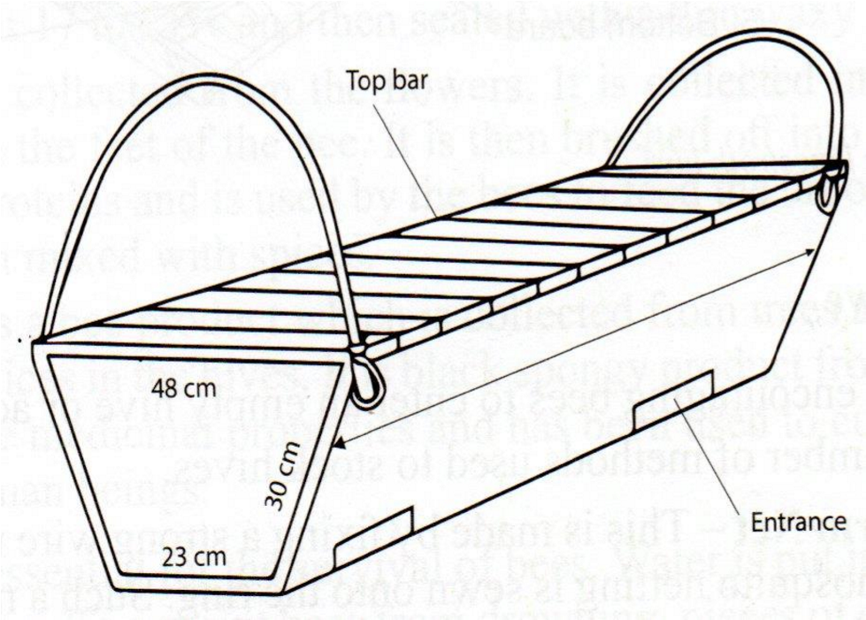
  - Identify the type of hive above. (1mk)
Kenya Top bar hive.
  - Give three advantages of using this type of hive on the farm. (3mks)
      - Honey combs can be removed without disturbing the brood.
      - The top bar can be removed for inspection of the combs and replaced.
      - High quality honey is as if is harvested without brood combs.
      - It is easy to construct and repair.
      - It is cheap to build and it does not require expensive equipment to extract honey. (3X1=3mks)
c) | State any three reasons why bees swarm.  - Shortage of food and water in the surrounding.  - Dampness and bad smell.  - Sick or infertile queen.  - Overcrowding in the hive.  - Damage of brood combs. | (3mks)
 | - Outbreak of diseases and parasites. | (3x1= 3mks)
- The following diagram illustrate symptoms of a disease in poultry. Study it carefully and answer the question that follows.
(a) Identify: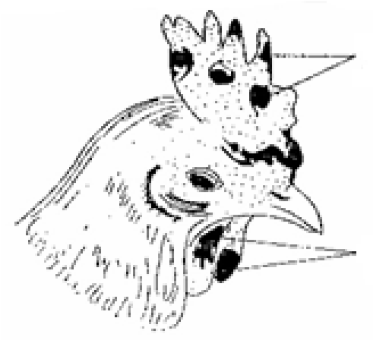 (i) The disease. (½ mark)
Fowl pox/Avian pox.

Lesions or
wound

Lesions or
wound

(ii) The causal organism. (½ mark)
Virus/Avian pox virus
(b) State two other symptoms of the disease apart from lesion. (2 marks)
        - There is watery discharge through eyes and nose in early stage of infection.
        - There is difficulty in breathing and swallowing.
        - The bird is emaciated and this may cause death.
        - Dullness.
        - Loss of appetite.
(c) State two control measures for the disease. (2 marks)
        - Isolation of the affected birds.
        - Removal and killing of all affected birds.
        - The remaining healthy birds should be vaccinated. - Observe hygiene in poultry house.
- ( a)Explain the reasons for the behavior of chicks in the above diagrams (4 marks ) A—Correct temperature in the brooder.
B—Very cold brooder. C—Very hot brooder.
D—Draught /cold wind from the right side of the brooder. | (4x1)= 4 marks)
(b) Give two other signs the chick will show other than the ones you have given in( a) above.(1 mark) - Spread wings .
- Open beaks /panting/grasping.
- Drinking a lot of water. - Making a lot of noise.
22. .a) Name the tools. (2 marks)
- Open-end spanner
- Rig spanner
- Adjustable spanner
W Burdizzo
b) State the functional differences between tools K and W. (1mark)
K- Expands rubber ring to facilitate to facilitate closed castration, docking and dehorning
W- used for closed castration in bull calves, rams and Billy goats
c).Advantage of tool C, over tool A and B
- Tool C, can be used to open and tighten nuts and bolts of deferent sizes while A and B can only be used to open or tighten nuts and bolts of specific sizes. d) Common maintenance of tool C and W
- Lubricating/oiling moving parts

SECTION C: (40 MARKS)
Answer any two questions from the section.
- a) Describe trypanosomiasis disease under the following sub-headings.
i) Causal organism  Typanosoma (spp)/ ii) Animals attacked  - cattle  - Sheep  - Goats  - Pigs  - Horses | (1 Mk)
iii) Symptoms of attacked animals - high temperature or fever  - The animal is observed to be dull  - Loss of appetite  - General weakness of the body  - Lachrimation which leads to blindness  - Diarrhea  - Rough coat sometimes no hair and cracked skin  - Swelling of parts of the belly  - Milk production decreases  - Loss of hair at tail and  - Anemia  - Abortion may occur in pregnant females due to high body | (Any 5x1 ) (5 Mks)
iv. Control measures | (3 Mks)
    - Treating animals with trypanocidal drugs. - Effective vector (Tsetse flies)control
    - Confinement of wild animals in game parks.
b) Describe five control measures for cannibalism in poultry (5 Mks)
-Control external parasites
  - keep birds busy by hanging green leaves or vegetables in the house
  - feed the birds on a balanced diet
  - provide adequate floor space
  - provide adequate laying nests
  - provide dim lights in the brooder
  - keep birds as per age group
  - debeak hens which peck others
(c) Explain the procedure in establishment of foundation in farm buildings (5mks)
  - Clear the vegetation
  - Level the site if sloppy
  - Measure the width of the foundation by pegging
  - Dig to remove all the loose soil to the basement rock
  - Place concrete of 1:2:4 or 1:3:6 at the flow
  - Compact the concrete
  - Lay the foundation stones and construct up to 15cm above the ground (5 mks)
- a) Functions of parts of a plunge dip
    - Holding yard –Holds animals before dipping
    - has concrete floor to remove mud from hooves
    - Footbath - removes mud from hooves
    - controls foot rot
    - Jump – Allows animals to jump into the dip one at a time
– Forces the animal to slide and Plunge into the dip wash
    - Dip tank - immersion of animals in dip wash containing an a caricide
    - Exit steps – Allows animals to come out of the dip wash slowly
    - Draining race – Allows the dip wash to drip from the animals and flow back to the dip tank
    - Drying yard – Temporarily retains the animal thus avoiding pasture contamination and allows animals to be released at the same time
    - Silt trap outlet – Traps mud/dung/silt from the dip wash before it flows back into the dip tank - Water tank – storing water for dipping purposes/cleaning the dip and preparing fresh acaricide solution.
    - Shelter/Roof – Reduce the loss of acaricide/dip wash through evaporation and to avoid dilution of dip wash by rain water. Collects rain water into the water tank.
    - Waste pit- Damping site for sediments from the dip tank.
b)- signs of parturition in cattle
    - Restlessness
    - Enlarged /swollen vulva
    - clear mucus discharge from vulva
    - Full and distended udder
    - Slackening of the pelvic muscles/relaxing of the hips muscles
    - Thick milky fluid (colostrum) from teats
    - Appearing and bursting of the water bag/sac
    - Loss of appetite
    - Isolating from others (5x1)
c) Maintenance practices of a fish pond
    - Clearing the bush/vegetation around the pond
    - Cleaning the pond
    - Desilting/removing the silt
    - Planting grass on the dyke
    - Repairing worn out parts/dykes - Maintain the water level.
    - Fertilize the pond
    - Fencing (5x1)
d) Factors considered when selecting livestock for breeding
    - Age – select young animals
    - Level of performance – select animals with the highest production level/high Performers or yielders.
-. Physical fitness – animals selected should be free from physical deformities/defects e.g limping, mono-eyed
    - Health – Select healthy animals/animal selected should be health
    - Body conformation – Animals selected should have proper body conformation eg dairy cow to be wedge shaped with a large udder.
    - Temperament/behavior – select animals with good temperament/behavior
    - Quality of products – select animals that give good quality products - Mothering ability – animals selected should have good mothering ability - Adaptability – animals selected should be well adapted to local conditions.
    - Prolificacy – selected animals that are highly prolific - Fertility – selected animals that are fertile
25.
a. Describe the management of a sow during parturition. (10 marks )
    - Deworm 7-10 days before parturition/spray the sow against external parasites/wash its body with soap and water.
    - Take the sow to the farrowing pen at least 5-7 days before the expected date of parturition. - Clean and disinfect the farrowing pen - Provide creep area.
    - Feed the sow entirely on bran.
    - Provide clean bedding materials in the farrowing pen.
    - Do not interfere but watch from a distance during farrowing.
    - Assist where necessary.
    - Ensure piglets are breathing.
    - Perform artificial respiration.
    - Ensure piglets are safe from being cannibalized by the sow.
    - Tie, cut and disinfect the navel cord of the piglet.
    - Weigh each piglet and record the birth weight.
    - Remove and dispose off the after birth/any piglet born dead (still births).
    - Put piglets in a warm place.
    - Ensure piglets suckle colostrum.
    - Get rid of excess piglets.
    - Provide plenty of clean water after parturition.
    - Feed the sow generously. (Any 10 x 1 = 10 marks)
- Describe the lifecycle of a three host tick. (7 marks)
  - Adult tick lay eggs on the ground.
  - Eggs hatch into larvae on the ground.
  - Larvae mount onto the first host.
  - Larvae on host one feed to full engorgement and drop down.
  - Nymphs mount second host suck blood until engorges.
  - Nymphs drop down.
  - Nymphs moults into adults.
  - Adults mount third host, suck blood to full engorgement.
  - Adults drop down to repeat cycle. (1 x 7 = 7 marks)
- Outline three effects of endo-parasites to the host animals (3mks)
They suck blood leading to anaemia
They deprives the host of its food
They damage internal organs like liver
Cause obstruction of bile duct and alimentary canal

