NAME … ADM NO:..................
SIGNATURE ...DATE: ................

AGRICULTURE
FORM ONE
TIME : 2 HOURS

INSTRUCTIONS TO CANDIDATES
- This paper consists of three sections; A, B and C.
- Answer ALL the questions in the three sections
- All answers to be written in English

FOR OFFICIAL USE ONLY
SECTION | QUESTION | MAX. SCORE | CANDIDATE SCORE
A | 1  10 | 40
B | 11  14 | 20
C | 15  16 | 40
 | TOTAL | 100

SECTION A (40 MARKS)
ANSWER ALL THE QUESTIONS IN THE SPACES PROVIDED
- Give the meaning of the following terms as used in Agriculture (3 mks)
a). Crop pathology

b). Agricultural entomology

c). Agricultural engineering

- Name four branches of livestock farming (4 mks)

- a). What is a farming system? (1 mk)

b). Name two forms of large scale farming practiced in Kenya (2 mks)

c). State four features of large scale farming. (4 mks)

- Give four human factors that affect agricultural production (4 mks)

- Name four soil constituents (4 mks)

- Differentiate between soil texture and soil structure (2 mks)

- Give four reasons why burning of land is discouraged (4 mks)

- Name four implements used for primary cultivation (4 mks)

- State the use of water in the farm (4 mks)

- List four surface water sources in a farm (4 mks)

SECTION B (20 MARKS)
ANSWER ALL THE QUESTIONS IN THE SPACES PROVIDED

- The following diagram illustrate farm equipment. Study it and answer the questions that follow.

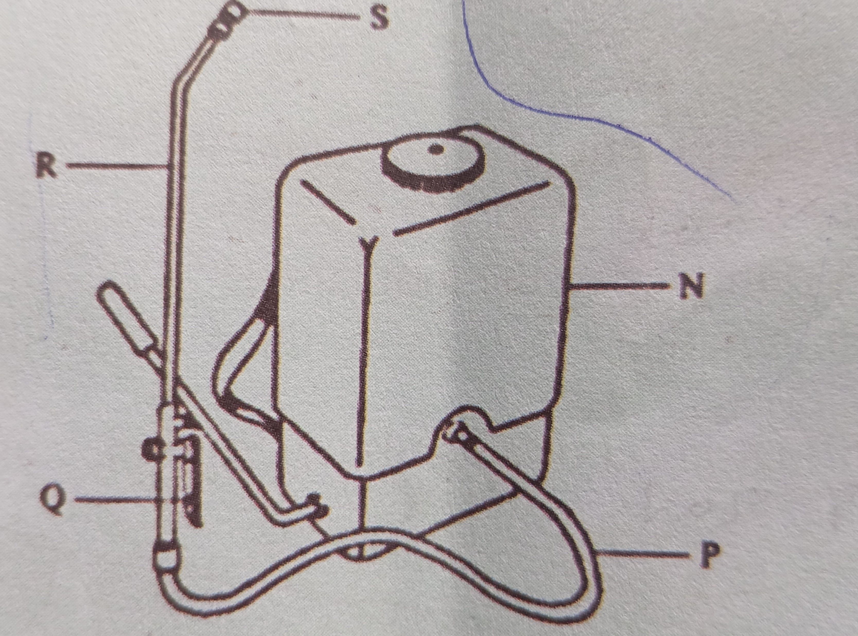

a). Identify the farm equipment. (1 mk)

b). Name the parts labelled P, Q and N. (3 mks)
P
Q
N

c). Give one use of the above equipment (1 mk)

- The diagram below illustrates an experiment on soil. Study it carefully and answer the questions that follow.

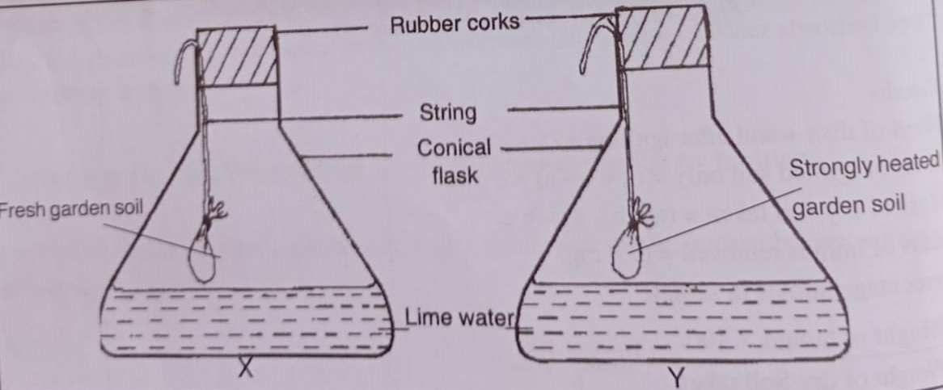

a). State the aim of the experiment. (1 mk)

b). Record observations in flask X and Y (2 mks)

c). Give reasons for your answer in (b) above. (2 mks)

- The diagram below illustrates a field practice

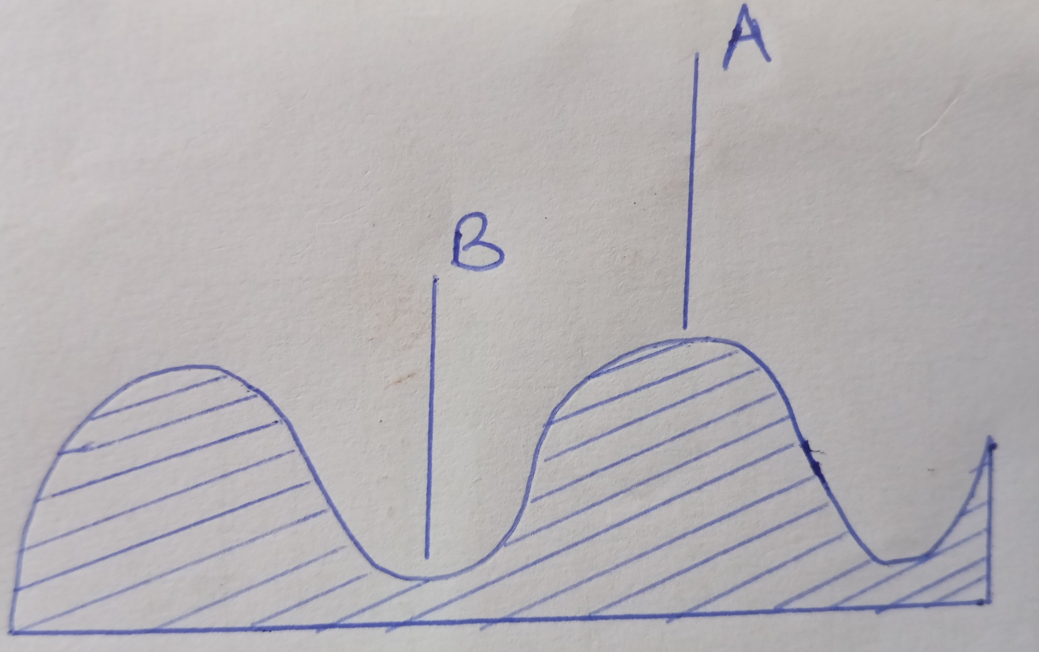

a). Identify the practice. (1 mk)

b). Identify the parts labelled A and B (2 mks)
A
B

c). State two advantages of carrying out the practice (2 mks)

- The diagram labelled A and B shows method of water collection and storage.

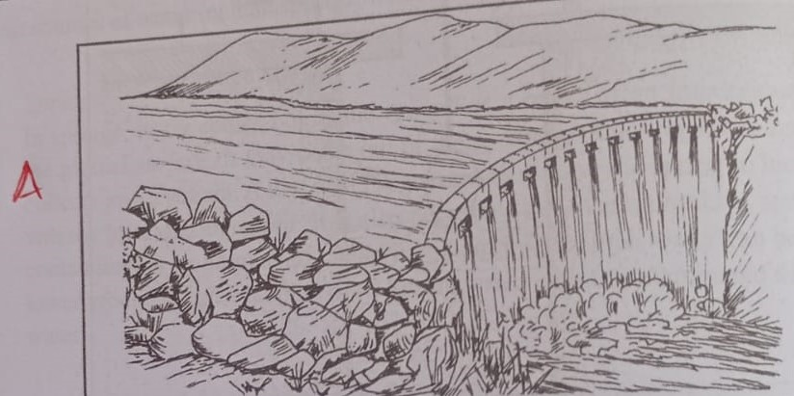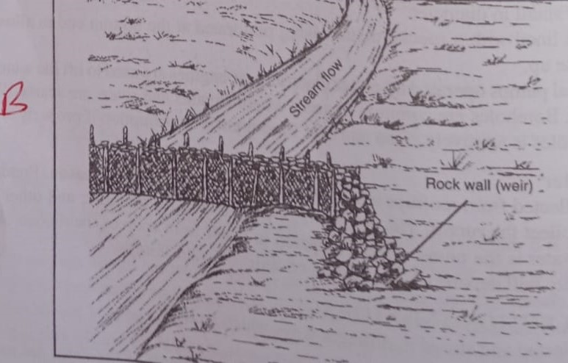

a). Identify structures A and B (2 mks)
A
B
b). Name three sources of water in the farm. (3 mks)

SECTION C (40 MARKS)
ANSWER ALL THE QUESTIONS IN THE SPACES PROVIDED

- a). Describe five government policies that affect agricultural production (5 mks)

b). i) Identify four minimum tillage operations (4 mks)

ii). Give four reasons for carrying out minimum tillage. (4 mks)

c). i). Name four physical agents of weathering (4 mks)

ii). Identify three factors that influence soil formation. (3 mks)

- a). State seven reasons for preparing land before planting. (7 mks)

b). Describe the uses of the following tools (10 mks)
i). Milk churn

ii). Garden line

iii). Wheelbarrow

iv). Rip saw

v). G  clump

vi). Halter

Vii). Troca and canula

viii). Pipe wrench

ix) Spade

x). Rubber ring and elastrator

c). Give three reasons for treating water for human consumption (3 mks)

*THIS IS THE LAST PRINTED PAGE*

