***Name………………………………………………………….Index No………………………..***

**443/2**

**AGRICULTURE**

**Paper 2**

2 Hrs

**SET 5**

**FORM 4**

**Instructions**

*This paper consist of three sections* ***A,B*** *and* ***C****. Answer all questions in section* ***A*** *and* ***B*** *and any two questions in section* **C.**

**All answers be written in the spaces provided.**

**For Examiner’s Use Only**

|  |  |  |  |
| --- | --- | --- | --- |
| Section | Question | Maximum Score | Candidates Score |
| **A** | 1-18 | **30** |  |
| **B** | 19-23 | **20** |  |
| **C** |  | **20** |  |
|  | **20** |  |
| **Total Score** | | **90** |  |

**SECTION A (30 marks**)

***Answer all questions in this section in the spaces provided***

1 State four maintenance practices carried out on a rotary mower. (2mks)

………………………………………………………………………………………………………………………………………………………………………………………………………………………………………………………………………………………………………………………………………………………………………………………………………………………………………………………………………………………………………………………………………………………………………………………………………………………………………………

2 Give three advantages of using contemporary comparison method in selection of a breeding stock in livestock. (1 ½ mks)

………………………………………………………………………………………………………………………………………………………………………………………………………………………………………………………………………………………………………………………………………………………………………………………………………………………………

3 Give three reasons why water power is not commonly used in the farm. (2mks)

………………………………………………………………………………………………………………………………………………………………………………………………………………………………………………………………………………………………………………………………………………………………………………………………………………………………………………………………………………………………………………………………………………………………………………………………………………………………………………

4 State two basic rules that should be followed in order to achieve success in control and treatment of endoparasites. (1mk)

………………………………………………………………………………………………………………………………………………………………………………………………………………………………………………………………………………………………………………………

5 State four ways through which vaccines are administered to control diseases in livestock.

(2mks)

………………………………………………………………………………………………………………………………………………………………………………………………………………………………………………………………………………………………………………………………………………………………………………………………………………………………………………………………………………………………………………………………………………………………………………………………………………………………………………

6 Give the meaning of the following terms as used in livestock health.

1. Immunity (1mk)

………………………………………………………………………………………………

1. Curative treatment ( 1mk)

………………………………………………………………………………………………

7 State three characteristics of air cooled Engines. (1 ½ mks)

………………………………………………………………………………………………………………………………………………………………………………………………………………………………………………………………………………………………………………………………………………………………………………………………………………………………

8 (a) Name three dual purpose breeds of sheep. (1 ½ mks)

………………………………………………………………………………………………………………………………………………………………………………………………………………………………………………………………………………………………………………………………………………………………………………………………………………………………

1. Give the home origin of Angora goat breed. ( ½mk)

……………………………………………………………………………………………………………………………………………………………………………………………..

9 List two factors associated to the animal that determines the amount of feed that an animal consumes. (1mk)

………………………………………………………………………………………………………………………………………………………………………………………………………………………………………………………………………………………………………………………10 List four Bacterial diseases of cattle. (2mks)

………………………………………………………………………………………………………………………………………………………………………………………………………………………………………………………………………………………………………………………………………………………………………………………………………………………………………………………………………………………………………………………………………………………………………………………………………………………………………………

11 Give two reasons for out breeding in livestock. (1mk)

………………………………………………………………………………………………………12 Name two methods of identification used in pigs. (1mk)

………………………………………………………………………………………………………………………………………………………………………………………………………………………………………………………………………………………………………………………

13 Define the following terms as used in livestock breeding

1. Outcrosssing (1mk)

……………………………………………………………………………………………

1. Crossbreeding (1mk)

……………………………………………………………………………………………

14 (a)State three signs of heat in pigs. (1 ½ mks)

………………………………………………………………………………………………………………………………………………………………………………………………………………………………………………………………………………………………………………………………………………………………………………………………………………………………

1. Give three signs of farrowing in pigs. (1 ½ mks)

………………………………………………………………………………………………………………………………………………………………………………………………………………………………………………………………………………………………………………………………………………………………………………………………………………………………………………………………………………………………………………………………………………………………………………

15 What is the intermediate host for liver fluke? ( ½mk)

………………………………………………………………………………………………………

16 State three advantages of two stroke cycle engine. (1 ½ mks)

………………………………………………………………………………………………………………………………………………………………………………………………………………………………………………………………………………………………………………………………………………………………………………………………………………………………

17 State four effects of parasites in livestock. (2mks)

…………………………………………………………………………………………………………………………………………………………………………………………………………………………………………………………………………………………………………………………………………………………………………………………………………………………………………………………………………………………………………………………………………………………………………………………………………………………………………………………………………

18 (a) Give four reasons why the feeding of colostrum is important in the rearing of piglets.

(2mks)

………………………………………………………………………………………………………………………………………………………………………………………………………………………………………………………………………………………………………………………………………………………………………………………………………………………………

(b)Name the hormone that controls heat period in pigs. ( 1mk)

………………………………………………………………………………………………………

**SECTION B (20 marks)**

***Answer all questions in this section in the spaces provided.***

19 Calculate the amount of silage required by a cow weighing 400 kg using the following information. A cow requires 3kg of dry matter (DM) for every 100kg of body weight per day. Silage contains 40% dry matter. Calculate the amount of silage the cow should be given per day.

(2mks)

………………………………………………………………………………………………………………………………………………………………………………………………………………………………………………………………………………………………………………………………………………………………………………………………………………………………………………………………………………………………………………………………………………………………………………………………………………………………………………………………………………………………………………………………………………………………………………………………………………………………………………………………………………………………………………………………………………………………………………………………………………………………………………………………………………………………………………………………………………………………………………………………………………………………………………………………………………………………………………………………………………………………………………………………………………………………………………………………………………………………………………

20. Below is an illustration of a livestock routine management practice. Study it and answer questions that follow.

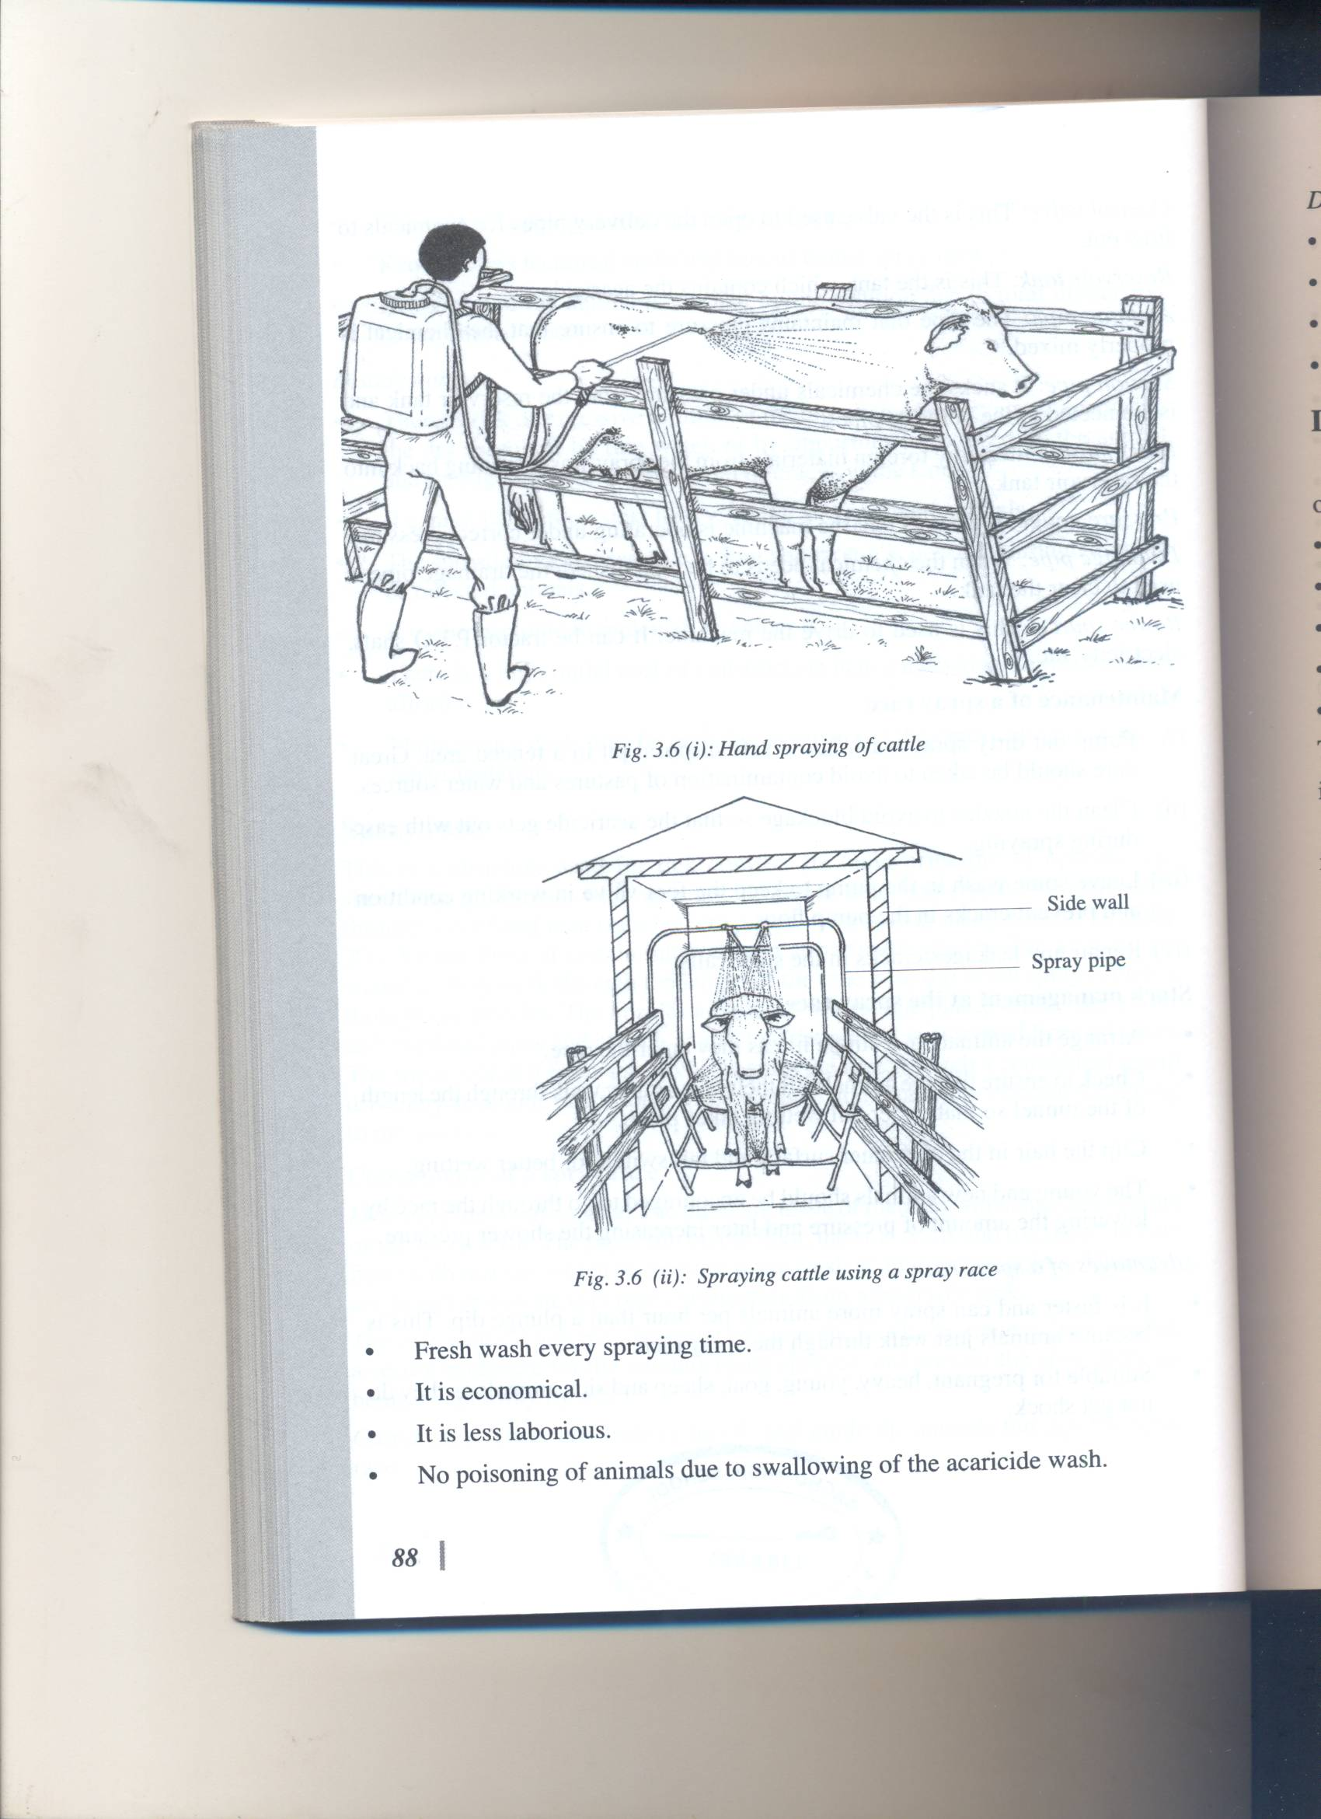

(i) State the reason for carrying out the routine practice shown above. (1mk)

………………………………………………………………………………………………………

(ii)Give three factors that affect the effectiveness of the chemical used above. (1 ½ mks)

………………………………………………………………………………………………………………………………………………………………………………………………………………………………………………………………………………………………………………………………………………………………………………………………………………………………

21 The diagram below represents a workshop tool. Study the diagram and answer the questions that follow .

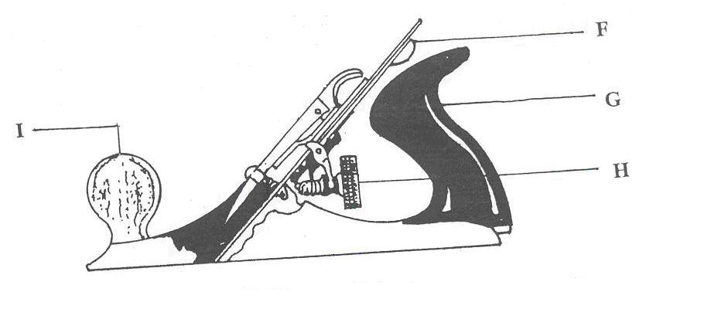

(i)Name the parts **F , G , H ,** and **I** as indicated on diagram. (2mks)

**F**………………………………………………………………………………………….

**G**………………………………………………………………………………………..

**H**……………………………………………………………………………………….

**I**………………………………………………………………………………………….

(ii)Give one use of the tool. ( ½mk)

………………………………………………………………………………………………………

(ii)Name two other tools which would do a similar job as the workshop tool shown in the diagram above (1mk)

………………………………………………………………………………………………………………………………………………………………………………………………………………………………………………………………………………………………………………………

(iii)State two precautions that should be taken when using the tool. (1mk)

………………………………………………………………………………………………………………………………………………………………………………………………………………………………………………………………………………………………………………………

(iv) Give two maintenance practices carried out on the above tool. (1mk)

………………………………………………………………………………………………………………………………………………………………………………………………………………………………………………………………………………………………………………………

22 Study the illustration below and answer questions that follow.

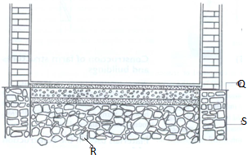

(i)Name the parts labeled **Q , R** , and **S**. (1 ½ mks)

**Q**……………………………………………………………………………………………………

**R**……………………………………………………………………………………………………

**S**……………………………………………………………………………………………………

(ii)Give the function of the part labeled **Q.** ( ½ mk)

………………………………………………………………………………………………………

(iii)State four factors that determine the type of materials to use in construction of the wall.

(2mks)

………………………………………………………………………………………………………………………………………………………………………………………………………………………………………………………………………………………………………………………………………………………………………………………………………………………………………………………………………………………………………………………………………………………………………………………………………………………………………………

23 Diagram **T** and **M** below show farm implements.

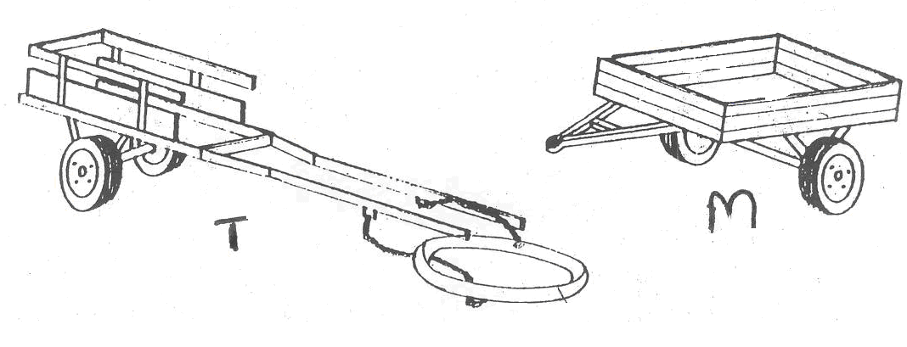

(i)Give the source of power used in operating each of the implements. (1mk)

**T**……………………………..

M………………………………….

(ii)State the means by which each of the above implements are attached to its source of

power.

T………………………………………….. (1mk)

M………………………………………….. (1mk)

(iii) Give two advantages of implement **T** over **M**. (1mk)

………………………………………………………………………………………………………………………………………………………………………………………………………………………………………………………………………………………………………………………

(iv) State two maintenance practices for implement **T**. (2mks)

……………………………………………………………………………………………………………………………………………………………………………………………………………………………………………………………………………………………………………………....

**SECTION C (40 marks)**

**Answer any two questions from this section in the spaces provided after question 26.**

24(a) Explain the procedure 0f drenching a calf using a bottle. (6marks)

………………………………………………………………………………………………………………………………………………………………………………………………………………………………………………………………………………………………………………………………………………………………………………………………………………………………………………………………………………………………………………………………………………………………………………………………………………………………………………………………………………………………………………………………………………………………………………………………………………………………………………………………………………………………………………………………………………………………………………………………………………………………………………………………………………………………………………………………………………………………………………………………………………………………………………………………………………………………………………………………………………………………………………………………………………………………………………………………………………………………………………

(b)Explain the advantages of deep litter system in poultry rearing. (7marks)

………………………………………………………………………………………………………………………………………………………………………………………………………………………………………………………………………………………………………………………………………………………………………………………………………………………………………………………………………………………………………………………………………………………………………………………………………………………………………………………………………………………………………………………………………………………………………………………………………………………………………………………………………………………………………………………………………………………………………………………………………………………………………………………………………………………………………………………………………………………………………………………………………………………………………………………………………………………………………………………………………………………………………………………………………………………………………………………………………………………………………………

(c) Explain the factors that influence milk composition. (7marks)

…………………………………………………………………………………………………………………………………………………………………………………………………………………………………………………………………………………………………………………………………………………………………………………………………………………………………………………………………………………………………………………………………………………………………………………………………………………………………………………………………………………………………………………………………………………………………………………………………………………………………………………………………………………………………………………………………………………………………………………………………………………………………………………………………………………………………………………………………………………………………………………………………………………………………………………………………………………………………………………………………………………..

25 (a) State and explain the rearing practices carried out on a male calf from birth to weaning period (5marks)

…………………………………………………………………………………………………………………………………………………………………………………………………………………………………………………………………………………………………………………………………………………………………………………………………………………………………………………………………………………………………………………………………………………………………………………………………………………………………………………………………………………………………………………………………………………………………………………………………………………………………………………………………………………………………………………………………………………………………………………………………………………………………………………………………………………………………………………………………………………………………………………

(ii)Describe the process of castration in male piglets using surgical blade. (5marks)

………………………………………………………………………………………………………………………………………………………………………………………………………………………………………………………………………………………………………………………………………………………………………………………………………………………………………………………………………………………………………………………………………………………………………………………………………………………………………………………………………………………………………………………………………………………………………………………………………………………………………………………………………………………………………………………………………………………………………………………………………………………………………………………………………………………………………………………………………………………………………………………………………………………………………………………………………………………………

1. (i)State the predisposing factors of calf pneumonia. (3marks)

………………………………………………………………………………………………………………………………………………………………………………………………………………………………………………………………………………………………………………………………………………………………………………………………………………………………………………………………..

(ii)Outline five signs of the above disease. (5marks)

………………………………………………………………………………………………………………………………………………………………………………………………………………………………………………………………………………………………………………………………………………………………………………………………………………………………………………………………………………………………………………………………………………………………………………………………………………………………………………………………………………………………………………………………………………………………………………………………………………………………………………………………………………………………………………………

(iii) Give two control measures. (2marks)

………………………………………………………………………………………………………………………………………………………………………………………………………………………………………………………………………………………………………

26 (a) State and explain the management of fish and fish pond. (8marks)

……………………………………………………………………………………………………………………………………………………………………………………………………………………………………………………………………………………………………………………………………………………………………………………………………………………………………………………………………………………………………………………………………………………………………………………………………………………………………………………………………………………………………………………………………………………………………………………………………………………………………………………………………………………………………………………………………………………………………………………………………………………………………………………………………………………………………………………………………………………………………………………………………………………………………………………………………………………………………………………………………………………………………………………………………………………………………………………………………………………………………………………………………………………………………………………………………………………………………………………………………………………………………………………………………………………………………………………………………………………………………………………………………………………………………………………………………………………………………………………………………………………………………………………………………………………………………………………………………………………………………………………………………………………………………………………………………………………………………………………………………………………………

(b) Describe the processing of honey using heat method. (7marks)

………………………………………………………………………………………………………………………………………………………………………………………………………………………………………………………………………………………………………………………………………………………………………………………………………………………………………………………………………………………………………………………………………………………………………………………………………………………………………………………………………………………………………………………………………………………………………………………………………………………………………………………………………………………………………………………………………………………………………………………………………………………………………………………………………………………………………………………………………………………………………………………………………………………………………………………………………………………………………………………………………………………………………………………………………………………………………………………………………………………………………………………………………

(c) Give the advantages of using disc plough over mouldboard plough. (5marks)

…………………………………………………………………………………………………………………………………………………………………………………………………………………………………………………………………………………………………………………………………………………………………………………………………………………………………………………………………………………………………………………………………………………………………………………………………………………………………………………………………………………………………………………………………………………………………………………………………………………………………………………………………………………………………………………………………………………………………………………………………………………………………………………………………………………………………………………………