Name: ………………………………………….Index No: …………………....

443/2
AGRICULTURE
Paper 2
2 hours

KASSU EXAMINATION
Kenya Certificate of Secondary Education
AGRICULTURE
PAPER 2
2 HOURS

Instructions to candidates.

- Write your name and index number in the spaces provided.
- This paper consists of three sections A, B and C.
- Answer ALL the questions in section A and B and any two questions in section C.
- All answers must be written in the spaces provided.
- Do not remove any pages from the question paper.

For Examiner`s use only

Section | Questions | Maximum score | Candidates score
A | 1-18 | 30
B | 19-22 | 20
C |  | 20
 |  | 20
 | Total Score | 90

SECTION A (30 marks)
Answer all questions in this section in the spaces provided

- Give two uses of the roof of cattle dip tank. (1mk)
........................................................................................................................................................................................................................................................................................................................
- State two causes of soft shelled eggs. (1mk)
........................................................................................................................................................................................................................................................................................................................
- Give four signs of farrowing in a sow. (2mks)
................................................................................................................................................................................................................................................................................................................................................................................................................................................................................................................................................................................................................................................
- Outline four causes of cannibalism in a flock of layers in the deep system. (2mks)
...............................................................................................................................................................................................................................................................................................................................................................................................................................................................................................................................................................................................................................................
- State four maintenance practices carried out on a Jack plane. (2mks)
..............................................................................................................................................................................................................................................................................................................................................................................................................................................................................................................................................................................................................................................
- State three uses of solar power on the farm. (1½ mks)
....................................................................................................................................................................................................................................................................................................................................................................................................................................................................................

- Name four types of layer breeds of chicken. (2mks)
...............................................................................................................................................................................................................................................................................................................................................................................................................................................................................................................................................................................................................................................
- Give the distinguishing characteristics of Essex and Wessex Saddle back breed of pigs.(1mk)
.......................................................................................................................................................................................................................................................................................................................
- Give four symptoms of brucellsis in cows. (2mks)
................................................................................................................................................................................................................................................................................................................................................................................................................................................................................................................................................................................................................................................
- State four reasons why inbreeding may be useful in livestock production. (2mks)
..............................................................................................................................................................................................................................................................................................................................................................................................................................................................................................................................................................................................................................................
- Give two effects of Tsetse flies on livestock. (1mk)
........................................................................................................................................................................................................................................................................................................................
- Name two types of rabbit houses. (1mk)
........................................................................................................................................................................................................................................................................................................................
- List four types of vaccines used in livestock production. (2mks)
...............................................................................................................................................................................................................................................................................................................................................................................................................................................................................................................................................................................................................................................

- Name four types of pests that affect bees. (2mks)
...............................................................................................................................................................................................................................................................................................................................................................................................................................................................................................................................................................................................................................................
- Outline three reasons why farmers dehorn cattle. (1¹/2mks)
....................................................................................................................................................................................................................................................................................................................................................................................................................................................................................
- (a. Differentiate between cropping and harvesting as used in fish production. (1mk)
......................................................................................................................................................................................................................................................................................................................
b. Name two species of fresh warm water fish. (1mk)
.......................................................................................................................................................................................................................................................................................................................
- Give four reasons for steaming up dairy cattle. (2mks)
..............................................................................................................................................................................................................................................................................................................................................................................................................................................................................................................................................................................................................................................
- List four post milking practices. (2mks)
...............................................................................................................................................................................................................................................................................................................................................................................................................................................................................................................................................................................................................................................

SECTION B (20 Marks)
Answer all questions in this section in the spaces provided.
- The diagram below shows the digestive system of a chicken. Study it and answer question that follow.
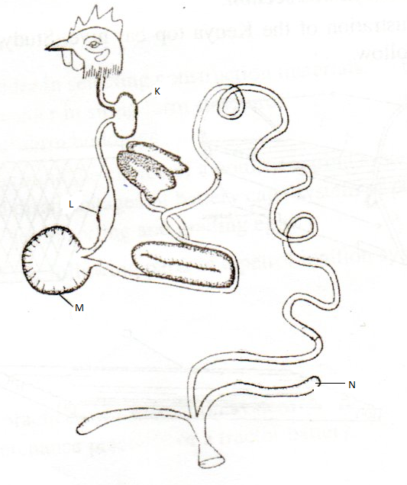
- . Identify the parts labeled K.L,M and N above. (2mks)
K………………………………………………………………………………………
L………………………………………………………………………………………
M………………………………………………………………………………………
N……………………………………………………………………………………….
- . Give the function of the part labeled M that makes it efficient in digesting food. (2mks)
.........................................................................................................................................................
(C) . Give two characteristics of the part labeled M that make it efficient in digesting food.(1mk)
........................................................................................................................................................................................................................................................................................................................
- Study the illustration below showing an animal suffering from a disease. Study it and answer question that follow.
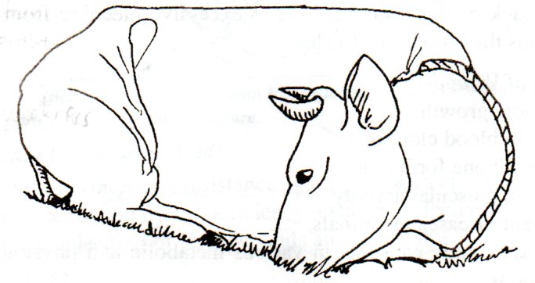
- . Identify the disease the animal is suffering from. (1mk)

...........................................................................................................................................................
(b. What causes the disease shown above? (1mk)

.....................................................................................................................................................
(c. Give three symptoms shown by a cow suffering from the disease above. (3mks
...................................................................................................................................................................................................................................................................................................................................................................................................................................................................................
- Study the farm structure shown below and answer questions that follow.

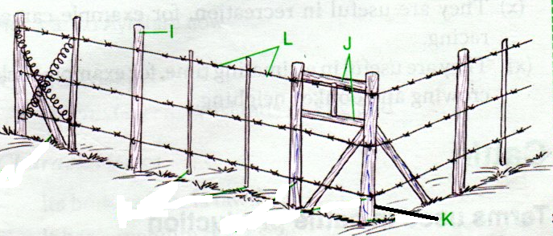
- . Identify the structure shown above. (1mk)
......................................................................................................................................................
(b) . Name the parts labeled I,J,K and L. above. (2mks)
I...............................................................................................................
J................................................................................................................
K...............................................................................................................
L................................................................................................................

(c ) . Give two disadvantages of using the structure above in pasture fields. (1mk)

..........................................................................................................................................................

- The diagram below shows a stir up pump. Study it and answer questions that follow.
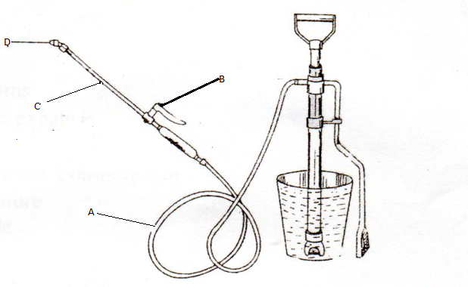

(a. Name the parts labeled A,B,C and D. (2mks)
A.................................................................................................................
B..................................................................................................................
C...................................................................................................................
D...................................................................................................................
(b. State two maintenance practices that should be carried out on the equipment illustrate above (2mks)
........................................................................................................................................................................................................................................................................................................................
(c. State one disadvantage of using the equipment above in controlling ticks. (1mk)
................................................................................................................................................

SECTION C (20 Marks
Answer any TWO questions in this section in the spaces provided.

- (a) .Describe Newcastle disease under the following sub headings
- Causal organism (1mark)
………………………………………………………………………………………………..
- Symptoms (6marks)
………………………………………………………………………………………………………………………………………………………………………………………………………………………………………………………………………………………………………………………………………………………………………………………………………………………………………………………………………………………………………………………………………………………………………………………………………………………………………………
- Control measures (3marks)
………………………………………………………………………………………………………………………………………………………………………………………………………………………………………………………………………………………………………………………

(b) State and explain the requirements of a deep litter home in poultry (10marks)
………………………………………………………………………………………………………………………………………………………………………………………………………………………………………………………………………………………………………………………………………………………………………………………………………………………………………………………………………………………………………………………………………………………………………………………………………………………………………………………………………………………………………………………………………………………………………………………………………………………………………………………………………………………………………………………………………………………………………………………………………………………………………………………………………………………………………………………………………………………………………………………………………………………………………………………………………………………………

- (a) . Describe the procedure of training a calf to take milk from a bucket in artificial calf
Rearing. (5marks)
………………………………………………………………………………………………………………………………………………………………………………………………………………………………………………………………………………………………………………………………………………………………………………………………………………………………………………………………………………………………………………………………………………………………………………………………………………………………………………………………………………………………………………….
(b). Outline seven factors considered when selecting eggs for incubation. (7marks)
………………………………………………………………………………………………………………………………………………………………………………………………………………………………………………………………………………………………………………………………………………………………………………………………………………………………………………………………………………………………………………………………………………………………………………………………………………………………………………………………………………………………………………………………………………………………………………………………………………………………………………………………

(c ) Describe management practices that would ensure clean milk production in a dairy farm.
(8marks)
………………………………………………………………………………………………………………………………………………………………………………………………………………………………………………………………………………………………………………………………………………………………………………………………………………………………………………………………………………………………………………………………………………………………………………………………………………………………………………………………………………………………………………………………………………………………………………………………………………………………………………………………………………………………………………………………………………………………………………………………………………………………………………………………………………………………………………………………………………………………………………………………………………………………………………………………………………………………

25. (a). Describe the symptoms of livestock infection in livestock (6marks)
………………………………………………………………………………………………………………………………………………………………………………………………………………………………………………………………………………………………………………………………………………………………………………………………………………………………………………………………………………………………………………………………………………………………………………………………………………………………………………………………………………………………………………………………………………………………………………………………………………………………………………………………

- Explain the rearing of chicks from 1 day old to 8 weeks old. (14 marks)
………………………………………………………………………………………………………………………………………………………………………………………………………………………………………………………………………………………………………………………………………………………………………………………………………………………………………………………………………………………………………………………………………………………………………………………………………………………………………………………………………………………………………………………………………………………………………………………………………………………………………………………………………………………………………………………………………………………………………………………………………………………………………………………………………………………………………………………………………………………………………………………………………………………………………………………………………………………………………………………………………………………………………………………………………………………………………………………………………………………………………………………………………………………………………………………………………………………………………………………………………………………………………………………………

