**NAME ……………………………………………………………..INDEX NO …………..…...………**

**SCHOOL …………………………………………………… SIGNATURE …………………**

**DATE ……………………….**

**443/1**

**AGRICULTURE**

**PAPER 1**

**TIME: 2 HOURS**

**SET 5**

**FORM 4**

**INSTRUCTIONS TO CANDIDATES**

* Write your name and index number in the spaces provided
* This paper consists of three sections: **A, B** and **C.**
* Answer **all** the questions in section **A** and **B** and any other **two** in section **C**
* All answers **must** be written in the spaces provided in this booklet

**For examiner’s use only**

|  |  |  |  |
| --- | --- | --- | --- |
| **SECTION** | **QUESTIONS** | **MAXIMUM SCORE** | **CANDIDATES SCORE** |
| A | 1 - 18 | 30 |  |
| B | 19 - 22 | 20 |  |
| C | 23 - 25 | 40 |  |
|  | **TOTAL SCORE** | **90** |  |

***This paper consists of 10 printed pages.***

***Candidates should check the question paper to ascertain that all pages are printed as indicated and that no questions are missing***

**SECTION A (30 MARKS)**

***Answer ALL the questions in this section in the spaces provided****.*

1. a) What is land reform? (1 mark)

…………………………………………………………………………………………………………

…………………………………………………………………………………………………………

b) State **two** objectives of land reforms. (2 marks)

…………………………………………………………………………………………………………

……………………………………………………………………………………………………………………………………………………………………………………………………………………

…………………………………………………………………………………………………………

1. State **two** importance of ridging. (1 mark)

…………………………………………………………………………………………………………

……………………………………………………………………………………………………………………………………………………………………………………………………………………

…………………………………………………………………………………………………………

1. State **four** disadvantages of overhead irrigation. (2 marks)

…………………………………………………………………………………………………………

…………………………………………………………………………………………………………

…………………………………………………………………………………………………………

…………………………………………………………………………………………………………

…………………………………………………………………………………………………………

…………………………………………………………………………………………………………

1. State **four** sources of nitrogen in the soil for plants. (2 marks)

……………………………………………………………………………………………………………………………………………………………………………………………………………………

…………………………………………………………………………………………………………

…………………………………………………………………………………………………………

…………………………………………………………………………………………………………

…………………………………………………………………………………………………………

1. a) What is weed? ( ½ mark)

…………………………………………………………………………………………………………

…………………………………………………………………………………………………………

b) State **four** factors that contribute to the competitive ability of weeds. (2 marks)

……………………………………………………………………………………………………………………………………………………………………………………………………………………

…………………………………………………………………………………………………………

…………………………………………………………………………………………………………

…………………………………………………………………………………………………………

…………………………………………………………………………………………………………

1. a) What is solifluction? (½mark)

…………………………………………………………………………………………………………

…………………………………………………………………………………………………………

b) State the factors that influence solifluction. (2 marks)

……………………………………………………………………………………………………………………………………………………………………………………………………………………

…………………………………………………………………………………………………………

…………………………………………………………………………………………………………

1. State **two** field practices that can ensure efficient utilization of Urea fertilizer in a field of maize. (1 mark)

……………………………………………………………………………………………………………………………………………………………………………………………………………………

…………………………………………………………………………………………………………

…………………………………………………………………………………………………………

1. Give **two** advantages of tissue culture in crop propagation. (1 mark)

…………………………………………………………………………………………………………

……………………………………………………………………………………………………………………………………………………………………………………………………………………

…………………………………………………………………………………………………………

1. List **two** advantages of grass – legume mixture. (1 mark)

……………………………………………………………………………………………………………………………………………………………………………………………………………………

…………………………………………………………………………………………………………

…………………………………………………………………………………………………………

1. State **four** sources from which a farmer would obtain capital for farming activities. (2 marks)

…………………………………………………………………………………………………………

…………………………………………………………………………………………………………

…………………………………………………………………………………………………………

…………………………………………………………………………………………………………

1. State **four** factors that influence soil formation. (2 marks)

…………………………………………………………………………………………………………

…………………………………………………………………………………………………………

……………………………………………………………………………………………………………………………………………………………………………………………………………………

…………………………………………………………………………………………………………

…………………………………………………………………………………………………………

1. Give **two** management practices carried in a banana stool. (1 mark)

……………………………………………………………………………………………………………………………………………………………………………………………………………………

…………………………………………………………………………………………………………

…………………………………………………………………………………………………………

1. State **two** functions of polythene sheet when used as mulch material. (1 mark)

……………………………………………………………………………………………………………………………………………………………………………………………………………………

…………………………………………………………………………………………………………

…………………………………………………………………………………………………………

1. a) What is an incomplete compound fertilizer? ( ½ mark)

……………………………………………………………………………………………………………………………………………………………………………………………………………………

b) State **four** reasons why a maize crop continued showing deficiency of potassium despite application recommended amount of potassic fertilizer. (2 marks)

…………………………………………………………………………………………………………

…………………………………………………………………………………………………………

……………………………………………………………………………………………………………………………………………………………………………………………………………………

…………………………………………………………………………………………………………

…………………………………………………………………………………………………………

1. Give **three** benefits of timely planting of annual crops. (1½ marks)

…………………………………………………………………………………………………………

…………………………………………………………………………………………………………

…………………………………………………………………………………………………………

……………………………………………………………………………………………………………………………………………………………………………………………………………………

1. Why are farmers encouraged to conserve excess forage in the farm? (1 mark)

…………………………………………………………………………………………………………

…………………………………………………………………………………………………………

1. When does opportunity cost not exist? (1 mark)

…………………………………………………………………………………………………………

…………………………………………………………………………………………………………

1. Give **four** crops requiring training. (2 marks)

…………………………………………………………………………………………………………

…………………………………………………………………………………………………………

……………………………………………………………………………………………………………………………………………………………………………………………………………………

…………………………………………………………………………………………………………

………………………………………………………………………………………………………

**Section b 20 MARKS)**

***Answer ALL questions in this section in the spaces provided.***

1. The diagram below represents a method of crop propagation. 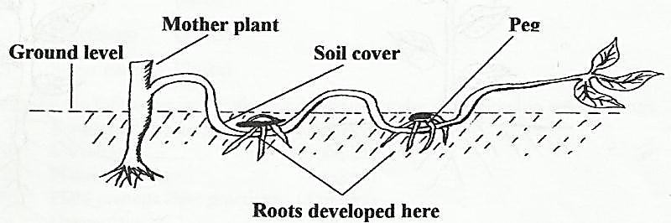

**Ground level**

**Mother plant**

**Peg**

**Soil cover**

**Roots developed here**

1. Identify the method of propagation. (1 mark)

…………………………………………………………………………………………………………

1. What is the benefit of the above method of crop propagation? (1 mark)

…………………………………………………………………………………………………………

…………………………………………………………………………………………………………

1. List any **three** processes by which part of a stem is induced to produce roots while attached to the mother plant. (3 marks)

……………………………………………………………………………………………………………………………………………………………………………………………………………………

…………………………………………………………………………………………………………

1. A farmer was asked to apply fertilizers as follows:-

50 kg / ha Nitrogen for top dressing.

60 kg / ha P2O5 at planting time

60 Kg/ ha K2O for top dressing.

1. Calculate how much Sulphate of Ammonia 20%N would be required per hectare. (2 marks)
2. Calculate how much double super phosphate 40% P2O5 would be required per hectare.(2 marks)
3. The diagram below show a practice out on various crops on the farm. Study them carefully and answer the questions that follow.

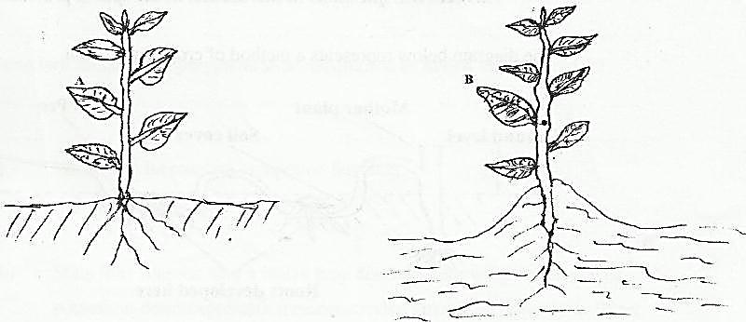

**B**

**A**

i) Identify the practice in diagram B. (1 mark)

…………………………………………………………………………………………………………

…………………………………………………………………………………………………………

1. State the importance of the practice in diagram B in the following crops. (4 marks)

Irish potatoes

…………………………………………………………………………………………………………

Ground Nuts

…………………………………………………………………………………………………………

Tobacco

………………………………………………..…………………………………………………….…

Maize

……………………………………………………………………….……………………………..…

1. At what stage of growth should the above practice be carried out in maize? (1 mark)

…………………………………………………………………………………………………………

…………………………………………………………………………………………………………

1. i) What do you understand by the term integrated pest management (IPM)? (1 mark)

…………………………………………………………………………………………………………

…………………………………………………………………………………………………………

ii) List **four** factors that affect efficiency of pesticides in crop production. (4 marks)

…………………………………………………………………………………………………………

…………………………………………………………………………………………………………

…………………………………………………………………………………………………………

…………………………………………………………………………………………………………

…………………………………………………………………………………………………………

…………………………………………………………………………………………………………

**SECTION C (40 MARKS)**

***Answer any TWO questions from this section the spaces provided at the end of the section.***

1. Describe the harvesting process of the following crops.
   1. Coffee. (6 marks)
   2. Pyrethrum. (7 marks)
   3. Sugar cane. (7 marks)
2. a) Describe the following production of dry beans under the following sub headings.
3. Ecological requirements. (2 marks)
4. Varieties. (3 marks)
5. Planting. (3 marks)
6. Field management practices. (4 marks)
7. Harvesting. (2 marks)

b) Outline any **six** measures that a mixed farmer should take in account to minimize water pollution. (6 marks)

1. a) Give **two** agents of soil erosion. (2 marks)

b) Briefly explain how the following soil erosion types occur. (4 marks)

1. Splash erosion.
2. Sheet erosion.
3. Rill erosion.
4. Gully erosion.

c) Discuss the methods of controlling soil erosion. (14 marks)

…………………………………………………………………………………………………………

……………………………………………………………………………………………………………………………………………………………………………………………………………………

……………………………………………………………………………………………………………………………………………………………………………………………………………………

……………………………………………………………………………………………………………………………………………………………………………………………………………………

……………………………………………………………………………………………………………………………………………………………………………………………………………………

……………………………………………………………………………………………………………………………………………………………………………………………………………………

……………………………………………………………………………………………………………………………………………………………………………………………………………………

……………………………………………………………………………………………………………………………………………………………………………………………………………………

……………………………………………………………………………………………………………………………………………………………………………………………………………………

……………………………………………………………………………………………………………………………………………………………………………………………………………………

……………………………………………………………………………………………………………………………………………………………………………………………………………………

……………………………………………………………………………………………………………………………………………………………………………………………………………………

……………………………………………………………………………………………………………………………………………………………………………………………………………………

……………………………………………………………………………………………………………………………………………………………………………………………………………………

……………………………………………………………………………………………………………………………………………………………………………………………………………………

……………………………………………………………………………………………………………………………………………………………………………………………………………………

……………………………………………………………………………………………………………………………………………………………………………………………………………………

……………………………………………………………………………………………………………………………………………………………………………………………………………………

…………………………………………………………………………………………………………

……………………………………………………………………………………………………………………………………………………………………………………………………………………

……………………………………………………………………………………………………………………………………………………………………………………………………………………

…………………………………………………………………………………………………………

……………………………………………………………………………………………………………………………………………………………………………………………………………………

……………………………………………………………………………………………………………………………………………………………………………………………………………………

…………………………………………………………………………………………………………

……………………………………………………………………………………………………………………………………………………………………………………………………………………

……………………………………………………………………………………………………………………………………………………………………………………………………………………

…………………………………………………………………………………………………………

……………………………………………………………………………………………………………………………………………………………………………………………………………………

……………………………………………………………………………………………………….……………………………………………………………………………………………………….……

……………………………………………………………………………………………………….…

………………………………………………………………………………………………………….………………………………………………………………………………………………………….

………………………………………………………………………………………………………….………………………………………………………………………………………………………….

………………………………………………………………………………………………………….………………………………………………………………………………………………………….

………………………………………………………………………………………………………….………………………………………………………………………………………………………….

………………………………………………………………………………………………………….………………………………………………………………………………………………………….

………………………………………………………………………………………………………….………………………………………………………………………………………………………….

………………………………………………………………………………………………………….………………………………………………………………………………………………………….

………………………………………………………………………………………………………….………………………………………………………………………………………………………….

………………………………………………………………………………………………………….………………………………………………………………………………………………………….

………………………………………………………………………………………………………….………………………………………………………………………………………………………….

………………………………………………………………………………………………………….………………………………………………………………………………………………………….

………………………………………………………………………………………………………….………………………………………………………………………………………………………….

………………………………………………………………………………………………………….………………………………………………………………………………………………………….

………………………………………………………………………………………………………….………………………………………………………………………………………………………….