11. Growth and development in (a) plants (b) animals

1. a) Moulting hormone/ ecdysone
b) It allows growth to take place; since growth can not take place in the presences of the

2. a) Long sightedness/ hypermetropia ;
b) Convex/ converging lenses;

3. (a) – Excretion;
- Osmo-regulation;
(b) – Glucose
- Amino acids;
(c) – Nephritis;
- kidney stones /Gall stones;
- Hepatitis A and B; (mark first 2 pts (2mks)

4. (a) Intermittent growth curve;
(b) Moulting;
(c) Ecdysone;

5. Natural immunity is inherited /transmitted from parent to offspring; Acquired immunity
is developed after suffering from a disease or through vaccination;

6. A – Cell elongation/expansion ;
B – Cell division/multiplication ;
C – Cell différentiation/maturation ;

7. Continuous variation shows gradation in characteristic with intermediate; discontinuous shows distinct characteristics between organisms with no intermediate groupings;

8. a) to investigate the effect of the force of gravity on the growth of a seedling
(shoot and root);
b) Force of gravity cause accumulation of auxins on the lower side of the seedling
- Higher concentration of auxin will promote growth in the shoot but inhibit growth in the
Roots;
- There will be more/ faster growth on the upper side of the root than on the lower side hence
the downward bending;
-There will be more/ faster growth on the lower side of the shoot than on the upper part hence
the upward curvature;

9. i) Between xylem and phloem;

10. Growth – Increase in size of an organism or its parts due to synthesis of protoplasm
Development – Differentiation and formation of various tissues to perform specialized
functions;

11. - Reduce competition between the young ones (larvae) ;
- Avoid predation of the young ones as they are different ;
- The pupa stage can withstand harsh environment by being inactive;

12. Disadvantages of exoskeleton;
– Limits growth
- heavy to the insect;

13. Primary growth results form the activity of primary/embryonic tissues/apical meristems and
lead to increase in height, while secondary growth result from activities of secondary meristems; /cambium and leads to increase of girth/diameter /circumference;

14. i) — Oxidizes food to release energy needed for germination;
ii) — Stores food for the seed;
- Stores enzymes;
15. .- Selective weeding
- Ripening of fruits
- Parthenocorpy
Reject Prunning of coffee and tea
16. - -Contraction of muscles
- Formation of bones
17. allow growth to the place;
(ii) Grain/cotyledon remains underground below the soil level: (I mark)
18. (a)(i) Hypogeal;
(b) Photosynthesis; OWTTE
-Gaseous exchange; accept. Transpiration.
19. (a) Effect of unilateral/unidirectional light on shoots:
(b) Seedling/shoots growth towards light’ growth curvature towards light;
20. (a) Intermittent growth;
(b) Moulting /ecdysis;
(c) Ecdysone rej. Moulting hormones;
21. (a) Divide giving rise to more vascular tissues – phloem and xylem; hence leading to secondary
growth/thickening of the stem;
(b) They lack vascular cambium;
22. - It has chondrionic villis to increase surface area for excahgne of materials
- Has thin epithelium for rapid exchange of exchanged substances
- Has counter current flow of foetal and maternal blood to enhance speed diffusion gradient.
- Highly vascularised (dense network of capillaries) for faster transport of exchanged material
23. (a) For oxidation of stored food;
(b) Breakdown and oxidation of food
24. (a) (i) osmotaxi/cremotaxis
(ii) phototaxis
(i)Sensory neuron
(ii) Direction of nerve impulse
(iii) Schwarn cell
(iv) insulate the axon/Speed up transmission of impulses
(c)
Reflex action | Conditioned reflex action
Single stimulus to bring about response.  Simplest form of behaviouir and is independent of experience  Sensory and mother component are the same at all times | Repeatal stimulus to bring about response  Involves modifications of behaviour and dependent experience .  Primary sensory component is repeat by a sensory component bat the motor.  Component remains unchanged.
25.

(a) To absorb carbon (IV) oxide;
(b) to provide moisture to germinating seeds;
(c) (i) (Left – right direction );
(ii) Oxygen in the tube is taken up by the seeds for germination; the Carbon (IV Oxide
Produced during respiration and the one in the tube reacts with potassium hydroxide
pellets; lowering the pressure inside the set-up; the higher pressure from outside the tube
forces the dye in the direction shown;
26. (i) Lag phases; Dry mass increases slowly; became in plant has not developed
leaves; for photosynthesis hence is depending on stored food;
(ii) Expontial phase; Rapid growth /increase in dry mass, leaves developed; photosynthesis taking place leading to accumulation of food and rapid cell division / plant adapted to the environment
(iii) Death phase/ senescence; Negative growth/decrease in dry mass as some tissues die after reaching maximum maturity; Fall in photosynthesis activity; toxic wastes poison tissues;
(c) (i) When dry mass was first recorded/at germination
(ii) Dry mass would decrease first because food is oxidized to produces energy; water and
carbon dioxide/utilized in respiration;
(d) (i) Harvest every week about five seedlings; dry in oven to a constant dry mass; Calculate the average mass for one seedling and record the results.
(ii) Advantage; Dry mass is not affected by environmental conditions while fresh weight is
dependent on the amount of water in the plant which fluctuate with environmental factors
affecting transpiration rate.

27. a)klinostat/clinostat;
b)i)the radicle remains /grow horizontally;
ii)rotation of klinostal causes uniform distribution of auxins/ indoleacetic acid; hence
uniform growth/clongations (no curvature formed); c)the experiment repeated but with stationary klinostat;
d)-(tropism)enable plants to get water-hydrotropism;
-chemotropism aids plants in fertilization and nutrients absorption;
-thigmotropism enable weak plants to obtain support
-phototropism enable plants to obtain light for photosynthesis;
-geotropism enables the roots grow down the soil towards the centre of the earth thus
providing support to the plant

28. a)graph
-axes have to be labelled- ½ mk@-1mk No axes marking stops there.
-scale-should be appropriate and workable- ½ mk @-1mk
-plotting correctly-1mk@*RCH*∗wrong scale stop marking.
-curve-smooth and not extrapolated beyond 3 small squares- ½ mk@-1mk
-identity- ½ mk each-*RCH*
Note/ -axes reversed-award only for identity
-no origin-award only for one scale/vertical one.

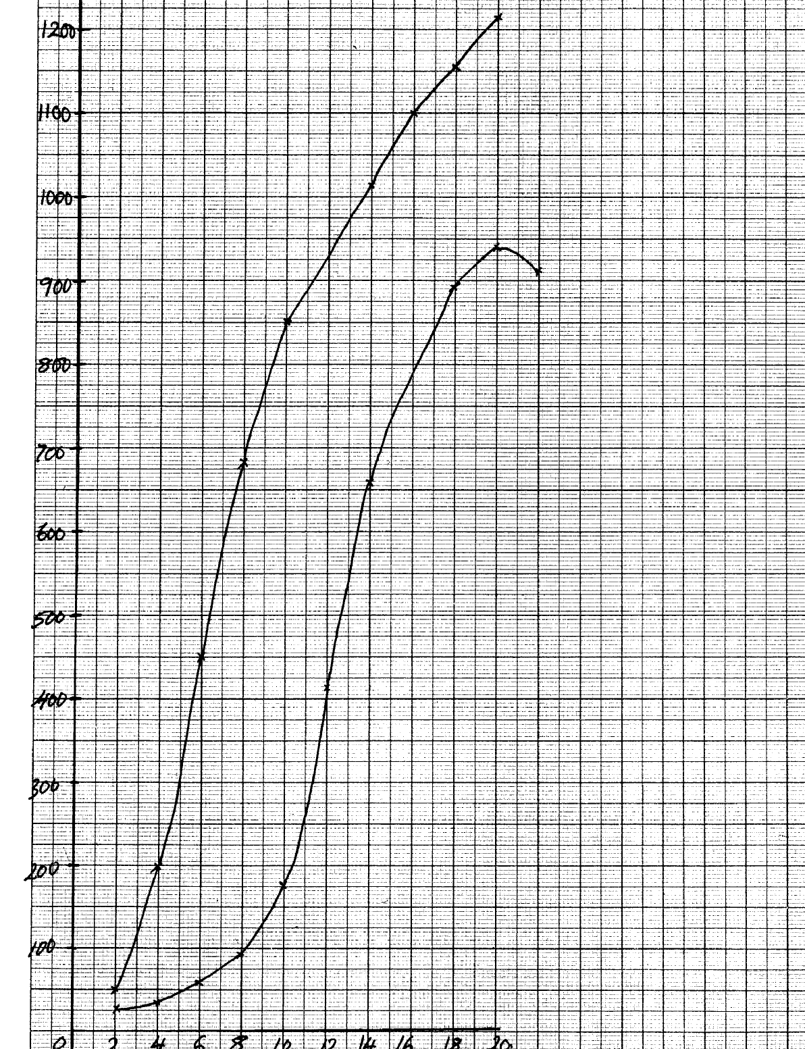

Average dry weight in grammes

Maize
Bamboo
C
C

P
P

Time in weeks

b) i)bamboo;
ii)(bamboo)have higher average weigh
c) i)average height of maize plant between weeks 14 and 18 constant (at 2.1m); maximum
height attained; average weight increased; because there was slight increased in the girth;
ii) dry weight represents the actual dry matter/fresh weight includes weight of water;
iii)-average height was determined by measuring the length; of the plants at various intervals;
-average dry weight was determined by heating the plants to exclude all the water; and then
taking their dry weights;
d) both height and weight are used to show rates of growth;
e) lacks cambium(tissue)hence no secondary thickening;

29. a) Fusion of an egg cell nucleus with sperm cell nucleus; to form a zygote
b) i) Meiosis
ii) In the testis/ testes/ ovary/ ovary
c) i) There is increased blood supply causing thickening of the uterine walls;
ii) Capillaries break up/ endometrium is lost with some blood/ menstruation occurs
d)
- Large number/ numerous blood vessels to increase surface area for exchange of materials
- Thin membrane for faster diffusion across it
- Has villi to increase surface area for diffusion
- Special cells to produce hormones
- Membrane selectively allows materials across it

30. a) Number of seeds that germinate X 100 = % seed germination
Number of seeds planted
b) Seeds dry mass would have resulted in death of embryo thus no germination
c)i) Mean seedling fresh mass include the mass of water that has not resulted from growth
ii) At regular intervals of time; uproot seedlings (say five each) dry to constant weight,
and record
d) Directly proportional / Increase in seed mass results in increase in % seed germination,
survival and seedling fresh mass
e) Embryo well developed/ Embryo very mature;
- Large food reserves for growth and development

30. a) Directly proportional/ increase in enzyme concentration results in increase in
reaction rate
b) i) Increase in substrate concentration results in increase in reaction rate
Increase in concentration results in more active sites occupied by substrate
molecules, resulting in higher turn over
ii)A rate of reaction constant/ does not change
Active sites fully occupied
iii) Sharp decrease in reaction rate
Enzymes denatured
c) PH/ Enzyme inhibitors/ Enzyme co- factors

31. a)

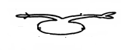

b) the rotation of the machines/ klinostat ensured equal distribution of Auxins in the
seedling (upper & inner) side;
c) Klinostat;
d) radicle grow dominants; plumule grow upwards;
e)
STIMULI | RESPONSE (name)
light | Phototropism;
gravity | Geotropism;

32. (a) (i) Carbam inohaemoglohin:
(weak) Carbonic acid: (2marks)
(ii) Oxyhaemoglobin; (I mark)
(b) Secretes pleural fluid:
- Makes lungs air tight:(OWTTE) (2marks)
(c ) Carboxyhaemoglobin doesn’t dissociate readily (OWTTE):
Hence its formation reduces the capacity of haemoglobin to carry oxygen to time lungs
hence resulting in death: (2marks)
(d) Cuticle: lenticels: (Both to be correct to score I mark) (I mark)
33. (a) Region of rapid growth / cell elongation in a radicle: root
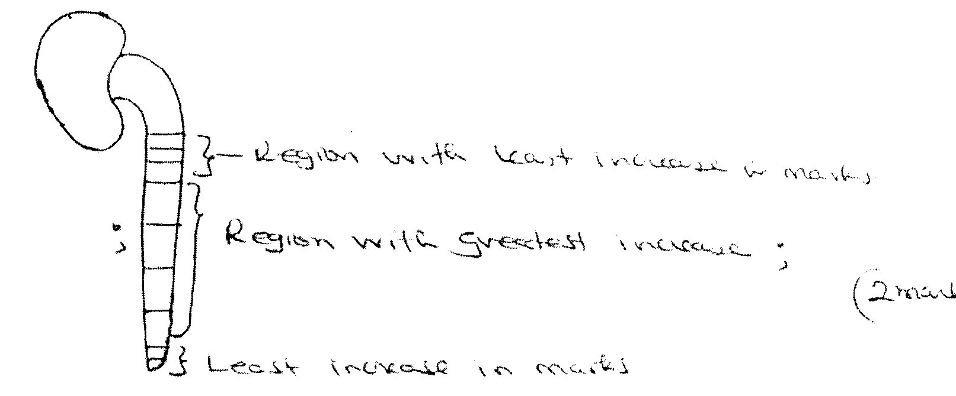
(b)
Least increase in ma mrks
Least increase in marks
Region with least increase in marks
;

(c ) Dense cy1oplasms
Lack cell vacuoles
Thin cell walls
(d) -Presence of germination inhibitors / abscicic acid:
- Low concentration of hormones / Enzymes/ gibberclic acid:
- Impermeable seed coats to water and oxygen:
- Embryo not fully developed:

