8. Excretion and homeostasis
1. i) Ammonia is highly soluble in water and requires a lot of water for excretion hence assists in
the removal of excess ammonia;
ii) All the glucose is reabsorbed at the proximal convoluted tubule;

2. (a) – Excretion;
- Osmo-regulation;
(b) – Glucose
- Amino acids;
(c) – Nephritis;
- kidney stones /Gall stones;
- Hepatitis A and B;
3. (a) Extra long loop of henle; Have fewer and smaller glomeruli;
(b) Salty food increased the salt concentration in blood; Blood becomes hypertonic to kidney tubules; more water is reabsorbed from kidney tubules; hypertonic urine is thus produced;

4. (a) Glucose;
(b) The person was a sufferer of diabetes mellitus;
(c) Pancrease;

5. a) i)insulin;
ii) Diabetes mellitus;
b) Diuresis is a condition which is characterised by production of large volumes of dilute urine;

6. i) urea;
ii) Triethylamine;
iii) Ammonia;

7. a) i) Fresh water; reject water
ii) Desert/ Arid areas; reject land
b) Reduces blood flow to the skin as more blood is stored in the spleen, reducing heat loss
through the skin;

8. a) Ultra filtration;
b) Selective reabsorption;
c) Proteins have large molecular weights hence not ultrafiltrated;

9. Produces sebum to keep hair and epidermis supple and water proof; and protect skin against
bacteria (through antiseptic substances);

10. a) Sweat produced does not evaporate due to high humidity;
b) Body does not cool hence more sweat is produced leading to accumulation;

11. Diabetes mellitus
- Caused by failure of the pancreas to secrete enough insulin;
- High glucose concentration in the blood than normal;
Diabetes insipidus
- Inability of the pituitary gland to secret anti-duretic hormone;
- High concentration of solutes in blood ;
12. Two processes through which plants excrete metabolic wastes:-
-Gaseous exchange;
-Transpiration;
-Shading leaves;
-Production of resins and gums;
-Storage of wastes in seeds/bark/fruits;
13. Has got long loop of henle in order to maximize water reabsorption thus conserving it;

14 .i) urea;
ii) Triethylamine;
iii) Ammonia;

15. (a) i) Fresh water; reject water
ii) Desert/ Arid areas; reject land
b) Reduces blood flow to the skin as more blood is stored in the spleen, reducing heat loss through
the skin;

16. a) Ultrafiltration;
b) Selective reabsorption;
c) Proteins have large molecular weights hence not ultrafiltrated

17. Produces sebum to keep hair and epidermis supple and water proof; and protect skin against
bacteria (through antiseptic substances);

18. a) Sweat produced does not evaporate due to high humidity
b) Body does not cool hence more sweat is produced leading to accumulation
19.
Diabetes mellitus | Diabetus insipidus
-Caused by failure of the pancreas to secrete enough insulin  -High glucose concentration in the blood than normal  - Caused by failure of the pancreas to secrete enough insulin  - High glucose concentration in the blood than normal | -Inability of the pituitary gland to secret anti-duretic hormone  -High concentration of solutes in blood  Inability of the pituitary gland to secret anti-duretic hormone  High concentration of solutes in blood

20. Two processes through which plants excrete metabolic wastes:-
-Gaseous exchange
-Transpiration
-Shading leaves
-Production of resins and gums
-Storage of wastes in seeds/bark/fruits

21. a) A – medulla; B – Cortex;
b) Cortex;

22. a) Enhances more reabsorption of water; leading production little but conc urine;
b) Reabsorption of water; Na⁺/CL⁻ ions;

23. a) Aldosterone;
b) Loop of Henle;
c) Positive feed back;

24. - Reabsorption of unuseful substances in the kidney;
- Absorption of digested food from the ileum;
- Removal of metabolic waste products from kidney;

25. a) A D H / Vasopression;
b) Pituitary gland;
c) Diabetes Inspidus;
26. a) - Afferent vessels are wider than effereal vessels;
- Presence of pores on capillary and Glomerula membrane;
- Highly coiled narrow capillaries to reduce speed of flow of blood and increase ;
pressure
27. a) Arid/ semi arid areas
b) Ammonia
c)i) Contractile vacuole
Malpigian tubules

28. - Deamination
- Detoxification
- Breakdown of haemoglobin

29. a)Deamination;
b)-Removal of excess amino acids;
-Availing of energy in the body;
-Formation of glycogen /fats for storage; (award any one)

30. a)diabetes insipidus;
b)antidiusetic hormones (ADH);

31. a) large quantities of dilute urine;
b) Small quantities of concentrated urine ;( renal failure if habitual)
c) Production of urine containing glucose/sugar;

32. (a) Excretion — Separation and elimination of waste products of metabolism from
bodies of living organisms:
Egestion; Removal of undigested materials from food vacuoles/alimentary canals of animals:
(b) Removes waste products metabolism to create/pro’. idea suitable internal environment for
best working of cells

33. (a) N – desert/arid/semi arid;
(b) Small sized glomeruli; to reduce ultra filtration longer loop of henle; to increase
reabsorption of water – conservation of water.
N.B – Reject 12(b) if 12 (a) is wrong.

34. (a) – Organisms whose body temperature varies with the environmental temperature; 
(b) – Reptilia - rej. Reptile;
- amphibia - rej. Amphibians;

35. Glomerulus;
Adaptations of part R
- Coiled to increase the surface area for re-absorption of some glomerular filtrate
- Presence of numerous Mitochondria to promote active transport of glucose, amino acids
- covered by dense network of blood capillary for absorption of useful glomerular filtrate

36. Internal environment is the immediate surrounding of the body cells while external environment is the immediate surrounding of the organism
37.
- Radiation;
- Conduction;
- Convection;
- Evaporation ;

38. a) A – capsular space/ Bowmans capsule;
B – Descending wing of loop of Henle;
D – Glomerula
b) Urea;

39. Ovary; accept ovules
Anthers;

40. a) Detoxification;
b) Liver;
c) Prevents ammonia from accumulating to toxic levels; which would affect body functions;
d) Urea;
e) Excess amino acids are broken down to form amino group; which is combined with
hydrogen atom to form ammonia;
f) It is transported to the kidney; through the renal artery where it is excreted

41. a) platelets exposed to air rupture on damage tissues to release thromboplastin/(enzyme) /thrombokinase; Thromboplastin neutralizes heparin; and activates prothrombin to thrombin;
throbin activates the conversion of fibrinogen to fibrin; which forms meshwork of fibres on the bruised surface;
b) blood clotting is the conversion of soluble blood protein into a mass of tangled threads of
insoluble protein; while haemogglutination is the clumping together of red blood cells; c)haemophilia;

42. a)i)glucose is completely reabsorbed at proximal convoluted tubule back to blood stream;
ii) Protein has molecules hence not ultrafiltered (from glomerulus) to proximal
convoluted tubule); b) Create a steep diffusion gradient; hence higher rate of reabsorption of useful
Substances-glucose/amino acids/sodium and chloride ions from the nephron tubules back to the blood stream;
c) -antidiuretic hormone;
-Aldosterone;
d) nephritis; kidney stones

43. (a) Nephron;
(b) (i) D = Afferent arteriole;
M = Efferent vessel;
(ii) Q = Aldosterone ; G - ADH/ vasopressin.
(c) Red blood cells/white blood cells/ plasma proteins;
(d) This shows that reducing sugar (glucose) was present in urine; the person is likely
to be suffering from Diabetes mellitus;

44. (b) (i) Blood sugar level increased as a result of the glucose being absorbed in the ileum; by
diffusion / or active transport;
(ii) – The blood sugar level dropped as a result of the conversion of glucose to glycogen;
(and fats) by influence of insulin;.
- There was also an increased rate of respiration reducing the blood sugar level;
(c) 90 mg/100ml of blood;
(d) Person B has a defect in the pancreas; He did not produce enough insulin to control the
blood sugar level;
(e) By administration of insulin;
(f) - A constant level of blood sugar ensures optimum levels of metabolism;
- High level will increase the osmotic pressure and that affect metabolism;
- Low levels reduce energy supply in the body tissues and affect metabolism;
(g) - Glucose is used for respiration;
- Glucose was lost in urine;
45. a) Axis
Scale
Plotting

b) i) The rate increases with time;
Because a lot of acid been drunk;
Very little ADH or No ADH produced yet;
No reabsorption taking place;

ii) The rate remain constant
Pituitary not stimulated to produce ADH
Nephrone, less permeable
No water being reabsorbed back to blood;

iii) The rate reduces with time;
Little water remaining in blood; due to a lot of water lost through urine;
No water being taken

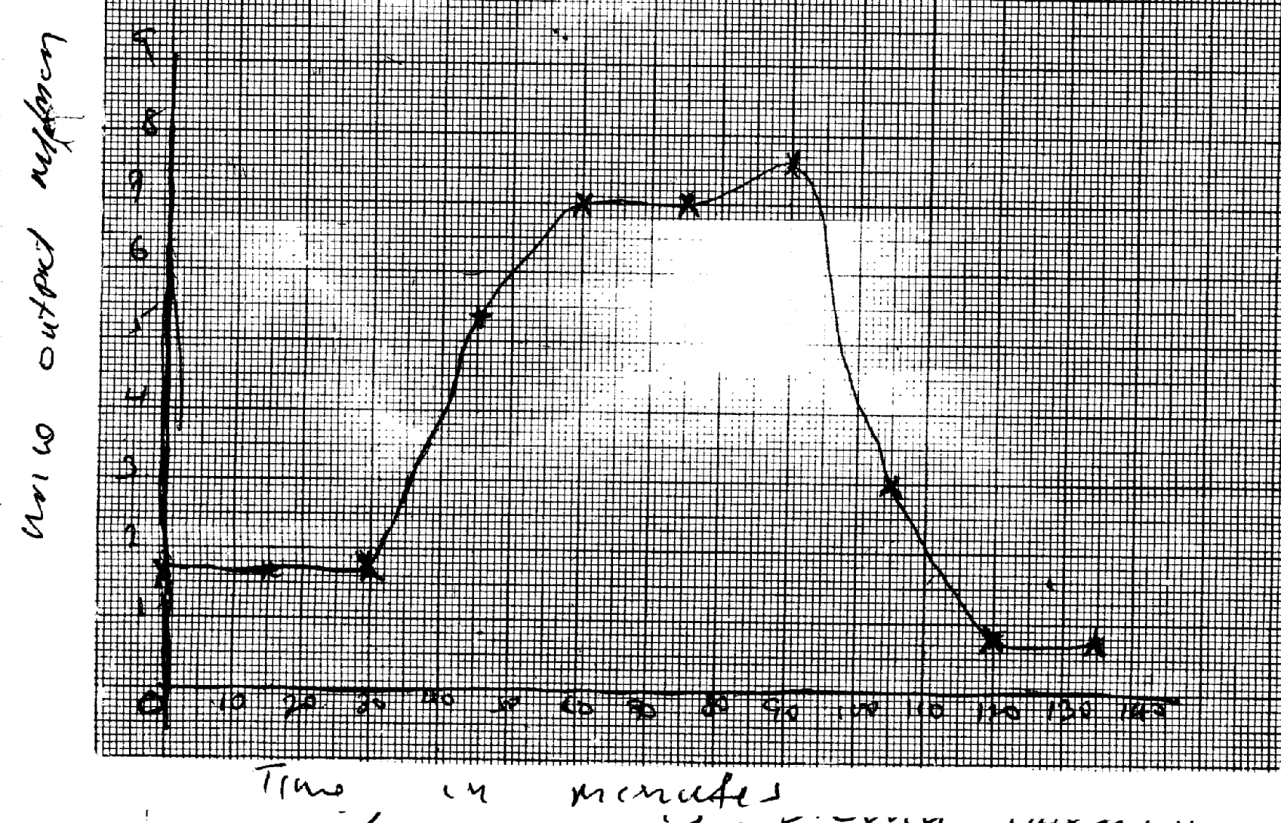
c) ADH; Adosterone
Urine output ml/mcm

Time in minutes

46. (a) Explain how urea is formed in the human body:
- Excess amino acids are deaminated and the converted into urea in the liver
(b) Describe the path taken by urea from the organ where it is formed until it leaves the human body
- Urea from the liver is carried through hepatic vein into post/in prior vena cava; right auricle,
right ventricle; pulmonary artery into lungs; Pulmonary vein , left auricle; left ventricle; aorta
renal artery; glomerulus’s; into Bowman’s capsule; kidney tubules ascending and descending);
collecting tubule ureter; into urinary bladder , urethra and out of the body in the form of urine.

47. a) B- Bowman’s capsule
C- Loop of Henle
D- Distal convoluted tubule
b)
- have numerous/ many microvilli; to increase surface area for reabsorption
- coded to slow down filtrate for reabsorption
- have many/ numerous mitochondria to provide energy for reabsorption
c) - Active transport
d) Afferent arteriole is wider than the efferent arteriole

(d) Storage of vitamins (e.g. vitamin A, B2 & D)
- Storage of mineral salts (e.g. Potassium and Iron)
- Storage of Blood
- Manufacture of R.B.C
- Manufacture of plasma proteins (Albumen, fibrinogen & Globulin)
- Regulation of amino acids (deamination)
- Regulation of lipids
- Regulation of body temperature (thermoregulation)
- Destruction of worn out R.B.C
- Elimination of sex cells

48. a) X- Thromboplastin
Y- Fibrin
Z-- Thrombin
b) Promotes wound healing; stops further loss of blood/ bleeding; prevents entry of
pathogens/ injection
- Blood contain leparin/ anti clotting factor eight; that inhibits blood coagulation

49. a) Response of an endotherm to heat grain
i) Subcutaneous of fat little/ localized: to encourage heat loss/ not to impede heat loss
ii) Hair is lowered/ lies flat; by relaxation of erector pilli muscles; insulator reduced/
little air trapped; heat readily lost (by radiation and convector)
iii) Sweating/ panting occur
Evaporation of water absorbs latent heat of vaporization; leaving a cooling effect
iv) Cutaneous/ superficial blood vessels dilate;
Blood flows near skin surface facilitating heat loss
v) Metabolic rate falls/ BMR falls
Less heat generated to avoid overheating
b) Response of Endotherm to heat loss
i) Subcutaneous/ Adipose fat insulates; facilitating heat conservation
ii) Hair raised/ erects; by contraction of erector pili muscle; Insulator increased/ traps
air; facilitating heat conservation
iii) Cutaneous/ superficial blood vessel vasoconstrict blood flows deep in the
dermis; conserving heat
iv) Sweating/ panting stops; little heat is conserved
v) Extra heat is produced; by increase in metabolic rate of liver/ muscles/ shivering/
goose pimples/ animals become more active

50. (a) (i) Efférent arteriole/vessel; (I mark)
(ii) Loop of Henle: (Rj. Wrong spelling) (I mark)
(b) (i) Small sized; Few; (2mrks)
(ii) Large sized: Many: (2marks)
(c) (i) Glucose:
(ii) Diabetes mellitus: (Rej; wrong spelling)
51. High body temperature above normal: sweat glands: produce sweat: water in the sweat
evaporates/ sweat evaporates: absorbing latent heat of vaporization produces a cooling effect.
Hairs lie flat; due to relaxation of erector pilli muscles: no/little air is trapped: [fins increased heat loss from the body; Blood arterioles/vessels; vasodilate/dilates: more blood floss to the skin hence more heat is dispersed by radiation and convection: when the body temperature is low below normal; sweat glands produce less/no sweat: no latent heat is absorbed/more heat is retained in the body; The hairs stand upright/erect: to trap air between them: that insulates the body against at loss; more heat is retained in the body; Blood vessels/arterioles constrict/vasoconstrict: less blood flows to the skin: reduces heat loss/ more heat is retained in the body;
Subcutaneous fat/ adipose [issue; beneath the skin insulates the body against heat loss: more
heat is retained in the body: 22 marks

