PRODUCT MARKETS
1. - To check on the quality of goods produced by monopoly.
- Ensure there are a variety of goods in the market.
- Monopolist may resist emergence of new ideas or technology due to lack of competition.
- Monopolies tend to be inefficient in their operation due to lack of competition.
- The consumers may not enjoy quality good and services because they can only consume what his monopolis produces.
- To control the prices charges by the monopolies
- Make sure monopolies operate at optimum capacity so as not to charge high prices.

3. Short-run equilibrium of a firm in monopolistic competition
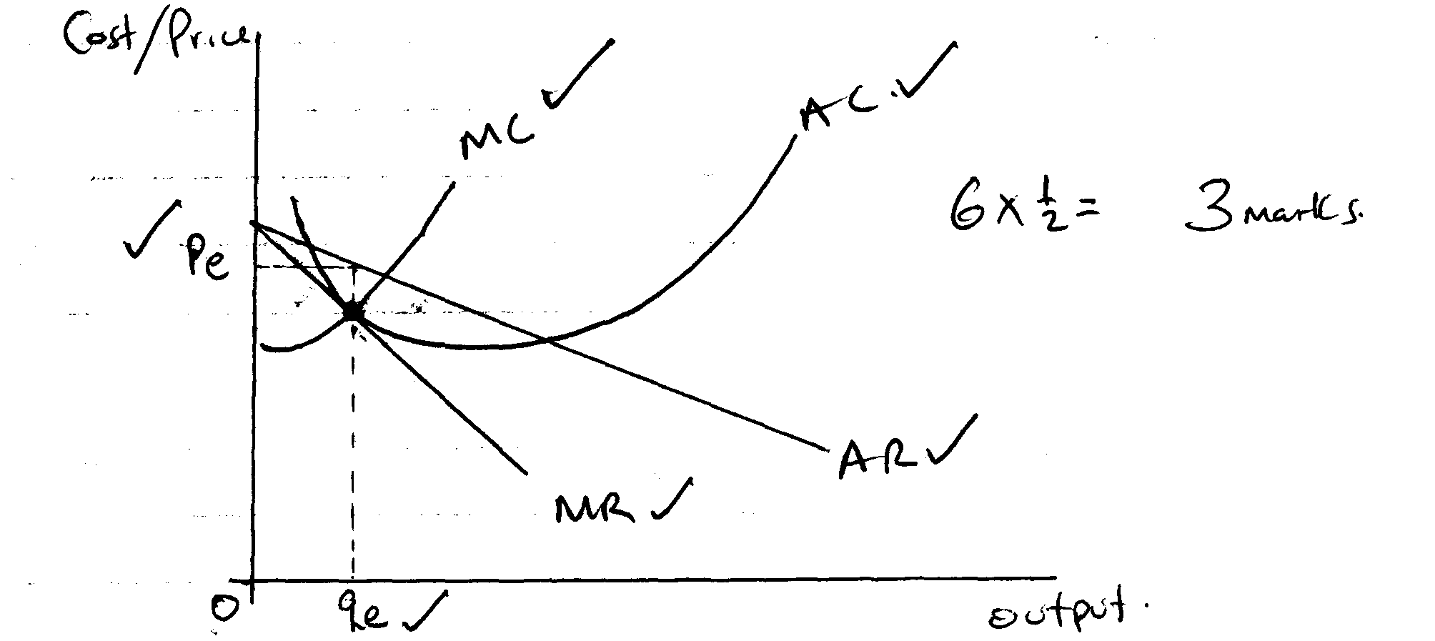

4. - When the product is a necessity
- When the product is the only one in the market
- When the consumers are not aware of the market changes
- When the price of the product makes an insignificant figure of the consumers income

5. i) Control of an important input in production
ii) Ownership of production rights i.e. patent
iii) Internal economies of scale
iv) Size of market
v) Ownership of a give technology
vi) Financial factor
vii) Restructure factors

6. i) monopolistic market
ii) a – marginal cost A/C
b – Average cost A/C
c – Average revenue A/R
d – Marginal revenue M/R

7. - Establishes size of the market
-Establishes the most effective modes of promotion
-Establish existing competition and suitable ways of overcoming it
-Establishes most suitable prices for a product
-Establishes most favourable form of quantity of presenting the product

PRODUCT MARKETS
1. Characteristic of a monopolistic market
- One producer/supplier
- many buyers on the market
- product has no substitute
- no free entry into the market by suppliers
- The producer determines the price on the market.
D/AR
TMC
TMR
PO
O
QO
Quantity
2.

The cartel will produce where TMC of all the firms in the industry are equal to the TMR hence produce at OQ◦ and sell at OP◦

3.
PERFECT COMPETITION | MONOPOLISTIC COMPETITION
- Sellers deal in homogeneous product  - are not involved in promotion of products  - it’s a price taker  - large number of sellers  - activities of one firm does not influence the activities of other firms | - Sellers deal in differentiated products  - Incur heavy expenses in promotion of products  - it’s a price setter/giver  - large number of sellers operating independently

4. a) How a monopolist enjoy supernormal profit in both short run and long run
- When a monopoly decides on quantities to produce, consumer will decide the price to buy. When the quantity is increased the price fells and vise versa
- Profit is maximized Q when MR = MC and P = AC = MC = MR
- Due to increased demand, equilibrium output is sold at X instead of P hence enjoying a super normal profit
5. Five distinctions between perfect competition and monopolistic firms
PERFECT COMPETITION | MONOPOLISTIC
i)firms sell homogenous and identical products  ii)firms are prize takers  iii)firms demand curve is perfectly elastic  iv)no heavy expenditures on advertising  v)no excess capacity in the ling run  vi)prize equals to marginal cost | i)firms sell similar but differentiated products  ii)firms have their own pieces  iii)firms have normal demand curve  heavy expenditure on advertisement  iv)firms operate excess capacity in the long run  v)prize higher than marginal cost

A. The firm will be at equilibrium when profits are maximized. This happens at the point where
MR = MC and MC curve cuts MR curve from below
- Profits are maximized at level of output OQ and price determined by the demand curve
AR at price OP
- At this Quantity [OQe] and price [ OPe] the firm is making supernormal profits

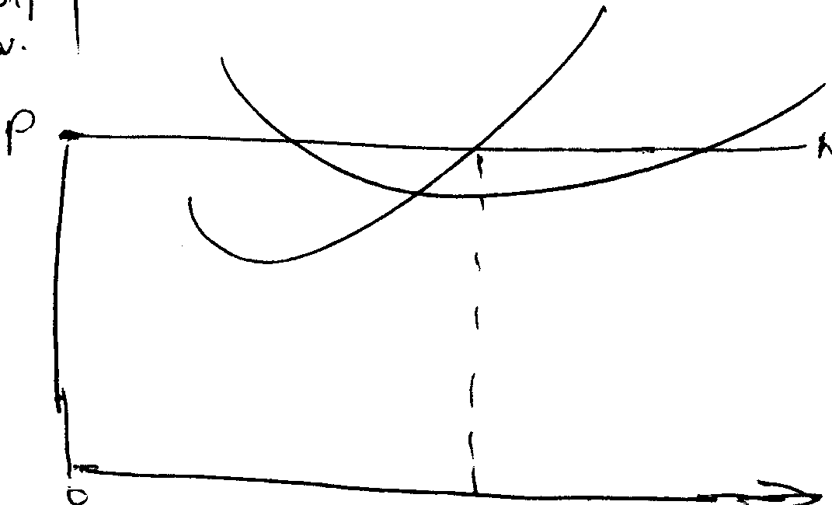
MC
AC
MR = AR = P
Cost / Rev.
Qe output
P
AR = MR
(i) Equilibrium of a firm under perfect competition
-profits are maximized at output Q where MC is equal
to MR and MC cuts the MR curve form below.

AR is higher than MR
MC
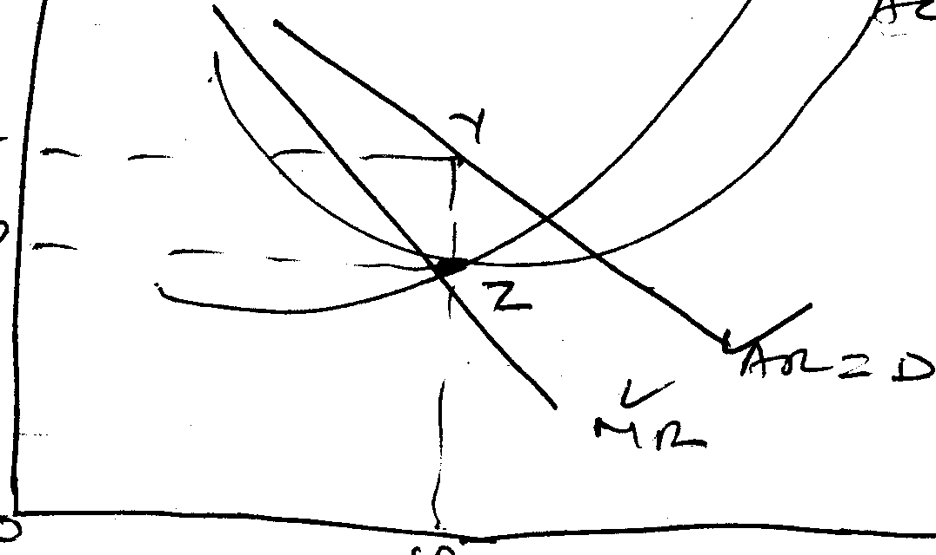
AC
(i) Profits are maximized and output level OQ since at this point output the cot per unit AC is given by P.
(ii) At this level of output, the cot per unit AC is given by P
(iii) Equilibrium output can be sold at the demand price which is equal X

X

P

Q

