# ORGANIC CHEMISTRY I

# (HYDROCARBONS)

By the end of this chapter, the learner should be able to:

(a)  Define organic chemistry.

(b)  Define hydrocarbons and classify them according to their structure and bonding.

(c)  Write molecular and structural formulae of alkanes, alkenes and alkynes.

(d)  Name and draw the structures of alkanes, alkenes and alkynes.

(e)  Define an isomer, name and draw the structures of the isomers of hydrocarbons with up to five carbon atoms in their molecules.

(f)  Describe the general methods of preparing different hydrocarbons.

(g)  Explain the gradual change in properties among the members of a homologous series.

(h)  State some uses of hydrocarbons.

**Organic chemistry is the study of carbon compounds excluding the oxides of carbon and carbonates.**

Carbon forms a very large number of compounds. This is due to the fact that carbon:

(a)   Uses all its valence electrons to form four covalent bonds with carbon atoms and with atoms of other elements.

(b)   Can form single, double and triple bonds with other carbon atoms.

(c)   Atoms can join each other to form long chains.

HYDROCARBONS.

**Hydrocarbons** are compounds which are made up of carbon and hydrogen atoms only.

They are classified into three groups depending on the type of bond that exists between individual carbon atoms in a molecule. The groups are alkanes, alkenes and alkynes.

## ALKANES

Alkanes are a group of hydrocarbons whose carbon atoms are linked by single covalent bonds.

Hydrocarbons in which only single covalent bonds are present in the molecules are said to be saturated.

## Sources of Alkanes

Alkanes occur naturally as natural gas, biogas and in crude oil.

Crude oil is the major natural source of alkanes. It contains a range of alkanes which can be separated into various components by fractional distillation. This is due to the fact that the different alkanes have different boiling points. The fractions with short carbon chains have low boiling points. As the boiling point of the fractions increase, the viscosity and the intensity of colour of the fractions increase while flammability decreases.

Crude oil is separated into different components through fractional distillation. Each component separates at different temperature at different parts of the fractionating column. The different fractions have different uses.

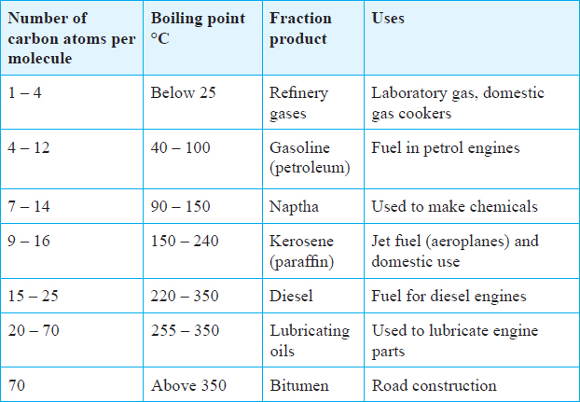

Cracking of Alkanes

Long chain alkanes are broken up through a process called cracking of alkanes.

During the cracking process short chain alkanes, alkenes and hydrogen are produced.

The general equation for cracking is:

Long chain alkane imageSmaller chain alkane + Alkenes + Hydrogen For example, when propane is irradiated with high energy radiation, the following reaction occurs.

image

There are two ways of cracking of alkanes; thermal cracking and catalytic cracking.

* Thermal cracking takes place at a very high temperature and only involves heating the long chain alkanes.
* Catalytic cracking takes place at a relatively low temperature and involves heating the long chain alkanes in the presence of a catalyst and at low pressure.

## Nomenclature

Alkanes have names which end with the suffix, – ane; and a prefix numeral used to indicate the number of carbon atoms in the chain. The first four members have their prefixes as meth-, eth-, prop -**but**- with the next members being , pent- (5), hex- (6), and hept- (7). The simplest alkane is methane where n = 1 and its formula is CH4.

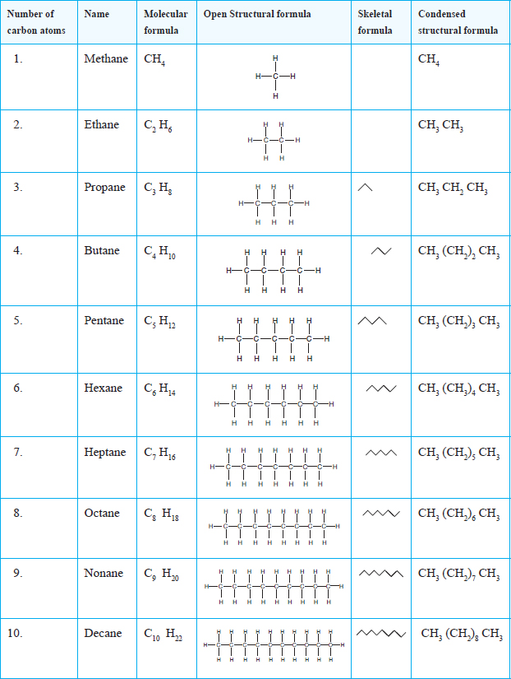

In the skeletal formula, only bonds between carbon atoms are shown. The bonds are drawn in a zig-zag manner. A straight section of a zig-zag line represents a covalent bond between two carbon atoms in the structure.

A molecular formula shows the elements present in a compound and the proportions of their atoms in the compounds.

A structural formula shows how the atoms of the different elements are arranged in the compound.

The consecutive members of the alkane homologous series differ by a – CH2 unit, and conform to the **general formula CnH2n+2 where n is 1, 2, 3…**

A homologous series is a group of compounds with similar chemical properties, chemical formulae, and they exhibit a steady gradual change in physical properties.

The homologous series of alkanes has the following characteristics:

(i)    All members conform to a **general molecular formula of CnH2n+2.**

(ii)   All members show similar chemical properties.

(iii)   The physical properties of the members change gradually along the series.

(iv)  The general methods of preparation can be applied to any member of the series.

## Isomerism in Alkanes

Isomers are compounds that have the same molecular formula but different structural formulae.

The isomers of the same alkane differ in their physical properties such as boiling points, melting points and density but their chemical reactions are similar.

If any hydrogen atom attached to an alkane chain is removed, an alkyl group is formed. The suffix –ane in the alkane is replaced by –yl, for example:

|  |  |
| --- | --- |
| **Alkane** | **Alkyl group** |
| Methane, CH4 | Methyl, CH3– |
| Ethane, CH3CH3 | Ethyl, CH3CH2– |
| Butane, CH3CH2CH2CH3 | Butyl, CH3CH2CH2CH2– |

Methane, ethane, and propane do not have isomers. Isomerism in alkanes starts from butane.

If any hydrogen atom attached to any middle carbon atom is replaced by an alkyl group, a branched alkane is obtained.

**Rules for naming of the branched alkanes**

1.    Identify the longest continuous carbon chain to determine the name of the parent alkane. For example, in the structure,

image

The longest chain has four carbon atoms hence the parent name is butane.

2.    Number the longest chain from the end of the chain that is near the branching. For example, in the structure above, numbering should start from the left, thus:

image

The branching is therefore on carbon 2 of the longest chain and the substituent group is a methyl.

3.    In case there are two or more similar substituent groups in the chain, they are indicated by the prefixes; di-, tri-, tetra-, … Comas are used to separate the numbers for example, in the following:

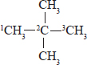

There are two methyl groups attached to carbon number two of the longest chain hence, 2, 2 -dimethyl. When naming the Isomers of an alkane, the position of the substituent group is written first followed by the name of the substituent group and finally the name of the parent alkane.

Examples

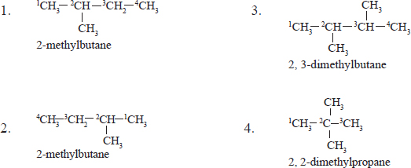

4.    When the substituent groups are a halogen and an alkyl group, the halogen is always placed before the alkyl group. For example;

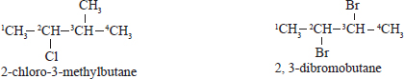

## Preparation of Alkanes

In the laboratory, alkanes are prepared by the reaction between sodalime (mixture of sodium hydroxide and calcium oxide) and an appropriate alkanoate.

.

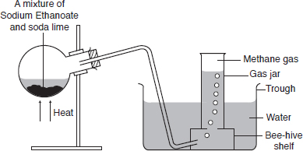

When a mixture of sodium ethanoate and soda lime (sodium hydroxide and calcium oxide) is heated, methane gas is obtained.

image

Similarly, when a mixture of sodium propanoate, and soda lime is heated ethane gas is obtained.

image

## Physical Properties

* Methane is a non-poisonous, colourless gas.
* It is slightly soluble in water and hence can be collected over water. However, it is quite soluble in organic solvents such as ethanol and tetrachloromethane. It is less dense than air.

**The general physical properties of the first ten alkanes**

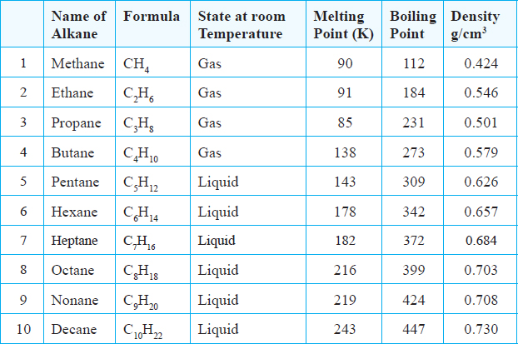

* The melting and boiling points of alkanes **increase with increase in the number of carbon atoms.** An increase in number of carbon atoms results in an increase in the strength of intermolecular (van der Waals forces).
* The first four straight chain alkanes are gases, the next six are liquids, and the rest are solids. Density increases with an increase in molecular mass.
* Generally, the solubility of alkanes decreases as the molecular size increases.

**Chemical Properties**

**Combustion**

Methane burns in excess air with a pale blue flame to form carbon(IV) oxide and water.

CH4g)+ 2O2(g) → CO2(g) + 2H2O(l)

In a limited supply of air the flame is luminous due to incomplete combustion.

CH4(g) + O2(g) → CO(g) + 2H2O(l)

Other alkanes behave in a similar manner.

**Substitution reactions**

***A substitution reaction is a reaction in which one atom or group of atoms in a molecule is replaced by another.***

Alkanes undergo substitution reactions with halogens in the presence of sunlight because the halogen molecules are supplied with energy from light necessary to split them into atoms. These free halogen atoms are very reactive hence they replace the hydrogen atoms in the methane molecule.

All the alkanes undergo substitution with chlorine and bromine in the presence of sunlight.

When a substituent, like a halogen, is present in the alkane, the resulting name **must** contain the halogen. The name of the **halogen becomes the prefix, and the parent alkane, the suffix.** The name of the halogen is therefore written as:

Iodo– to represent iodine.

Bromo– to represent bromine.

Chloro– to represent chlorine.

Fluoro– to represent fluorine.

Chlorine reacts with methane in the presence of ultra violet light. Chlorine atoms repeatedly substitute the hydrogen atoms in the methane molecule until all the hydrogen atoms have been replaced as shown below.

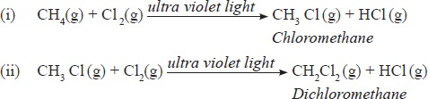

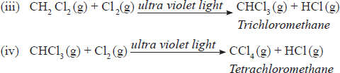

If bromine is used, it likewise substitutes hydrogen but the reaction is slow. The mixture of bromine and methane gets decolourised when left in sunlight. The equation for the reaction of methane and bromine is:

CH4(g) + Br2(g) → CH3 Br(g) + HBr.

## Uses of Alkanes

1.    Gaseous alkanes such as methane, propane, butane are used in homes as fuels.

2.    They are used in the manufacture of carbon black which is a component of printers’ ink, and paint.

3.    They are used in the manufacture of methanol, methanal, and chloromethane which are useful industrial chemicals.

4.    As a source of hydrogen during the cracking process.

Review Questions: Alkanes

1.    Name each of the following compounds:

(a)   H3C—CH2—CH2—CH3

image

image

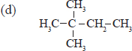

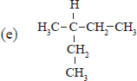

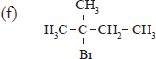

2.    Give the names and molecular formula of the following.

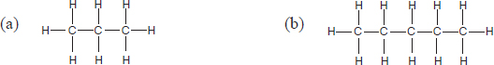

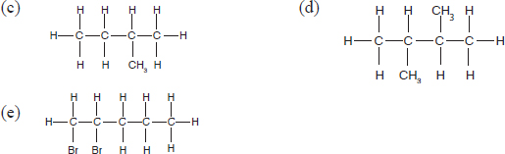

3.    Draw the structural formula for each of the following compounds:

(a)   2-methylheptane.

(b)   3-ethylhexane.

(c)   2, 2, 4-trimethylpentane.

(d)   2, 3-dichlorobutane.

4.    Draw and name the structures of all the isomers of:

(a)   Butane.

(b)   Pentane.

(c)   Hexane.

5.    Distinguish between thermal and catalytic cracking of alkanes.

6.    The following set up was used to prepare ethane in the laboratory.

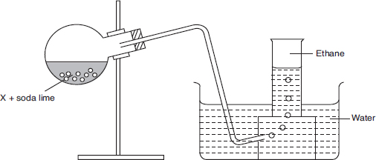

(a)   Identify a condition missing in the set up.

(b)   Name substance X and write its chemical formula.

(c)   Name the product produced alongside ethane in the reaction.

7.    Draw and name all the possible isomers of an alkane with the molecular formula C6H14.

8.    State three uses of alkanes.

9. The figure below represents the set up that was used to crack an alkane.

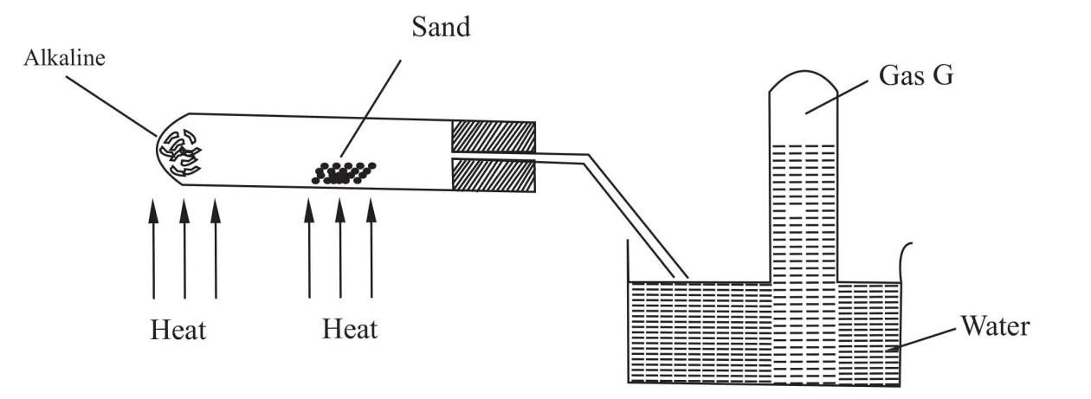

**Alkaline**

**Sand**

**Heat**

**Heat**

**Gas G**

**Water**

* + 1. What was the purpose of the sand?

* + 1. After some time, a colourless gas G was collected in the test-tube. Describe a chemical test and the observation that would be made in order to identify the class of compounds to which gas G belongs

1. Give the name and draw the structural formula of the compound formed when one mole of ethane reacts with one mole of chlorine gas.
2. Study the flow chart below and answer the questions that follow

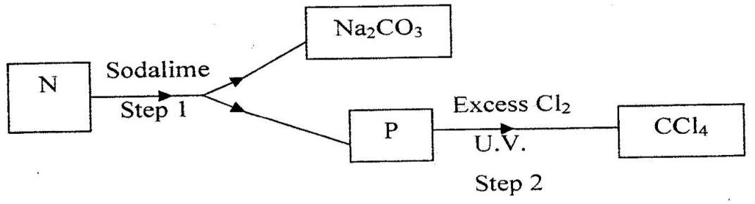

1. Identify N and P
2. What name is given to the type of halogenations/ chlorination reaction in step 2?
3. (a) What is meant by isomerism? (1 mark)

(b) Draw and name two isomers of butane. (2 marks)

1. What name is given to a compound that contains carbon and

hydrogen only? (½ mark)

1. Hexane is a compound containing carbon and hydrogen.
   1. What method is used to obtain hexane from crude oil?
   2. State one use of hexane

**2. ALKENES**

Alkenes are hydrocarbons which contain at least **one double bond** between two carbon atoms in a molecule image. The first member of the series is ethene C2H4. because at least two carbon atoms are necessary for a double bond to be formed.

The First members of the alkene series

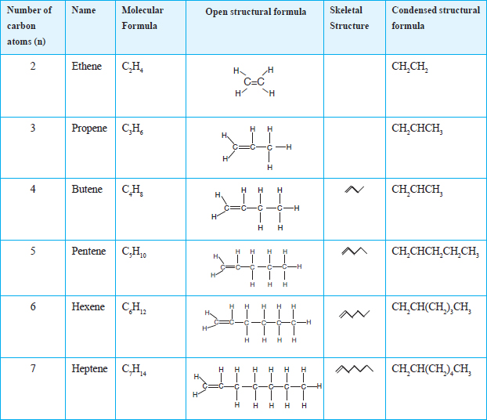

Each alkene differs from the next one by a –CH2. group, and conforms to the **general formula CnH2n where n represents the number of carbon atoms in a molecule (n = 2, 3, 4, 5…).**

The presence of a double bond in alkenes results in unsaturation. The double bond in alkenes is easily broken to accommodate more atoms. The C = C double bond determines the chemical properties of alkenes.

A functional group is an atom or group of atoms which is responsible for the characteristic reactions of a compound.

## Nomenclature

The longest straight chain in alkenes is that which contains the C– C double bond. All alkenes have names ending with – ene. To name them, a prefix indicating the number of carbon atoms in the longest straight chain is followed by the suffix – ene.

Naming of alkenes is based on the following rules:

1.    To determine the parent name of the alkene identify the longest carbon chain containing the double bond.

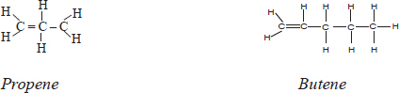

2.    Number the carbon atoms in the longest carbon chain starting from the end nearer to the double bond. The double bond should be given the **lowest possible number.**

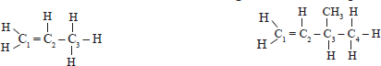

In the two cases, the double bond is between carbon 1 and carbon 2. In naming the lower position is used.

3.    Indicate the positions of the substituent groups by showing the position of the carbon atom to which they are attached. For example:

The structure should be:

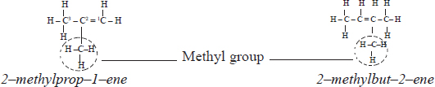

Examples

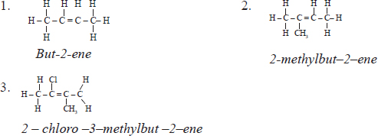

## Isomerism in Alkenes

Alkenes show branching, and positional isomerism.

Branching isomerism occurs when a substituent group is attached to one of the carbon atoms in the longest chain containing the double bond.

For example, the branched isomer of but-1-ene is:

image

Pentene has two branched isomers:

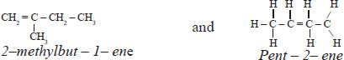

Positional isomerism occurs when **the position of the double bond in an alkene changes.** For example:

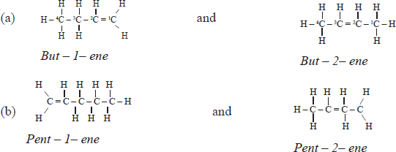

Laboratory preparation of alkenes.

Alkenes can be prepared by **dehydrating their corresponding alkanols** using concentrated sulphuric acid or aluminum oxide.

For example, ethene can be prepared by dehydrating ethanol using concentrated sulphuric acid or aluminium oxide. The mixture of ethanol and concentrated sulphuric acid or aluminum oxide must be heated to a temperature of 170°C.

1. **Dehydratingethanol with concentrated sulphuric acid.**

The ratio of ethanol to concentrated sulphuric acid is 1:2 respectively.

## imageDehydrating ethanol with aluminum oxide

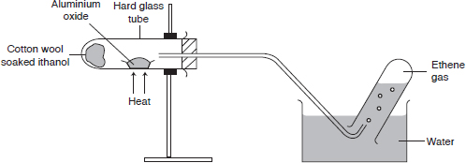

Discussion Questions.

1. **Write an equation for the reaction between ethanol and concentrated sulphuric acid.**

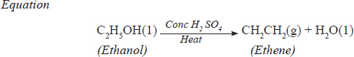 The removal of water molecules from ethanol is a dehydration process. Conc. sulphuric acid is a dehydrating agent.

1. **What is the purpose of the broken porcelain in the reaction flask?**

Broken porcelain or sand is used to prevent bumping which may result in cracking of the flask.

1. **Why was sodium hydroxide solution used in the experiment?**

The gas produced is passed through sodium hydroxide to remove sulphur(IV) oxide and carbon(IV) oxide which are formed when concentrated sulphuric acid and ethanol decompose respectively due to heat.

1. **What property of ethene gas enables one to use the above method of collecting it?**

Ethene is slightly soluble in water hence is collected over water.

1. **Why is it preferable to use a sand bath instead of heating the round-bottomed flask directly.**

To prevent bumping which may result in cracking of the flask.

1. **Explain how aluminium oxide is used to prepare ethene.**

imageThe aluminium oxide acts both as a catalyst as well as a dehydrating agent.

## Physical Properties

* Ethene is a colourless and oduorless gas.
* It is slightly soluble in water hence is collected over water.
* The solubility of alkenes decreases with increase in molecular mass. Ethene is very soluble in organic solvents such as methylbenzene, and tetrachloromethane.
* The melting point, and boiling points of alkenes generally **increase with increase in the number of carbon atoms** due to an **increase in inter-molecular** **forces**, hence, high boiling and melting points.

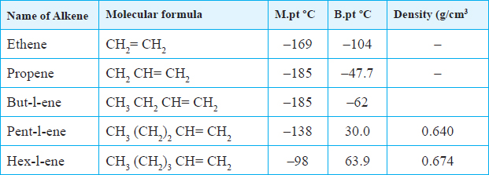

## Chemical Properties

Alkenes are more reactive than alkanes due to the presence of the double bond. The double bond is the reactive site of alkenes.

## (i) Combustion

**All alkanes burn in air with a yellow sooty flame** because they are **unsaturated**. They have a higher carbon to hydrogen ratio than alkanes.

Since alkenes burn with a sooty flame, they are not preferred for use as fuels.

C2H4(g) + 3O2(g) → 2CO2(g) + 2H2O(l)

## (ii) Addition reactions

Ethene undergoes addition reactions because of the double bond. **An addition reaction is one in which one molecule adds to another to form a single product.**

## (a) Halogenation

This is the addition of halogen atoms across a double bond. Chlorine and bromine are decolourised immediately when ethene is added. Equations for the reactions are:

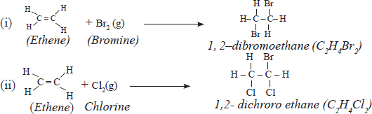

(iii)   When bromine is dissolved in water, and reacted with ethene, the following reaction takes place:

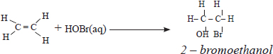

Bromine water is decolourised. This is a test for alkenes.

## (b) Hydrohalogenation

Addition of hydrogen halides such as hydrogen bromide, and hydrogen chloride is as shown:

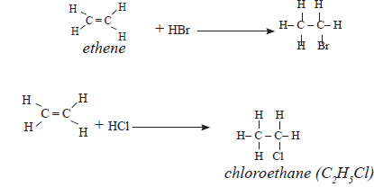

## (c) Hydrogenation

Hydrogen gas reacts with ethene at high temperature in the presence of palladium or nickel catalyst to form ethane.

image

When hydrogen gas is passed through liquid vegetable and animal oil heated to a temperature of 180°C, in the presence of a nickel catalyst, solid fat is formed. Therefore this process of hydrogenation is used in the manufacture of margarine to make the oils solid.

## (ii) Self-addition reaction (polymerisation)

Ethene molecules have the ability to react with each other to form a larger molecule which has a higher molecular mass. Each molecule of ethene is known as a **monomer**. When many monomers are joined together, they form a **polymer**. The following equation shows how a polymer is formed:

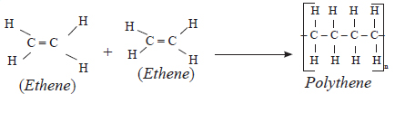

**The process in which several monomers combine to form a polymer is referred to as** polymerisation.

When ethene molecules join with each other this way, they form a polymer known as polyethene. This polymerisation process can be represented by a general equation;

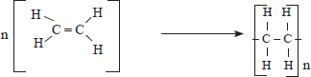

Where n = 2, 3, 4, 5..

## (iii) Addition reactions with oxidising agents

## (a) Potassium manganate(VII), KMnO4

When ethene is bubbled into acidified potassium manganate(VII) solution, **the colour of the solution turns from purple to colourless.** The manganate(VII) is an oxidising agent and it **adds oxygen at the double bond.** The manganate(VII) ion is reduced to manganese(II) ions and water.

This is also another test for alkenes. The equation is:

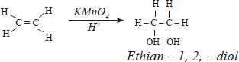

## (b) Acidified potassium chromate(VI) (K4Cr2O7)

When the potassium dichromate(VI) is used in the reaction the orange colour of the chromate(VI) changes to green. Potassium chromate(VI) acts as an oxidising agent adding oxygen at the double bond. The chromate(VI) ions are reduced to chromium(III) ions(Cr3+).

## (c) Reaction with concentrated sulphuric acid

Ethene reacts with concentrated sulphuric acid at room temperature to form ethyl hydrogen sulphate.

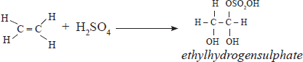

When ethyl hydrogen sulphate is added to water, and warmed, the product formed is ethanol.

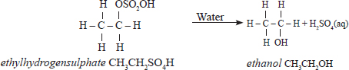

Ethyl hydrogen sulphate is hydrolysed to ethanol. This process is referred to as hydrolysis.

**Hydrolysis is the reaction of a compound with water such that the hydroxyl group of the water remains intact.**

Generally, the hydrogen atom is added first to ethene molecule to break the double bond, then the hydroxyl group is added.

## Tests for Alkenes

The addition reactions of alkenes with bromine water, acidified potassium manganate (VII) or acidified potassium(VI) dichromate can be used to test for the presence of a double bond.

## Uses of Alkenes

1.    In the manufacture of plastics.

2.    In the manufacture of ethanol through hydrolysis reactions.

3.    In the ripening of fruits (ethene).

4.    In the manufacture of detergents.

5.    In the laboratory preparation of ethan –1,2 –diol (glycol) which is used as in coolant (especially as an engine coolant).

Review Questions: Alkenes

1.    Name the following compounds:

(a)   H3C – CH= CH – CH3

(b)   H2C = CH – CH2 – CH2 – CH3

(c)   H2C = CH – CH = CH – CH3

(d)   H2C = CH – CH = CBr – CH3

2.    Draw the structural formula of the following compounds:

(a)   2–methylpent – 2–ene.

(b)   3–methylbut–1–ene.

(c)   1–chloro – 2 –methylpentane.

(d)   1 – bromo – 3 – ethylpentene.

3.    Define the following terms:

(a)   monomer.

(b)   polymer.

4.    Alkenes undergo hydrogenation to form alkanes as shown by the following equation;

image

Identify catalyst x and condition y.

5.    State four uses of alkenes.

6.    State a chemical test carried out to show evidence for the unsaturation in hydrocarbons.

7.    The following structure represents part of a polymer. Given that the molecular mass of the monomer is 76.5. Answer the questions below.

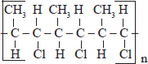

(a)   Identify and draw the structure of the repeat unit.

(b)   Name the monomer.

(c)   Write the molecular formula of the monomer.

8.    The following equation represents the reaction for the preparation of ethene from ethanol;

image

(a)   Name reagent A.

(b)   Name the process by which ethene is produced in the reaction represented by the equation.

* 1. Study the flow chart below and answer the questions that follow.



Step 3



1

mole HCL



Step 1



L + H

2

0



K



Ca(0H)

2



Gas J



S

tep

2



1

mole H

2

Step 4



H

2

0.

catalyst



R



CH

3

CH

2

OH



C

2

H

4



CH

3

CH

3



Cl H

C

C

H H



Step 5



Step 6



Ni. H

2

. 150

0

C

1. Identify reagent L.
2. Name the catalyst used in step 5.
3. Draw the structural formula of gas J.
4. What name is given to the process that takes place in step 5?
5. Propane can be changed into methane and ethane as shown in the equation below;

CH3CH2CH3(g) High temperature CH4(g) + C2H4(g)

Name the process undergone by propane.

## 3. ALKYNES

Alkynes are hydrocarbons which **contain a carbon – carbon triple bond (–C≡C–) in the molecule.**

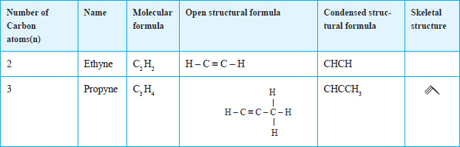

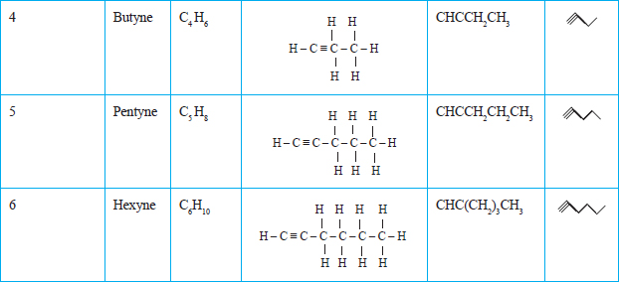

Each alkyne differs from the next by a –CH2 group and conforms to the **general formula, CnH2n-2, where 'n' represents the number of carbon atoms in a molecule, (n = 2, 3, 4…).**

The first alkyne member is n = 2 because at least two carbon atoms are necessary for the formation of a triple bond. The presence of the triple bond results in unsaturation.

## Nomenclature

All alkynes have names ending in –**yne**.

To name them, a prefix indicating the number of carbon atoms in the longest straight chain is followed by the suffix –**yne**.

The longest continuous carbon chain must contain the carbon-carbon triple bonds. This chain is numbered such that the carbon atoms having the triple bond have the lowest possible value as shown in the examples below.

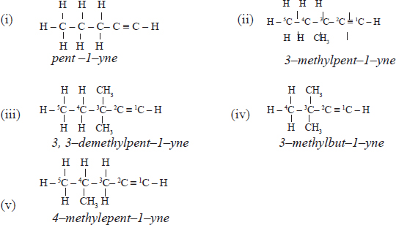

## Isomerism in Alkynes

Alkynes show branching isomerism, and positional isomerism.

## (a) Branching Isomerism

This occurs when a substituent group is attached to the longest chain containing the carbon - carbon triple bond.

For example the branched isomer of pent-l-yne is:

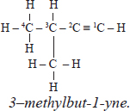

## (b) Positional Isomerism

The position of the triple bond in an alkyne molecule can change. This results in the formation of two or more compounds with the same molecular formula but different structural formula.

For example:

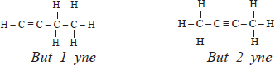

Ethyne and propyne do not show positional isomerism.

Laboratory Preparation of Ethyne

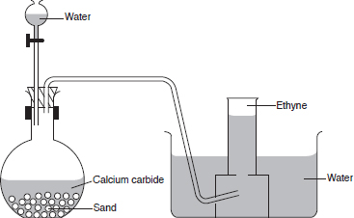

* Calcium carbide reacts with water at room temperature to form ethyne and calcium hydroxide.

CaC2(s) + 2H2O(l) → C2H2(g) + Ca(OH)2(aq)

* A layer of sand is placed at the base of the flask because the reaction is highly exothermic. The sand **absorbs** the excess heat and therefore **prevents the flask from breaking.**
* The flask must be dry before the start of the experiment **to avoid formation of the gas** before the set-up is complete.

## Physical Properties

Ethyne is a colourless gas and has a pleasant smell when pure. It is slightly soluble in water, and therefore can be collected over water. The solubility of alkynes is higher in non-polar solvents. The table below gives some properties of alkynes.

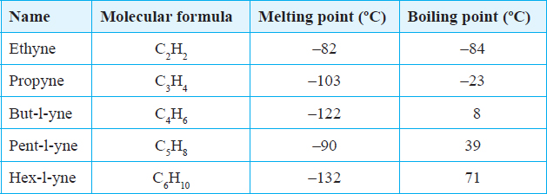

Alkynes with lower molecular mass are **gases** at room temperature. While those with a higher molecular mass are **solids**.

## Chemical Properties

Ethyne burns in air, and also undergoes addition reactions.

## (a) Combustion

Ethyne like any other hydrocarbon will burn in air to form an oxide of carbon, and water. This reaction is usually accompanied by production of a lot of heat, therefore, it is preferably used in oxy-acetylene flames.

In a limited supply of air, ethyne undergoes incomplete combustion to form a mixture of carbon and carbon(II) oxide. The yellow sooty flame observed is due to the **unburnt** carbon.

image

In excess air, ethyne burns **completely** to form carbon(IV) oxide and water.

image

## (b) Addition Reactions

Addition reactions in alkynes are faster than in alkenes due to the presence of the triple bond.

(i) Reaction with hydrogen (hydrogenation)

Ethyne reacts with hydrogen in the presence of a nickel catalyst to form first ethene, then ethane.

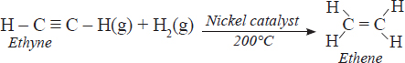

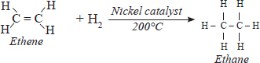

**(ii) Reaction with halogens (halogenation)**

When ethyne reacts with red-brown bromine vapour, **the bromine vapour is decolourised.** The decolourisation process is faster in ethyne than in ethene. The bromine atoms are added to the carbon-carbon triple bond to form 1, 1, 2, 2,-tetrabromoethane. This reaction takes place at **room temperature** and it is a two-step reaction. Thus:

image

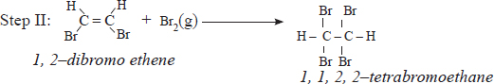

Pure chlorine reacts with ethyne with a violent explosion forming carbon, and hydrogen chloride.

C2H2 + Cl2(g) → 2C(s) + 2HCl(g)

When diluted with an inert gas, chlorine reacts with ethyne to from 1, 1, 2, 2-tetrachloroethane in a two step reaction.

image

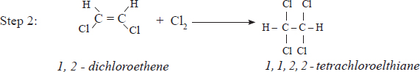

## (iii) Reaction with hydrogen halides (Hydrohalogenation)

Ethyne does not react with all the hydrogen halides. Hydrogen iodide reacts readily at room temperature, hydrogen bromide reacts when warmed while hydrogen chloride reacts slowly.

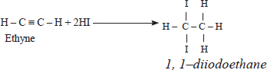

(ii) Hydrogen bromide reacts with ethyne to produce 1,1–dibromoethane (CH3CHBr2)

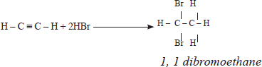

(iii) The reaction between hydrogen chloride gas is slow.

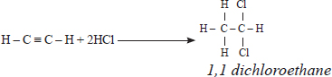

## Test for Alkynes

The test for an alkynes is similar to the tests for alkenes in which the oxidising agents are decolourised. However, the reaction is **faster** in alkynes than in alkenes.

## Uses of Alkynes

1.    They are used in the industrial manufacture of compounds such as adhesives, and plastics.

2.    In the manufacture of synthetic fibres such as rayon.

3.    In the production of important chemical reagents and solvents, in which it is used as a starting material.

4.    They are used in the oxy-acetylene flame which is used for welding, and cutting metals.

Review Questions: Alkynes

1. (a)   Write the molecular formula of butyne.

(b)   Draw the open structural formula of butyne.

(c)   Butyne burns with a yellow sooty flame in a limited supply of air. Explain.

(d)   Write the equation for the reaction in (c).

1. Name the compound represented by the following structure.

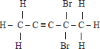

1. Draw the open structure of the compound with the following molecular structure: C6H10
2. The reaction between bromine vapour and ethyne is faster than with ethene. Explain.
3. The relative formula mass of a hydrocarbon is 58. Draw and name two possible structures of the hydrocarbon (C=12.0; H=1.0
4. Alkanes, alkenes and alkynes can be obtained from crude oil. Draw the structure of the second member of the alkyne homologous series.
5. Draw and name the structure of the compound formed when one Mole of ethyne reacts with one mole of hydrogen bromide.
6. Draw the structures of the alkynes whose molecular formula is C4H6
7. Study the flowchart below and answer the questions that follow:

water

HCl

Process Z



X



Polyvinylchloride



Y



C

2

H

2

(a) Identify X and Y

(b) State two uses of polyvinylchloride

10. Draw and name the isomers of butyne

1. State one use of polystyrene

Revision Exercise: HYDROCARBONS

1.    Crude oil is the main source of organic compounds such as hydrocarbons. The hydrocarbons in the crude oil have to be separated.

(a)   Name four important hydrocarbons obtained from crude oil.

(b)   Give the uses of the four hydrocarbons named in (a) above.

(c)   Explain with the help of a suitable diagram, the principles used in separating hydrocarbons in crude oil.

2.    What do you understand by the following terms:

(a)   Catalytic cracking.

(b)   Thermal cracking.

3.    Study the following reaction scheme and answer the questions that follow:

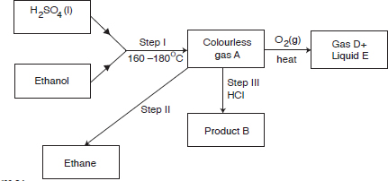

(a)   Name:

(i)   Colourless gas A.

(ii)   Product B.

(iii)  Gas D.

(iv)  Liquid E.

(b)   Write balanced equations for each of the reactions forming the products in (a).

(c)   Name the type of reactions taking place in Step I and II.

(d)   State the importance of the reaction taking place in Step II.

4.    Explain why an organic compound with formula C3H6 burns with a more sooty flame than C3H8

5.    Butane and bromine react as shown below:

CH3,CH2.CH2CH3 + Br2 → CH3CH2.CH2Br + HBr

(a)   Name the type of reaction taking place in the equation above.

(b)   State the condition under which the above reaction takes place. Explain.

6.    A hydrocarbon Q, was found to decolourise potassium manganate(VII) solution. When two moles of Q are burnt completely, six moles of carbon(IV) oxide and six moles of water were formed.

(a)   Write the structural formula of Q.

(b)   Name the homologous series to which Q belongs.

(c)   Name one industrial source of Q.

7.    The diagram below shows the combustion of ethane gas.

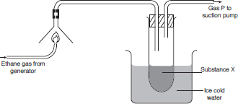

(a)   Identify substance x.

(b)   Write the equation for the complete combustion of ethane gas.

(c)   What is the purpose of ice cold water in the experiment?

(d)   The pH of substance X was found to be less than 7. Explain this observation.

8.    One mole of hydrogen bromide reacts with an organic compound N to give a single product with the structural formula shown below:

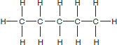

(a)   Give the name of the hydrocarbon.

(b)   Draw the possible structure of N.