233/1
CHEMISTRY
PAPER 1

MARKING SCHEME

1. a) Luminous flame 1mk

b) Produces less heat
or
Blackens the conical flask/ sooty 1mk

2. a) Fractionating column ½ mk

b) Fractional distillation ½ mk

c) Condensation would not occur 1 mk

d) Differences in boiling points 1mk

3. - Dissolve the mixture in hot water ½ mk
- Filter the solution to remove insoluble solid Q as a residue ½ mk
- Cool the filtrate. R crystallizes and is removed by filtration ½ mk
- Evaporate the latter filtrate to obtain P ½ mk

4. - H₂O has lone pairs of electrons which can be shared with H⁺ ion 1mk

5. a) Solution P ½ Weak acid ½ mk

b) Solution N ½ Weak base ½ mk

6. a) E 1 mk

b) C=8 ½ mk
A=4 ½ mk

7. - Helium is inert (unreactive) ½ while hydrogen is reactive ½ mk

8. - Moles of zinc=1.96 =0.03 ½ mk
63.5

- Moles of HCL 100x0.2 =0.02 ½ mk
1000
- Moles of zinc reacted 0.02 =0.01 ½ mk
2
Zinc is in excess ½ mk
- Mole ratio of HCL: H₂ 2:1
Moles of H₂ (g) produced = 0.02 = 0.01 moles ½ mk
2
- Volume of H_{2 g} at S.T.P= 0.01x22.4
= 0.224 dm³
or 224cm³ ½ mk

9. I 2, methyl pentane 1 mk

II 1- chloro propene 1 mk

a) To prevent oxidation of magnesium ribbon 1 mk
To generate steam 1 mk

b) Mg_{s} + H₂O_{(l)} MgO_{(s)} + H_{2(g)} 1 mk
Should be balanced with state symbols

10. i) K₂ CO_{3 (s)} + 2HCl_{(aq)} 2KCl_{(aq)} + CO_{2(g)}+ H₂O_{(l)} 1 mk
Should be balanced with state symbols

ii) Moles of acid 25x0.2
1000
=0.005 moles ½ mk

Moles of K2 CO3 = 0.005
2
=0.0025 moles ½ mk

iii) RFM of K₂CO₃ = 138 ½ mk
Mass of K₂CO₃ in the mixture
138x0.0025= 0.345_{g} ½ mk
Mass of KCL in the mixture
0.9-0.345
= 0.555_{g} ½ mk

11. i) Zinc 1 mk

ii) Hydrogen 1mk

iii) Zn²⁺ + 2OH⁻ _{(aq)} Zn(OH) _{2(s)} 1mk

12. a) Dynamic equilibrium is attained when the rate of the forward reaction is equal to that of the
reverse reaction 1mk
b) The intensity of the yellow colour in the equilibrium mixture increased 1mk.
Additional of NaOH reduces the concentration ofH+ ions hence equilibrium shifts to the left 1mk
13. [a] White precipitate was formed 1mk
[b] Pb²⁺_{[aq]} + 2Cl⁻ [aq] PbCl₂[s] 1mk
14.
Element | C | H | O
% Composition | 57.15 | 4.76 | 38.09 √ ½
R.A.M | 12 | 1 | 16
$\frac{\text{\% }}{R\text{.}A\text{.}M}$ | 4.7625 | 4.76 | 2.380625√ ½
Moles ratio | $\frac{4\text{.}\text{7625}}{2\text{.}\text{380625}}$=2.004 =2 | $\frac{4\text{.}\text{76}}{2\text{.}\text{380625}}$=2.00 | $\frac{2\text{.}\text{380625}}{2\text{.}\text{380625}}$=1 √ ½
Empirical formula= C₂H₂O√ ½
n =$\frac{\text{126}}{\text{42}}$ = 3 √ ½
Molecular formula = (C₂H₂O)₃ = C₆H₆O₃√ ½

15. (i) Copper(II) sulphate;√ 1 at 40⁰C ONLY 28gm is soluble leaving the rest undissolved. √ 1
At 40⁰C, all lead nitrate dissolves.

(ii) 35-28√ ½=7g√ ½

16. a) Strong acid ionizes completely in solution while concentrated acid contain high number of
acid molecules per given volume. 1mk

b) Ammonia in water dissociate to produce hydroxide ion √ 1while in methybenze it remain in
molecular form. √ 1

17. i) Sublimation √ 1
ii) Oxidation √ 1
iii) Dehydration √ 1

18. a) Filteration√ 1

b) Ca(OH)_{(s)} + H₂O_{(l)} Ca(OH)_{2(aq)} √ 1

c) Carbon(IV) oxide// Ammonia√ 1

19. a) Metallic bond√ 1

b) Group I√ 1; Has one delocalized electron from each atom√ 1

20. a) Melts into a silvery ball√ 1/darts on the surface of water√ 1/Floats on the surface of
water/hissing sound ( any two)

b) 2Na_{(s)}+ H₂O_{(l)} 2NaOH(aq) + H_{2(g)} √ 1

21. a) Permanent hardness is caused by the presence of MgSO₄/ CaSO₄/CaCl₂ √ 1which do not
decompose on heating√ 1
b) Addition of Sodium Carbonate√ ½/ammonium hydroxide√ ½/ Ion exchange
(any two)
22.
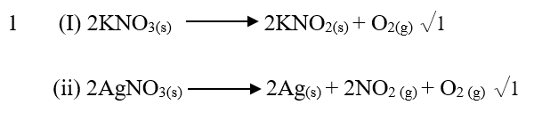

23. a) A brown solid is formed 1
c) Carbon (II) Oxide. 1
24. a) Rhombic or monoclinic✓1 Sulphur.
b) – For hardening rubber✓1
- Manufacture of sulphuric acid ✓1 Any two correct
- As a fungicide
- In making calcium hydrogen sulphite used in bleaching.
25.

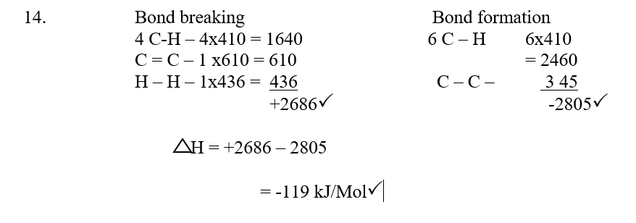

26. -The bulb lights √ 1
- Grey solid deposits at the cathode √ 1
- Brown gas bubbles produced at the anode √ 1

27. -Heat to sublime NH₄Cl. ½
- Add water ½ to dissolve NaCl. ½
- Filter ½ the residue is PbCl₂ ½
- Evaporate ½ the filtrate (NaCl solution) to obtain NaCl solid

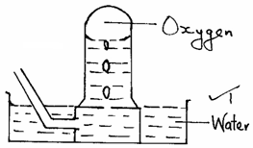
28. (a) Sodium peroxide ¹
(b)

- 2Na₂O_{2(S)} + 2H₂O_{(l)} → 4NaOH_{(aq)} + O_{2(g)}
_{29.} (a) 2KMnO_{4(S)} + 16HCl_{(aq)} → 2KCl_{(aq)} + 2MnCl_{2(aq)} + 8H₂O_{(l)} + 5Cl_{2(g)} ¹
(b) MnO₂ ¹
(c) Cl_{2(g)} + dye + H₂O_{(l)} → 2HCl_{(aq)} + (dye – O) 2

