232/2
PHYSICS
PAPER 2
MARKING SCHEME

1.
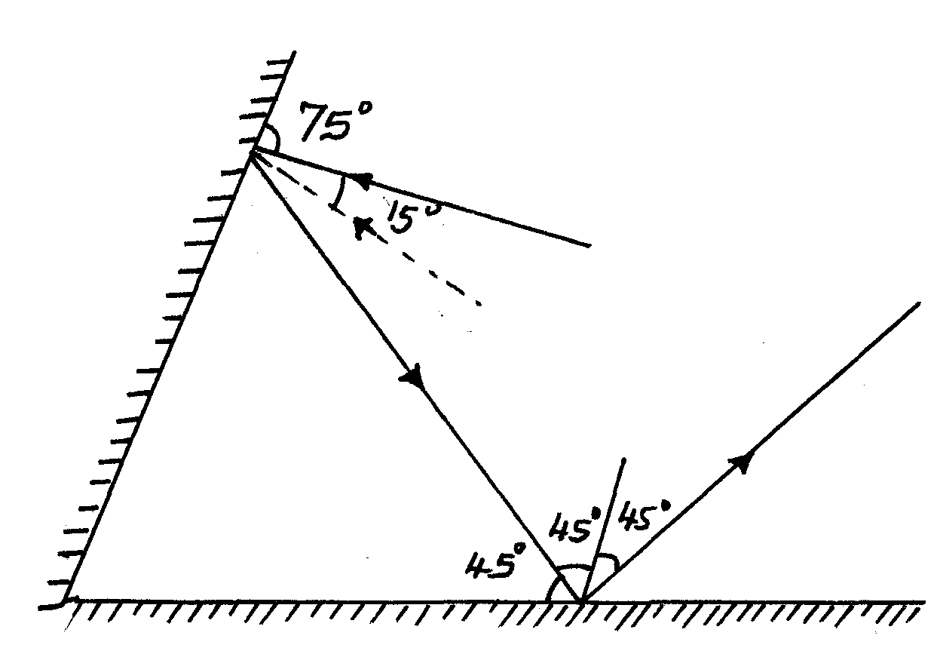

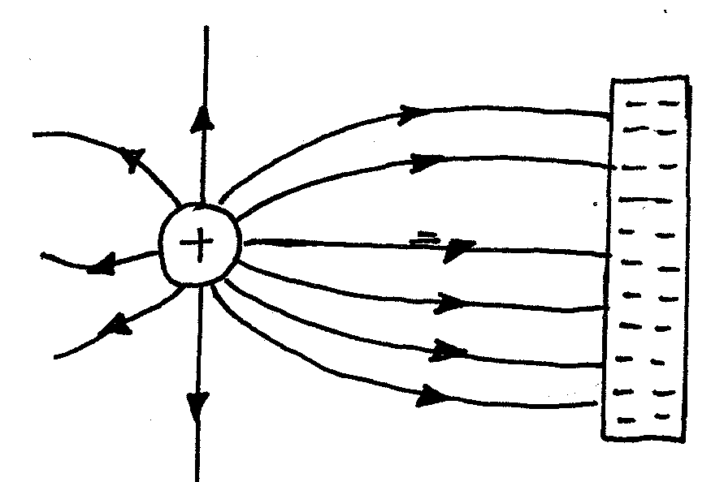

2.

3. They acquire North poles at the ends thus they repel.
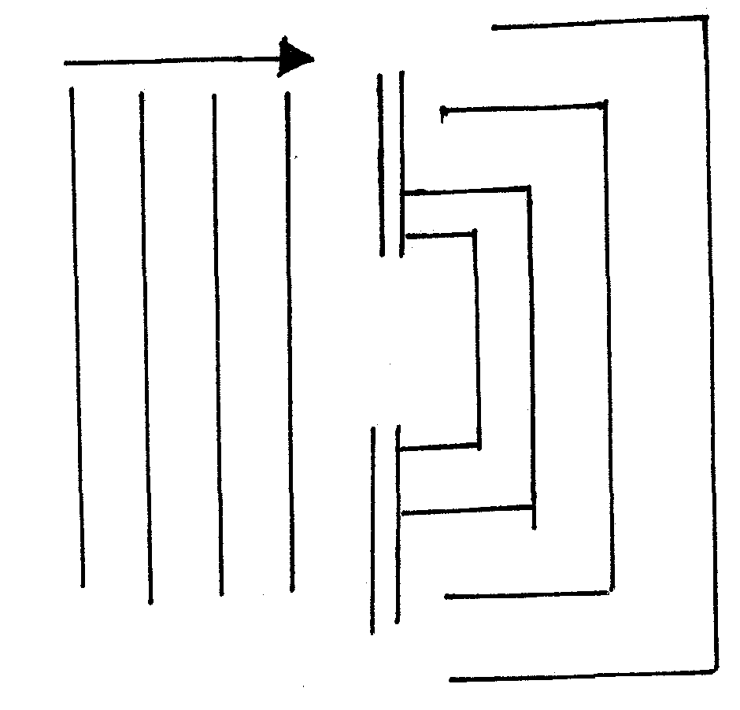
4. i)

ii)
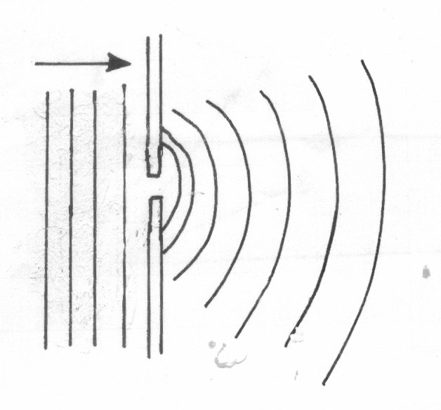
5. Light energy to electrical energy
6. i) Microwaves, infrared, visible light, x – rays
ii) - Observing objects
- Taking pictures
7. Alkaline - Produces higher current
- Lasts longer
- It is portable
- Less maintenance & care
$$\begin{aligned}8\text{.}V = \frac{\text{25}}{t}, ⇒ S = \frac{\text{Vt}}{2} \\ S = \frac{\text{330} x 0\text{.}6}{2} = \text{99}m\end{aligned}$$
9. Separation of colours of light from white light.
10 I = ^{V}/_{R}
= ²/₆ = ¹/₃
= 0.33A
$$\begin{aligned}\text{11}\text{.}n_{g} = \frac{3}{2}, n_{o} = \frac{6}{3} \\ ∴ n_{g} = n_{a}n_{g} \\ \frac{3}{6 } x \frac{3}{2} \\ \frac{9}{\text{12}} = \frac{3}{4} \\ \frac{3}{4} \text{or} 0\text{.}\text{75}\end{aligned}$$
12. - Distance between the plates
- Area of plates
- Dielectric material used

SECTION B
13. a) For an atomic conductor p.d across the ends is directly proportional to current
if temperature and other constants kept constant ;
b) i)
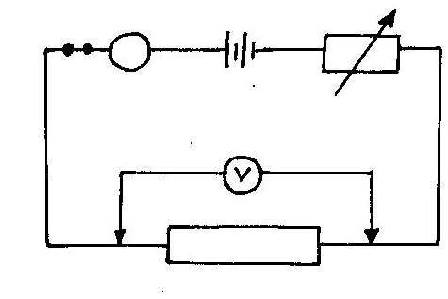
Ammeter in series ;
Voltmeter in parallel
Variable resistor in series
(apparatus must be workable)
ii) - Connect the apparatus as shown
- Vary variable resistor such that I is certain value ;
- Record I in ammeter and V in Voltmeter ;
- Draw graph of V against I ;
c) Parallel I = 1 + 1 + 1
R 6 4 8
1= 2+3+4
R 12
I = 9
R 12

R = 4=l ¹/₃Ω
R₁ = 4+1¹/₃
= 5¹/₃Ω
(ii)V=IR
I = V/R=4.5/5.33
= 0.844A
=3.377V

14. (i) Time taken for n number of claps. The claps should concide with the echos;
The distance between the civil and walls;
(ii) Sound has to travel to the walls and reflected back to the coil
Distance travelled is 2d;
For n claps there will be n echo’s;
Total distance travelled = n x 2d
2nd;
Speed of sound $= \frac{2\text{nd}}{t};$
(iii) 200m;
10m is short distance and timing will be inaccurate;
500m is too long for sound to travel through and be reflected back. Energy will have been lost along the way;
(i) 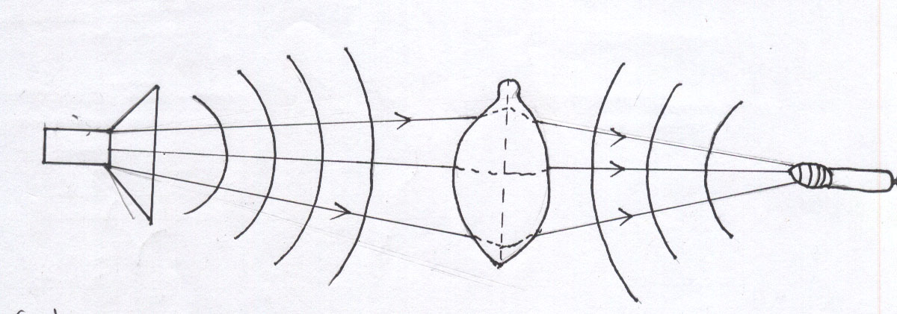
Wavelength maintained;
Wave form;

(ii) When the sound goes through the balloon it is focused to one point, hence changing the position the sound becomes less; (refracted)

(iii)$\begin{aligned}V = fλ \\ \text{340} = \text{1020} × λ; \\ λ = \frac{\text{340}}{\text{1020}} \\ = 0\text{.}\text{3333}m; \end{aligned}$
C) (i) Destructive and constructive interference

(ii) Maximum amplitude or horizontal line

(iii) Loud sound all through

15. (a) (i) Light must travel from denser medium to less dense medium.
Angle of incidence in the denser medium must be greater than critical angle in the less dense medium.
(b) (i) sini =n
sin r
sin30°= 1.618
sin 18°
n = 1.618
(ii) sin C=1
n
sin C = 1
1.6 18
C=sin⁻¹ 0.61804
C = 38.17°
16.Intercept = 1 
f
2.5 x 10⁻² cm⁻¹ = 1 
f
f = 40 cm 

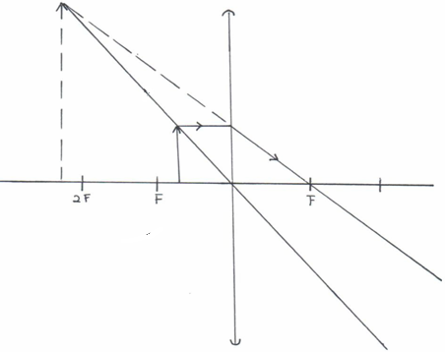
17. (i)

(ii) As a magnifying glass.

(iii) | EYE | CAMERA
 | - Crystalline convex lens.  - Choroids layer of eye is black  - Eye forms image in retina.  - Iris controls amount of light entering the eye. | - Convex lens.  - Camera box is painted black inside.  - Images formed on light sensitive film.  - Diaphragm controls amount of light  entering the camera.
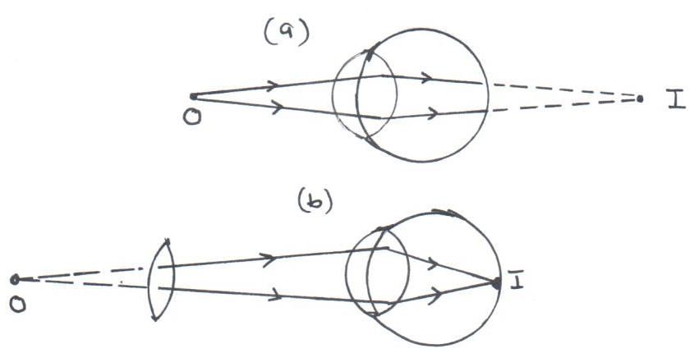

(c)

(d) (i) $\frac{1}{V} + \frac{1}{U} = \frac{1}{f}$ $\begin{aligned}f = −\text{20} \\ U = +\text{10}\end{aligned}$
$\frac{1}{V} = \frac{−1}{f} − \frac{1}{U}$ ¹
$= \frac{−1}{\text{20}} − \frac{1}{\text{10}} = \frac{\left(−1 − 2\right)}{\text{20}}$
$= \frac{−3}{\text{20}}$
V = 6.67cm ¹

(ii) $\text{Im}\text{age} \text{height} = \frac{\text{Im}\text{age} \text{dis}\text{tan}\text{ce} × \text{Object} \text{height}}{\text{Object} \text{dis}\text{tan}\text{ce}}$
$\text{HI} = \frac{V × H}{U}$¹
$= \frac{6\text{.}\text{67} × \text{10}\text{.}5}{\text{10}}$
= 7.00cm ¹

(iii) $M = \frac{V}{U} = \frac{6\text{.}\text{67}}{\text{10}}$
= 0.667cm ¹

