**Sunrise evaluation exams form 3**

name…………………………………………………adm no………………..class……………

school…………………………………………….candidates signature…………………...

DATE…..…..………………………

**PHYSICS END TERM**

**PAPER 2 HOURS** **GRAND TOTAL**

INSTRUCTIONS TO CANDIDATES

* Write your name and index number in the spaces provided above
* Sign and write the date of the examination in the spaces provided
* Attempt ALL questions in sections A and B.
* All your answers must be written in the spaces provided in this question paper.
* All working must be clearly shown
* Non programmable silent electronic calculators and KNEC mathematics table may be used except where stated otherwise

For Examiner’s Use Only

|  |  |  |  |
| --- | --- | --- | --- |
| Section | Question | Maximum Score | Candidates’ Score |
|  | 1-19 | 25  12  13  16  14 |  |
|  |  |
|  |
|  |
|  |
| 80 |  |

1. What is the reading on the micrometer screw gauge shown below with an error of +0.5mm? **(2mks)**

Figure 1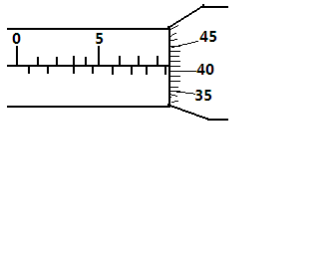

………………………………………………………………………………………………………………………………………………………………………………………………

1. In a ball and ring experiment, the ball goes through the rings at room temperature. When it is heated it does not go through the ring, but when left on the ring for some time, it goes through. Explain this observation

**(2mks**)

………………………………………………………………………………………………

………………………………………………………………………………………………………………………………………………………………………………………………………………………………………………………………………………………………

1. In the study of free fall, it is assumed that the force F acting on a given body of mass, m, is gravitational, given by F = ma. State two other forces that act on the same body (**2mks)**

………………………………………………………………………………………………………………………………..…………………………………………………………….………………………………………………………………………………………………

1. In the set up shown below, it is observed that the level of the water initially drops before starting to rise. Explain this observation  **(2mks)**

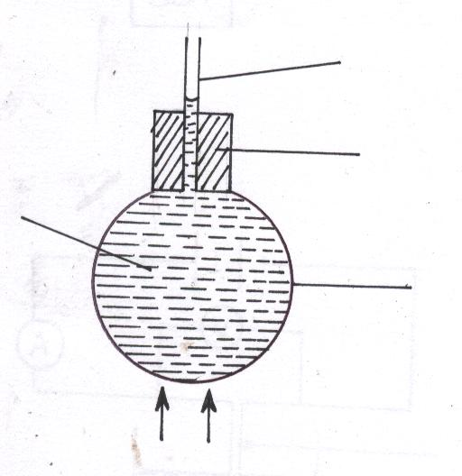Figure 2

Heat

Glass

Coloured water

Cork

Tube

………………………………………………………………………………………………

………………………………………………………………………………………………

……………………………………………………………………………………………………………………………………………………………………………………………

1. Distinguish between speed and velocity.  **(2mks)**

………………………………………………………………………………………………

………………………………………………………………………………………………………………………………………………………………………………………………

1. State how the pressure in a moving fluid varies with speed of the fluid.

**(1mk)**

………………………………………………………………………………………………

………………………………………………………………………………………………

1. Give one difference between luminous and non-luminous sources of light.

**(1mk)**

....................................................................................................................................................................................................................................................................................................................................................................................................................................................................................

1. When a negatively charged rod is brought near the cap of a leaf electroscope, the leaf rises. Explain this observation, **(2mks)**

..................................................................................................................................................................................................................................................................................................................................................................................................................................................................

1. Figure 3 represents a displacement-time graph for a wave.

Figure 3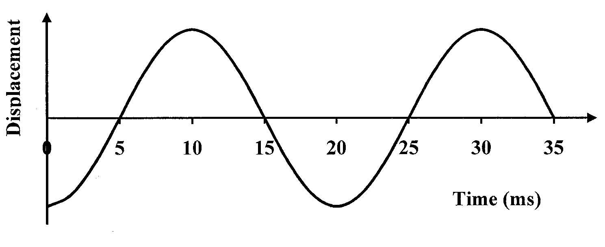

Determine the frequency of the wave. **(3mks)**

................................................................................................................................................................................................................................................................................................................................................................................................................................................................................................................................................................................................................................................

1. In an experiment to determine the focal length of a concave mirror, magnification M was determined for various image distances v. Figure 4 shows a graph of magnification M against image distance v for the results from the experiment.

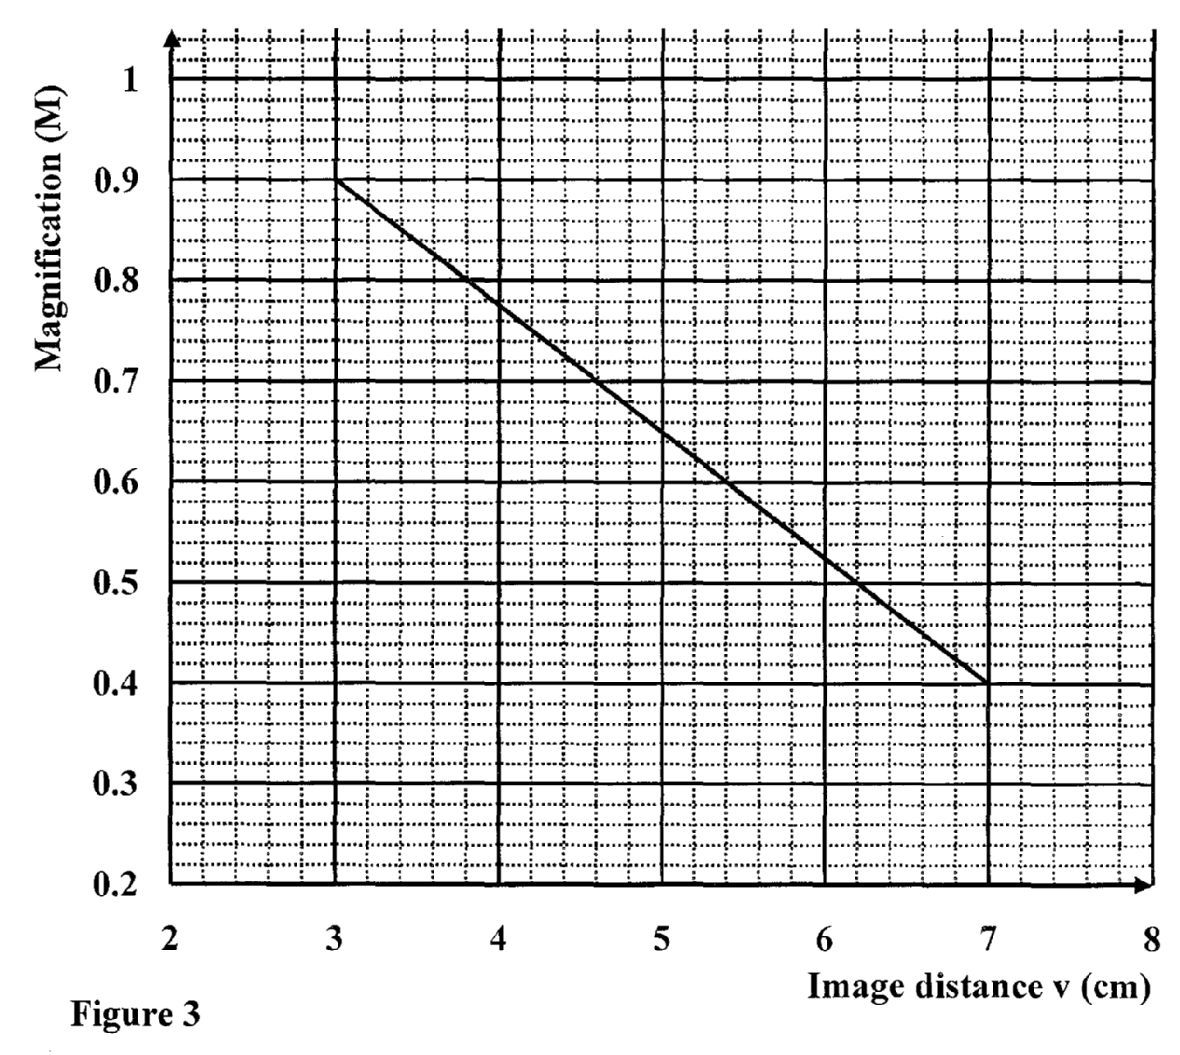

Given that M = -1, determine the focal length f of the mirror. (**3mks)**

.............................................................................................................................................................................................................................................................................................................................................................................................................................................................................................................................................................................................................................................

1. Figure 5 shows the magnetic field pattern round a current-carrying conductor. Indicate on the conductor the direction of the current.

**(1mk)**

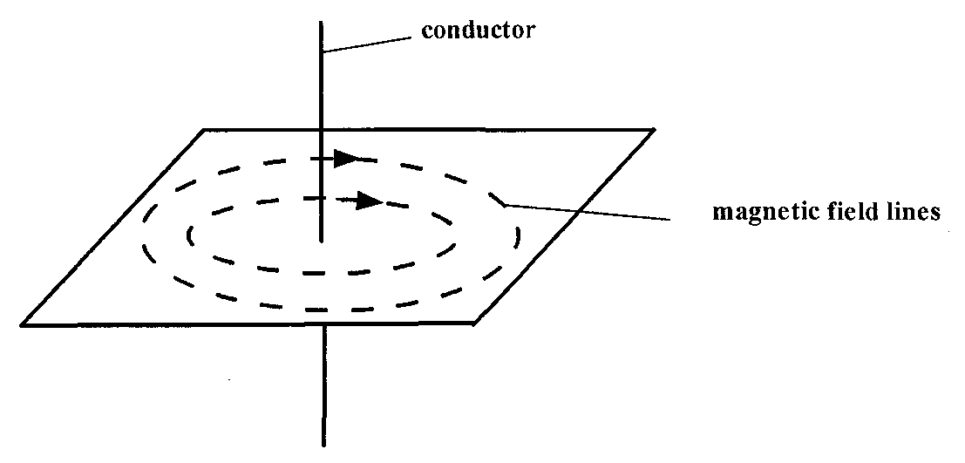

Figure 5

1. Why is repulsion the sure test for a magnet?

**(2mks)**

..........................................................................................................................................................................................................................................................................................................................

1. (a) (i) State Snell’s law of refraction of light

**(2mks)**

………………………………………………………………………………………………………

………………………………………………………………………………………………………

(ii)Give two advantages of totally internally reflecting prisms over plane

mirrors. **(2mks)**

………………………………………………………………………………………………………

………………………………………………………………………………………………………

(b) A ray of light is incident on a kerosene water interfaces as shown in figure 6

Fig. 6

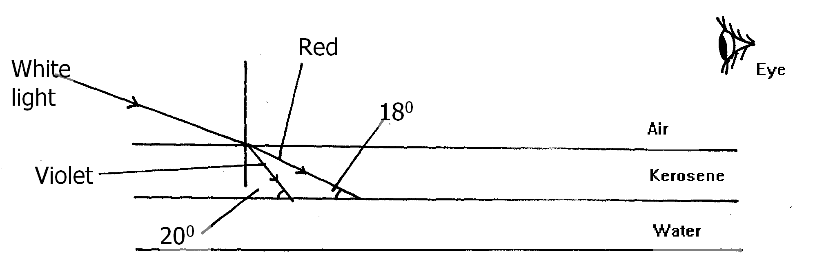

Given that the refractive index of water and kerosene are 1.33 and 1.44 respectively, Determine

(i) The refractive index for the kerosene – water interface **(3mks)**

………………………………………………………………………………………………………

………………………………………………………………………………………………………

………………………………………………………………………………………………………

………………………………………………………………………………………………………

………………………………………………………………………………………………………

………………………………………………………………………………………………………

(ii) Determine and show on the figure the path of the rays of light between the Kerosene-water surface **(3mks)**

………………………………………………………………………………………………………

………………………………………………………………………………………………………

………………………………………………………………………………………………………

………………………………………………………………………………………………………

………………………………………………………………………………………………………

………………………………………………………………………………………………………

(iii) Why does the colours of the light separate at the kerosene layer. **(2mks)**

………………………………………………………………………………………………………

………………………………………………………………………………………………………

(iv) State and explain the observation that the eye above the two surfaces would

see  **(2mks)**

………………………………………………………………………………………………………

………………………………………………………………………………………………………

………………………………………………………………………………………………………

………………………………………………………………………………………………………

1. (a) State the principle of conservation of linear momentum. **(2mks)**

………………………………………………………………………………………………

………………………………………………………………………………………………

* 1. Calculate the recoil velocity of a gun of mass 0.4kg which fires a bullet of mass 0.0045kg at a velocity of 400ms-1  **(3mks)**

(i) State two factors which affect frictional force of a body **(2mks)**

………………………………………………………………………………………………

………………………………………………………………………………………………

………………………………………………………………………………………………

(ii) Suggest three ways in which friction can be minimized  **(3mks)**

………………………………………………………………………………………………

………………………………………………………………………………………………

………………………………………………………………………………………………

………………………………………………………………………………………………

………………………………………………………………………………………………

(iii) State three advantages of friction (**3mks)**

………………………………………………………………………………………………

………………………………………………………………………………………………

………………………………………………………………………………………………

………………………………………………………………………………………………

………………………………………………………………………………………………

1. a) Fig. 7 shows a cylindrical can filled with a liquid of density 0.8 gcm-3. A hole of diameter 2.0 cm is drilled at a depth of 2.8 m from the top of the can.

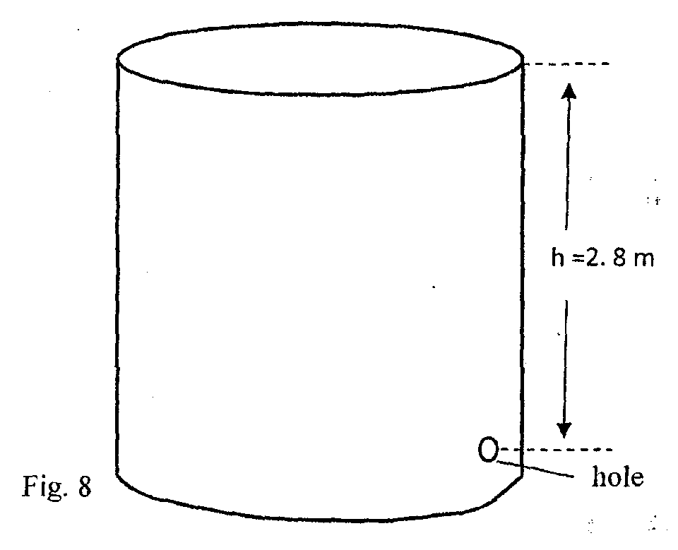

Determine:

1. The cross-sectional area of the hole. **(3mks)**
2. The maximum pressure exerted by the liquid at the hole. **(3mks)**
3. The maximum force exerted on a jet of liquid through the hole. (3mks)
4. a) An object is projected vertically upwards with a velocity of 200m/s. Calculate:
5. Its velocity after 5 seconds  **(2mks)**
6. The distance covered in the first 8 seconds  **(3mks)**
7. The maximum height reached **(3mks)**
8. The figure below shows a uniform cardboard in the shape of a parallelogram.

Locate the centre of gravity of the cardboard**. (2 mks)**

1. Two samples of bromine vapour are allowed to diffuse separately under different conditions, one in a vacuum and the other in air. State with reasons the conditions in which bromine diffuse slower.  **(2 mks)**

……………………………………………………………………………………………

………………………………………………………………………………………………

………………………………………………………………………………………………

………………………………………………………………………………………………

1. Students set up a mass attached to spring such that when it oscillates it taps on water surface in a wide shallow tank.

Fig. 9

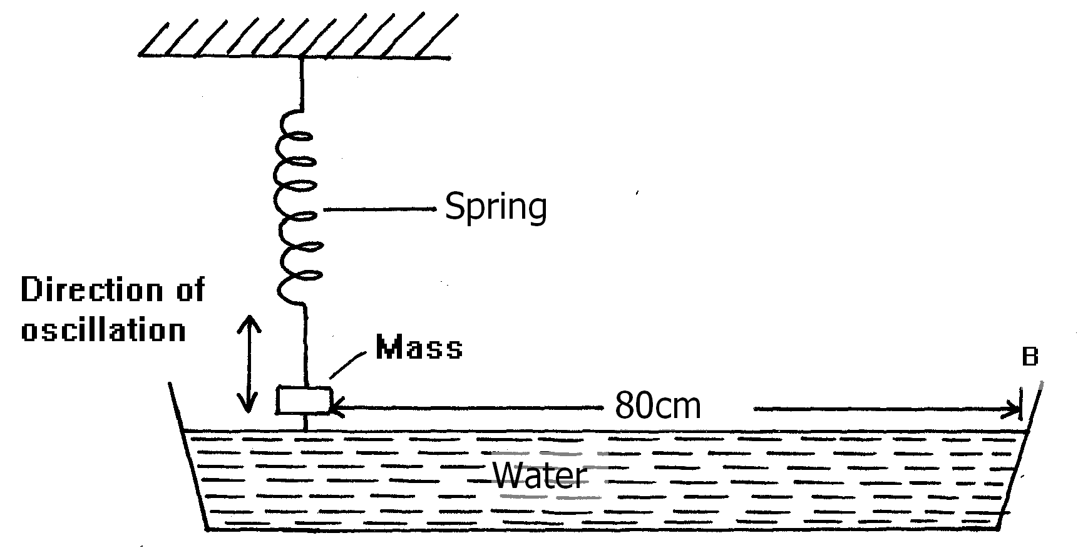

The students measured time for 20 oscillations and found that the mass takes 36 seconds.

(i) Determine the periodic time of the mass **(3mks)**

………………………………………………………………………………………………………

………………………………………………………………………………………………………………………………………………………………………………………………………………

………………………………………………………………………………………………………

………………………………………………………………………………………………………

………………………………………………………………………………………………………

(ii) Calculate the frequency of the waves produced on the water surface **(3mks)**

………………………………………………………………………………………………………

………………………………………………………………………………………………………

………………………………………………………………………………………………………

………………………………………………………………………………………………………………………………………………………………………………………………………………

………………………………………………………………………………………………………

………………………………………………………………………………………………………

………………………………………………………………………………………………………

(iii) Given that the student counted four ripples between the mass and end B of the tank, Determine the speed of the waves. **(3mks**)

………………………………………………………………………………………………………

………………………………………………………………………………………………………

………………………………………………………………………………………………………

………………………………………………………………………………………………………

………………………………………………………………………………………………………