**Sunrise EVALUATION exams form 2**

**Name: ………………………………………………………… Adm. No………..............................**

**Candidate’s sign: .............................Date……………………...**

**PHYSICS**

**(THEORY)END TERM 1**

**TIME: 2½ HOURS**

**FORM TWO**

**INSTRUCTIONS TO CANDIDATES:**

* *Write* ***your name, admission number****,* ***date*** *of examination and the* ***name*** *of your school in the spaces provided above.*
* ***Sign*** *and* ***write*** *the* ***date*** *of examination in the spaces provided above.*
* *This paper consists of sections:* ***A*** *and* ***B.***
* *Answer* ***all*** *the questions in section* ***A*** *and* ***B*** *in the spaces provided.*
* *All working* ***must*** *be clearly shown in the spaces provided.*
* *Mathematical tables and electronic calculators may be used.*

**For Examiner’s Use Only**

|  |  |  |  |
| --- | --- | --- | --- |
| **SECTION** | **QUESTION** | **MAXIMUM SCORE** | **CANDIDATE’S SCORE** |
| **A** | 1 – 12 | 25 |  |
| **B** | 13-17 | 13  12  16  14 |  |
|  |
|  |
|  |
| **TOTAL SCORE** |  | **100** |  |

*This paper consists of 8 printed pages. Candidates should check the question paper to ascertain that all the pages are printed as indicated and no questions are missing*

**SECTION A (25MARKS)**

***Answer all question this section***

1. Distinguish between mass and weight of a body stating the S.I units for each. **(2mks)**

……………………………………………………………………………………………………..

……………………………………………………………………………………………………..

……………………………………………………………………………………………………..

……………………………………………………………………………………………………..

1. a)The figure below shows part of scale of vernier calipers.

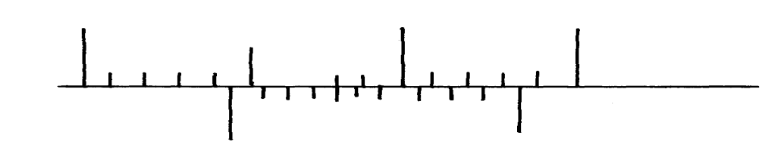

7cm

8cm

0

10

What is the reading indicated on the scale ………………………………………….. **(2mk)**

1. What is the reading on the micrometer screw gauge shown below with an error of +0.5mm? **(3mks)**

Figure 1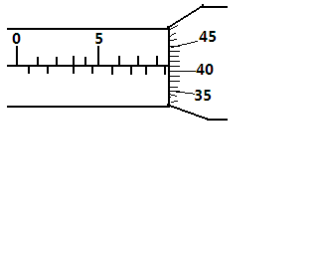

………………………………………………………………………………………………………………………………………………………………………………………………

1. 180cm3 of fresh water of density 100kg/m3 is mixed with 2200cm3 of sea water of density 1025kg/m3. Calculate the density of the mixture **(4mks)**
2. Explain why fish can survive under water when the surface is already frozen **(2mks)**

……………………………………………………………………………………………………..

……………………………………………………………………………………………………..

……………………………………………………………………………………………………..

……………………………………………………………………………………………………..

1. a) The figure below shows a method of magnetization used in making magnets.



i) Name the method. **(1 mark)**

………………………………………………………………………………………………………….

ii) Identify the polarities A and B of the magnet produced. **(2 marks)**

A ……………………………………………………….

B………………………………………………………… ­­­­­­­­

iii) Apart from this method, state any other **three** methods used in magnetization. **(3mark)**

­­­­­­­­……………………………………………………………………………………………………………

b) In demagnetization by electrical method:

i) State the type of current used. **(1 mark)**

………………………………………………………………………………………………………….

ii) Explain your answer in (i) above. **(2 marks)**

……………………………………………………………………………………………………..

……………………………………………………………………………………………………..

……………………………………………………………………………………………………..

……………………………………………………………………………………………………..

1. Explain why when demagnetizing a magnet, the magnet should be held in the East-West direction. **(2 marks**

……………………………………………………………………………………………………..……………………………………………………………………………………………………………………………….

…………………………………………………………………………………………………….……………………………………………………………………………………………………………………………….

1. 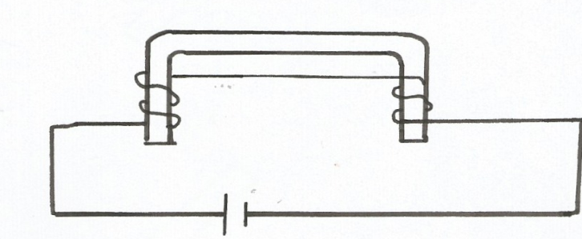Figure 3 shows a coil of insulated wire wound on a horse shoe soft iron core AB and connected to a power supply

**Figure 3**

**A B**

Name the polarity at **A**....................................................................... **(1mk)**

**B** ....................................................................... (**1mk)**

1. State **one** advantage of an alkaline battery over a lead acid battery. **(1mk**)

……………………………………………………………………………………………………..

1. The diagram below shows a permanent magnet suspended by a spring. State with reason the behaviour of the magnet when the switch is closed. (**2mks)**

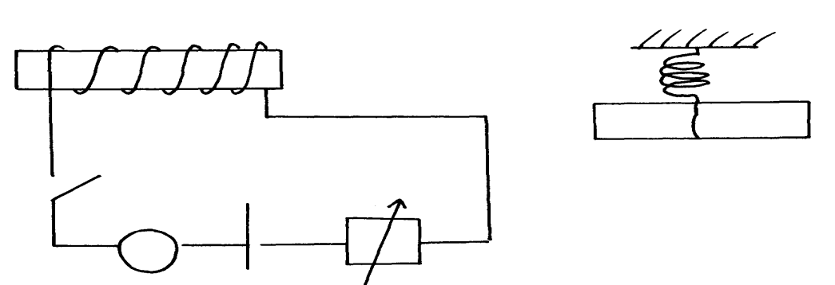

Spring

S

A

Y

N S

X

+ -

……………………………………………………………………………………………………..

……………………………………………………………………………………………………..

1. Convection and diffusion both involve motion of fluids. Distinguish between the two. **(2mks)**

……………………………………………………………………………………………………..

……………………………………………………………………………………………………..

……………………………………………………………………………………………………..

……………………………………………………………………………………………………..

1. A negatively, charged rod is brought close to (but not touching ) an uncharged sphere. If the

sphere is momentarily earthed and then the rod is removed, briefly explain what happens. **(2mks)**

……………………………………………………………………………………………………..

……………………………………………………………………………………………………..

1. Indicate on the diagram below, the level of mercury in the tubes **X** and **Y**  **(2mks)**

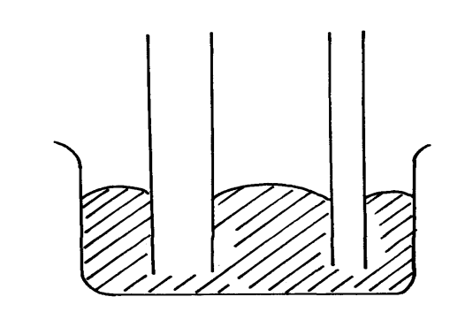

Mercury

X

Y

1. An object weighs 1200N on a certain planet. What is the gravitational field strength of this

planet if the object is 60kg? **(3mks)**

1. State **three**  properties of a thermometric liquid. **(3mks)**

……………………………………………………………………………………………………..

……………………………………………………………………………………………………..

**SECTION B (55MARKS)**

***Answer all question this section***

1. Define **pressure** and give its S.I nits. **(2mks)**

……………………………………………………………………………………………………..

……………………………………………………………………………………………………..

1. The diagram below represents a motor car hydraulic braking system;

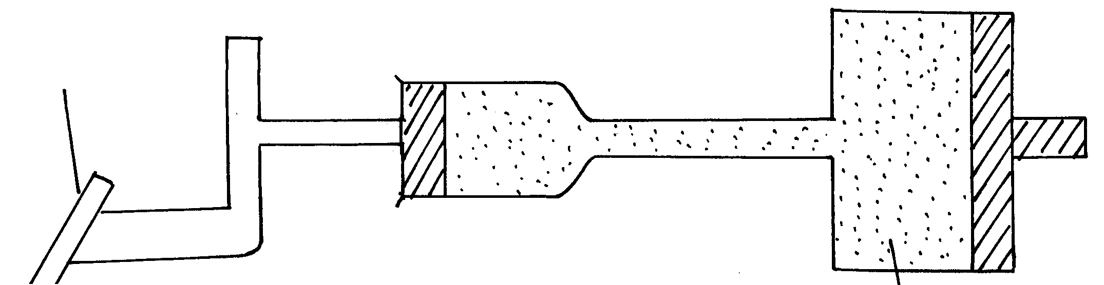

Brake pedal

Master piston

Slave piston brake fluid

**B**

**A**

1. State **two** properties of the liquid used as a brake fluid **(2mks)**

……………………………………………………………………………………………………..

……………………………………………………………………………………………………..

1. Given that in the diagram **(b)** above the master piston has an area of 15cm2 and the slave

piston has an area of 50cm2 a force of 100N is applied on the master piston. Find the force

used to stop the car. **(3mks)**

1. Compare the values of pressure in the two pistons above and give a reason for your

answer. **(2mks)**

……………………………………………………………………………………………………..

……………………………………………………………………………………………………..

1. Give a reason why gas is not suitable for use in place of the brake fluid. **(1mk)**

……………………………………………………………………………………………………..

1. Give reasons why it is necessary to leave the caps of the cells open when charging an accumulator **( 1mk)**

……………………………………………………………………………………………………..……………………………………………………………………………………………...

1. Define current and state its SI unit **( 2mks)**

……………………………………………………………………………………………………………………………………………………………………………………………………..……………………………………………………………………………………………………………………………………………………………………………………………………

1. A charge of 120 coulombs flow through a 1 am every minute. Calculate the current flowing through the lamp. **( 3mks)**
2. What do you understand by open and closed circuits. **( 2mks)**

…………………………………………………………………………………………………..……………………………………………………………………………………………………………………………………………………………………………………………………

C

B

D

A

1. State the polarities of A and B. **(2 mks)**

……………………………………………………………………………………………………..

……………………………………………………………………………………………………..

1. Name the chemical substances in the parts labeled C and D **( 2mks)**

……………………………………………………………………………………………………..

…………………………………………………………………………………………………….

1. The figure shows an arrangement of source of light, an opaque object and a screen. Using A, B and C as point sources, sketch on the same diagram labeled a ray diagram to show what is observed on the screen. (**3mks)**

**A**

**B**

**C**

1. In a certain pinhole camera, the screen is 10cm from the pinhole. When the pinhole is placed 6cm away from a tree, a sharp image of a tree 16cm high is formed on the screen. Find the height of the tree. **( 3mks)**
2. Distinguish between Lunar and Solar eclipse by stating the events that lead to the formation of each **(4mks)**

……………………………………………………………………………………………………..

……………………………………………………………………………………………………..

……………………………………………………………………………………………………..

……………………………………………………………………………………………………..

……………………………………………………………………………………………………..

……………………………………………………………………………………………………..

1. A girl stands 4 m in front of a plane mirror
2. What is the distance between the girl and the mirror **(3mks)**
3. i)State the basic law of electrostatics **(2mks)**

………………………………………………………………..……………………………………………………………………………………………………..………………………………………………………………………………………………………………………………………………………………………………......................................................................................................................................................

ii) Explain how you would use an electroscope to distinguish between a conductor and an insulator **(3mks)**

…………………………………………………………………………………………………..…..……………………………………………………………………………………………………..……………………………………………………………………………………………………..……………………………………………………………………………………………………..……………………………………………………………………………………………………..………………………………………………………………………………………………………………………………………………………………………………...

1. Fill in the table of charges appropriately **( 5mks)**

|  |  |  |
| --- | --- | --- |
| **Charge on Electroscope** | **Charge brought near cap** | **Effects on leaf divergence** |
| +  - | +  - |  |
| + or - | Uncharged body |  |

1. What is the name given to the method of charging an electroscope where it requires an opposite charge to the one of the charging materials? **(1mk)**

……………..……………………………………………………………………………………

……………..……………………………………………………………………………………

1. Distinguish between a basic physical quantity and a derived physical quantity giving an example of each.  **(3mks)**

|  |  |
| --- | --- |
| **Physical quantity** | **Derived physical quantity** |
|  |  |
|  |  |
|  |  |

1. State any **two**  ways by which frictional force between two surfaces can be reduced.  **(2mks)**

………………………………………………………………………………………………..……..………………………………………………………………………………………………

1. Explain why large mercury drops form oral ball on a glass slide **(2mks)**

……………………………………………………………………………………………………..……………………………………………………………………………………………………..……………………………………………………………………………………………………………………………………………………………………………..…………………

…………………………………………………………………………………..………………

1. Explain why a man using a parachute falls through air slowly while a stone falls through air very fast.  **(2mks)**

………………………………………………………..……………………………………………..……………………………………………………………………………………………………..……………………………………………………………………………………………

1. The figure below shows a uniform meter rule balancing when a mass of 200g is hung at one end. Determine the tension T in the string. **(4marks)**

