Name……………………………………………………Adm No………………
Date…………………………………………… Class…….……………………

231/1
BIOLOGY
THEORY
FORM TWO
Time: 2 hours

SUNRISE EXAMINATIONS

INSTRUCTIONS TO CANDIDATES
- Write your name, Admission number, date and sign in the spaces provided above.
- Answer all questions in the spaces provided. Candidates should check the question paper to ascertain that all the pages are printed as indicated and no questions are missing.

FOR EXAMINERS USE ONLY

Question | Maximum score | Candidates score
1 – 24 | 85

- Identify the discipline of biology that deals with the following.
- The relationship between organisms and their environment. (1mk)
………………………………………………………………………………………………
- Study of development of living organisms. (1mk)
………………………………………………………………………………………………
- Study of body functions of living organisms. (1mk)
……………………………………………………………………………………..……….
- Specialization in the study of chemical changes in an organism. (1mk)
……………………………………………………………………….……………………..
- Study of microscopic organisms. (1mk)
……………………………………………………………………..………………………..
- Name the organelles that are in abundance in:-
- White blood cells. (1mk)
……………………………………………..………………………………………………………….
- Skeletal muscles. (1mk)
……………………………………………………………..………………………………………….
- Involved in osmoregulation in amoeba. (1mk)
……………………………………………………………………………….……………………….
- (a) Distinguish between diffusion and active transport. (2mks)
………………………………………………………………………………………………………………………………………………………………………………………………………………………………………………………………………………………………………………….……………
(b) State one role that is played by osmosis in:
i) Plants. (1mk)
………………………………………………………………………………………………….………
ii) Animals
………………………………………………………………………………………………………….

- Classify the following organisms into their kingdoms (4mks)
Organisms Kingdom
a) Maize,Beans …………………………………….………………..
b) Mushrooms,Yeast …………………………………………………..….
c) Protoza, algae ……………………………………………………...
d) Bacteria ……………………………………………………...
- The diagram below shows a specialized cell from a human being.
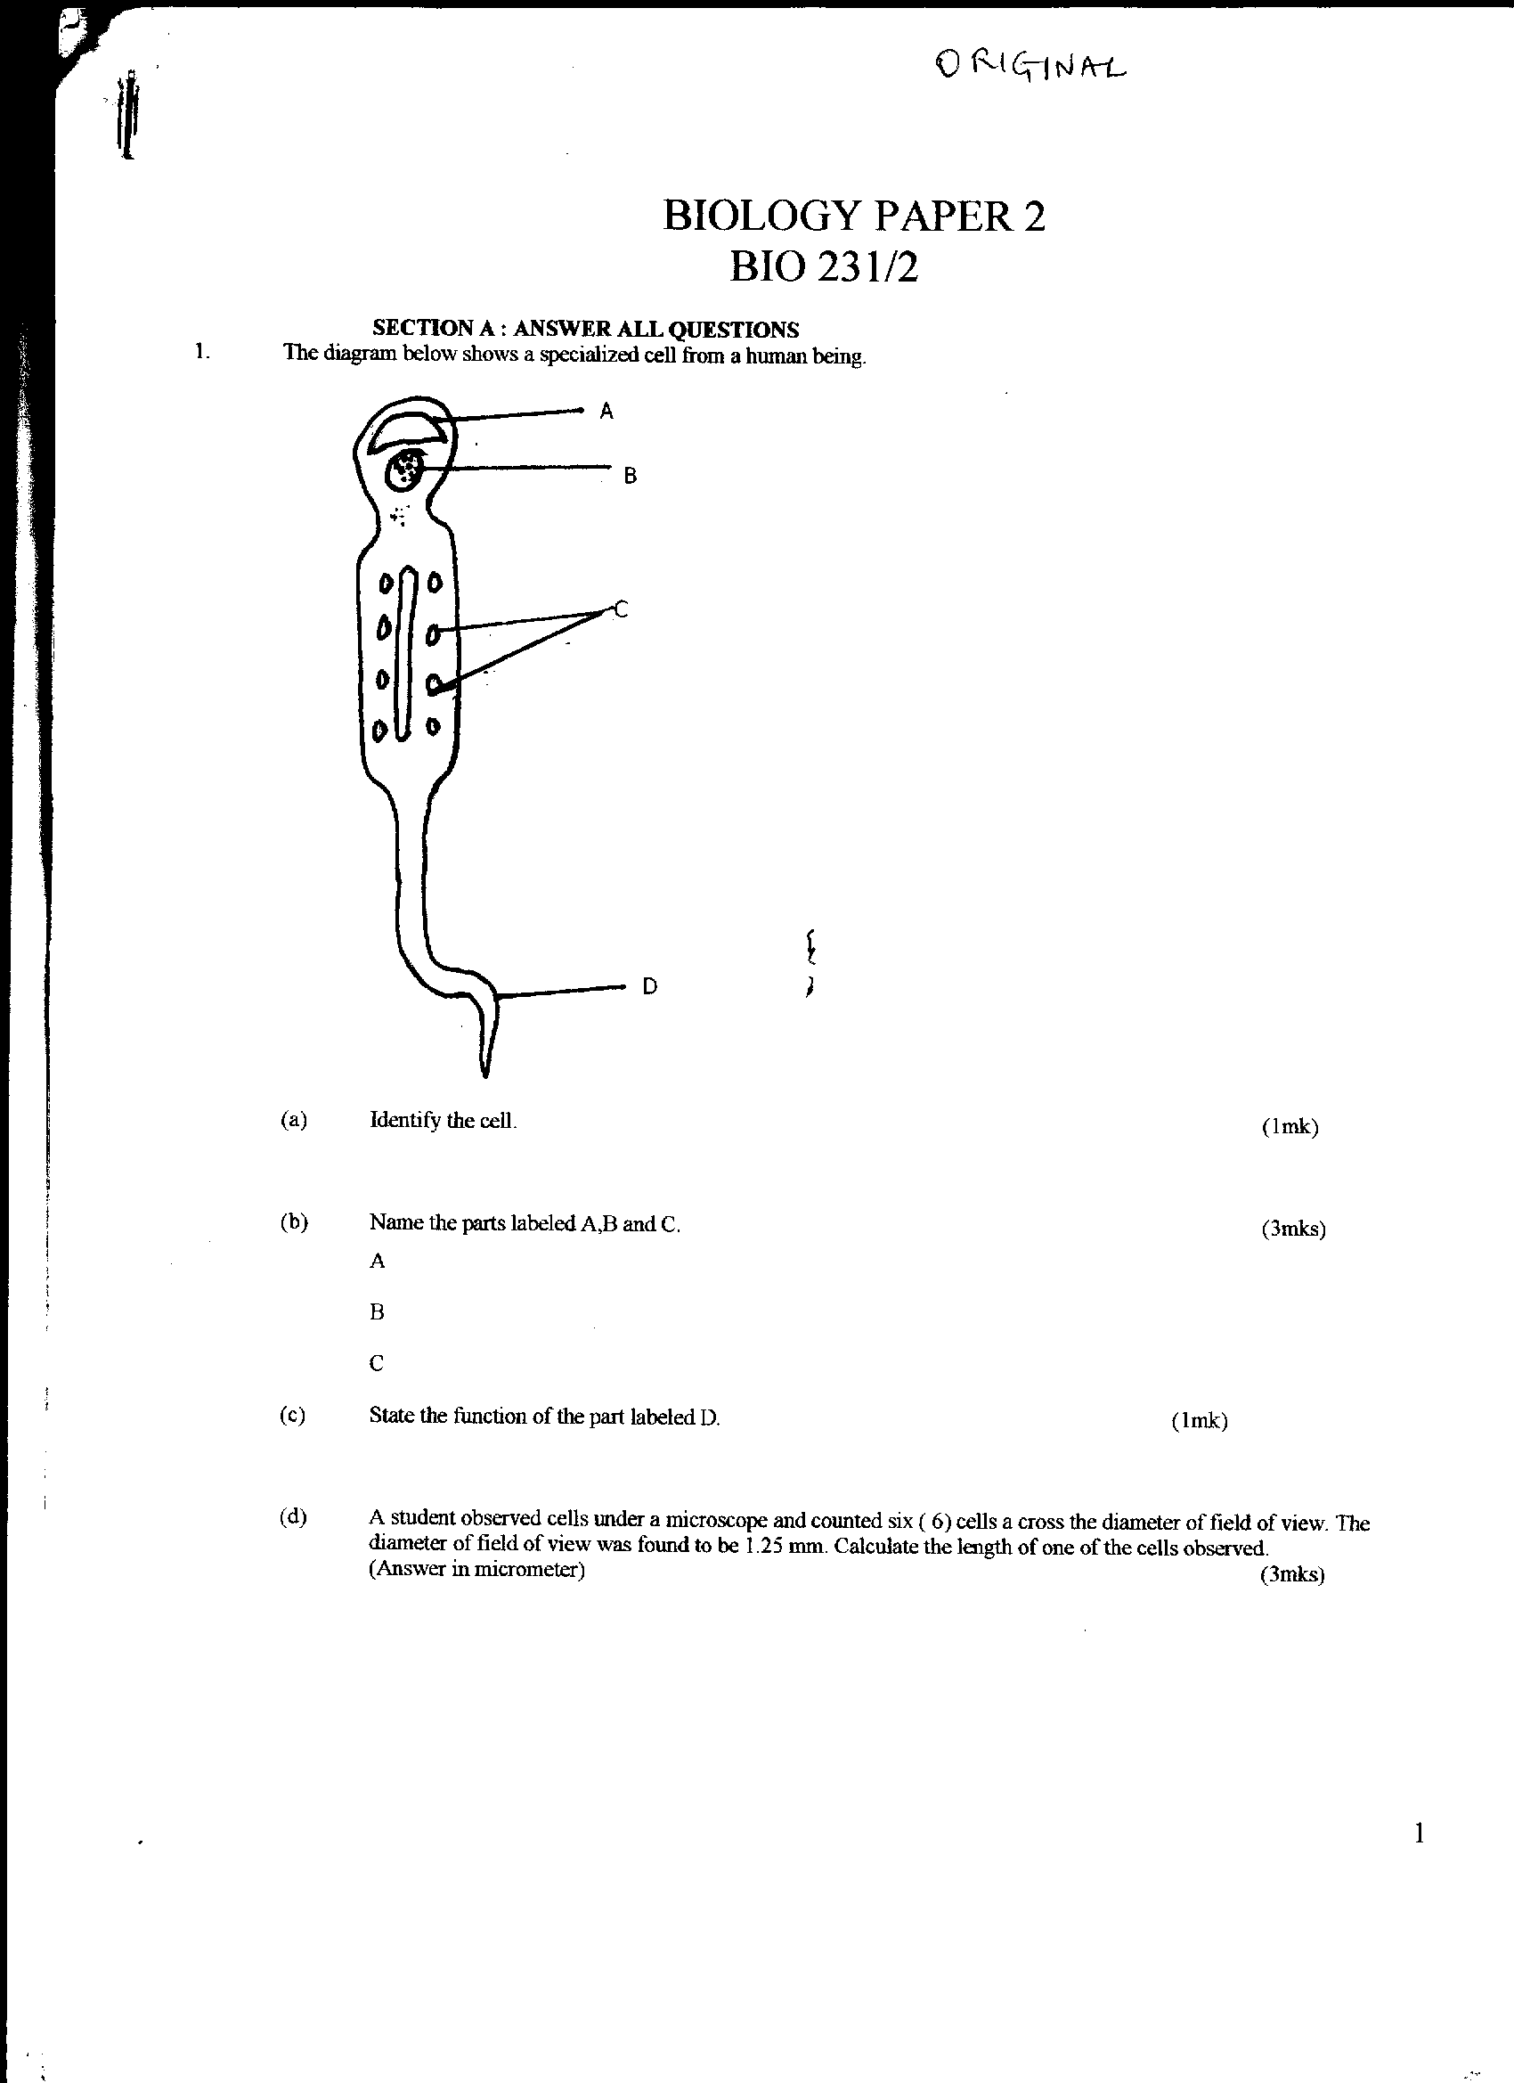
B
A
C

D

i. Identify the cell. (1mrk)
……………………………………………………………………………………………………..
ii. Name the parts labelled A,B, and C. (3mrks)
A:…………………………………………………………………………………………….
B:…………………………………………………………………………………………….
C:…………………………………………………………………………………………….
iii State the functions of the part labeled D. (1mrk)
……………………………………………………………………………………………………………………………………………………………………………………………………………………
- Study the figure below and answer the questions that follow.
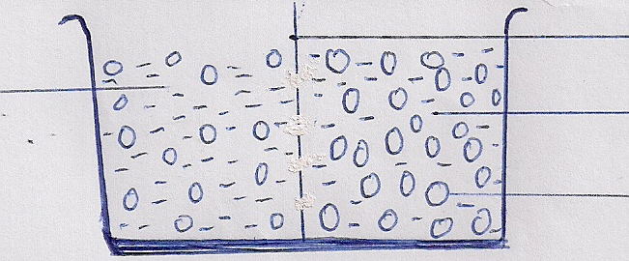
Semipermeable Membrane
Solution A
Solution B
Sugar Molecule
i. What physiological process was being investigated (1mk)
…………………………………………………………………………………..………………………
ii. Which solution has higher concentration of free water molecules? (1mrk)
…………………………………………………………………………………..………………………
iii. Which solution is more concentrated? (1mk)
…………………………………………………………………………………..………………………
iv. In which direction will osmosis take place? Indicate using the arrow. (1mk)
………………………………………………………………………………………………………….
v. What does semi-permeable membrane represent in an animal cell (1mk)
……………………………………………………………………………………….………………….
vi. Name three processes in living organisms that depend on osmosis. (3mks)
………………………………………………………………………………………………………………………………………………………………………………………………………………………………………………………………………………………………………………………………
- The table below shows the concentration of some ions in pond water and in the cells sap of an aquatic plant growing in the pond.
Ions | Concentration in pond water (parts per million) | Concentration in cell sap (parts per million)
Sodium  Potassium  Calcium  Chloride | 50  2  1.5  180 | 30  150  1  200

a) Name the processes by which the following ions could have been taken up by this plant. (2mks)
i) Sodium ions
…………..………………………………………………………………………………………

ii) Potassium ions
…………..………………………………………………………………………………………
b) For each processes named in (a) (i) and (ii) above, state one condition necessary for the process to take place. (2mks)
(i) ……………………………………..…………………………………………………………
(ii) ……………………………………….………………………………………………...……..
- a) What is meant by the term binomial nomenclature? (1mk)
………………………………………………………………………………..………………………..
………………………………………..………………………………………………………………..
b) Give two reasons why classification is important (2mks)
…………………………………………………………………………………………………………
- 16. The diameter field of view of a light microscopic is 3.5mm. Plant cells lying of the diameter are 10. Determine the size of one cell microns (1mm = 1000µm) (2mks)

- Define the following terms in relation to a cell (3mks)
a) Isotonic solution
…………………………………………………………………………………………………………..
b) Hypotonic solution
………………………………………………..…………………………………………………………
c) Hypertonic solution
…………………………………………………………………………………………………..............
- Explain why plant cells do not burst when immersed in distilled water. (1mk)
………………………………………………….……………………….………………………………………………………………………………………………………..…………………………………
- State the role of light in the process of photosynthesis. (2mks)
……………………………………………………………………..………………………………………………………………………………………………………..………………………………………
- Name one product of dark reaction in Photosynthesis (1mk)
…………………………………………………………………………………………………………
- Explain why the following procedures are important when testing a leaf for starch. (3mks)
- Boiling the leaf in the water
……………………………………………………………………………………………………………………………………………………………………………………………………………………
- Boiling the leaf in methylated spirit
……………………………………………………………………………………………………………………………………………………………………………………………………………………
- Dipping the leaf in hot water after boiling it in alcohol or methylated spirit
……………………………………………………………………………………………………………………………………………………………………………………………………………………
- State three importance of nutrition in living organisms. (3mks)
……………………………………………………………………………………………………………………………………………………………………………………………………………………………………………………………………………………………………………………………….
- Differentiate between plants and animals in terms of the following characteristics. (2mks)
- Gaseous exchange
……………………………………………………………………………………………………………………………………………………………………………………………………………………………………………………………………………………………………………………………….

- Nutrition
……………………………………………………………………………………………………………………………………………………………………………………………………………………………………………………………………………………………………………………………….
- Two fresh potato cylinders at equal lengths were placed one in distilled water and the other in concentrated sucrose solution.
- Account for the change of the length of the cylinder in:
- Distilled water (1mk)
……………………………………………………………………………………………………………………………………………………………………………………………………………………………………………………………………………………………………………………………….
- Sucrose solution (1mk)
……………………………………………………………………………………………………………………………………………………………………………………………………………………………………………………………………………………………………………………………….
- (i) What would be the result in term of length if a boiled potato was used? (1mk)
……………………………………………………………………………………………………………………………………………………………………………………………………………………………………………………………………………………………………………………………….
(ii)Explain your answer in (b)(i) above. (1mk)
……………………………………………………………………………………………………………………………………………………………………………………………………………………………………………………………………………………………………………………………….
- The diagram below shows apparatus used in biological study.
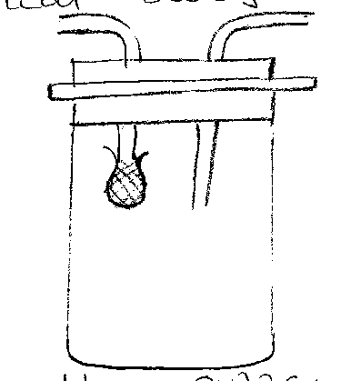

- Name the apparatus. (1mk)
………………………………………………………………………………………………………….
- State its function. (1mk)
………………………………………………………………………………………………………….
- Liver damage leads to impaired digestion of fats. Explain the statement. (1mk)
……………………………………………………………………………………………………………………………………………………………………………………………………………………………………………………………………………………………………………………………….
- In an experiment, a leafy shoot was setup in a photometer and kept in a dark room for two hours. The set up was then transferred to a well lit room for two hours.
- What was the aim of the experiment? (1mk)
……………………………………………………………………………………………………………………………………………………………………………………………………………………………………………………………………………………………………………………………….
- Explain the results which would be expected in each of the two experiment conditions? (3mks)
……………………………………………………………………………………………………………………………………………………………………………………………………………………………………………………………………………………………………………………………….
- Name two structures for gaseous exchange in aquatic plants. (2mks)

……………………………………………………………………………………………………………………………………………………………………………………………………………………………………………………………………………………………………………………………….
- The diagram below represents a model used to demonstrate breathing in mammals.
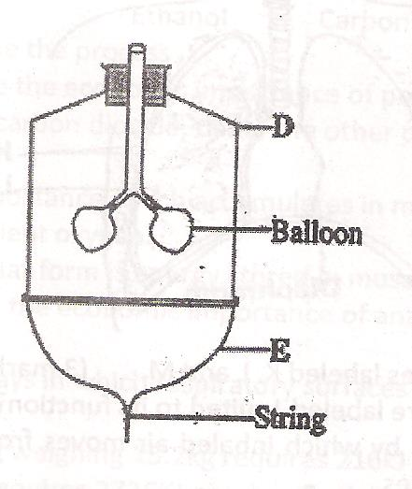
- Name the mammalian structure represented by the parts labelled D and E. (2mks)
……………………………………………………………………………………………………………………………………………………………………………………………………………………………………………………………………………………………………………………………….
- What is the effect of contraction of the part labelled E during breathing in a mammal? (3mks)
……………………………………………………………………………………………………………………………………………………………………………………………………………………………………………………………………………………………………………………………….

- The scientific name of a rat is RATTUS NORVEGICUS.
(i) Write thr name correctly. (1mk)
…………………………………………………………………………………………………………

(ii) Identify the genus and species names. (2mks)
……………………………………………………………………………………………………………………………………………………………………………………………………………………………………………………………………………………………………………………………….

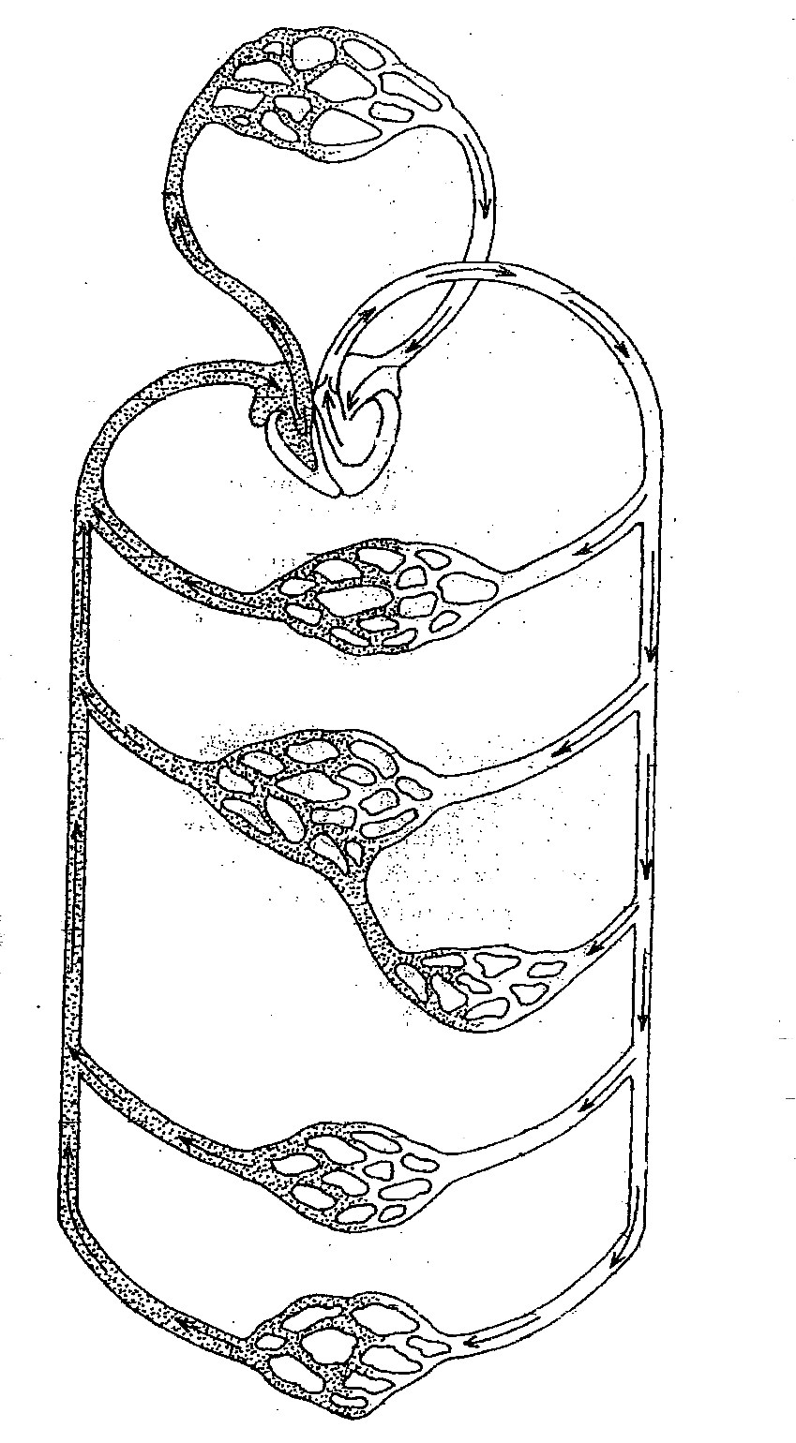
- The diagram below shows circulation of blood in a mammal.
D
C
B
Kidney
A

a) Name the type of circulation represented above (1mk)
……………………………………………………………………………………………………………………………………………………………………………………………………………………

b) Give reason for your answer (1mk)
……………………………………………………………………………………………………………………………………………………………………………………………………………………
c) Name the blood vessel labeled A, B, C ,D (4mks)
…………………………………………………………………………………………………………………………………………………………………………………………………………………………………………………………………………………………………………………………………………………………………………………………………………………………………………
d) Name other two types of blood vessels beside capillaries (2mks)
………………………………………………………………………………………………………………………………………………………………………………………………………………………………………………………………………………………………………………………………
e) State two roles of the red blood cells (2mks)
………………………………………………………………………………………………………………………………………………………………………………………………………………………………………………………………………………………………………………………………
f) Name the three types of immunity (3mks)
………………………………………………………………………………………………………………………………………………………………………………………………………………………………………………………………………………………………………………………………

