

**MARKING SCHEME**

***Kenya Certificate of Secondary Education (K.C.S.E)***

**Paper 3(232/3)**

**(Practical)**

**232/3**

**PHYSICS**

**Paper 3**

**Time 21/2 HOURS**

**INSTRUCTIONS TO CANDIDATES**

1. Write your **name, index number, class, date** and **signature** in the spaces provided above.

2. This paper consists of two questions **1** and **2.**

3. Answer all questions in the spaces provided.

4. Non-programmable calculators and mathematical tables may be used.

5. Show all your workings.

|  |  |  |  |  |  |  |  |
| --- | --- | --- | --- | --- | --- | --- | --- |
| **QUESTION 1** | **c** | **g** | **h** | **i** | **j** | **k** | **l** |
| **Maximum score** | **1** | **8** | **5** | **2** | **1** | **2** | **1** |
| **Candidates score** |  |  |  |  |  |  |  |

|  |  |  |  |  |  |  |
| --- | --- | --- | --- | --- | --- | --- |
| **QUESTION 2** | **c** | **d** | **e** | **k** | **l** | **GRAND TOTAL** |
| **Maximum score** | **6** | **3** | **7** | **2** | **2** |  |
| **Candidates score** |  |  |  |  |  |

***This paper consists of 7 printed pages.***

***Candidates should check the question paper to ensure that all***

***pages are printed as indicated and no questions are missing***

**QUESTION ONE**

You are provided with the following

**2** new dry cell size **D**

A cell holder

A switch

A milliameter of range **0** – **1mA**

A capacitor labelled **C**

**8** connecting wires at least four with crocodile clips on one end

A stop watch

A carbon resistor labelled **R**

Proceed as follows

a) Connecting the circuit as shown in the **figure 1** below, where **P** and **Q** are crocodile clips

**R**

**C**

**S**

**Figure 1**

b) Close the switch **S**

c) Record the highest reading of the milliammeter **Io** and then open the switch.

**Io** = ***0.64 mA*** **± 0.05mA** (1mark)

d) Use **Io** above to calculate **4/5Io, 3/4Io**, **2/3Io**, **1/2Io**, **2/5Io**, **1/3Io** and **1/4Io.** Record in the **table 1** below.

e) Close switch **S** for a second time and observe the deflection in the milliammeter (*the pointer should rise back to the same initial value Io*.)

f) Open switch **S** and at the same time start the stop watch to measure the time taken for the current to decrease to four fifth the value of **Io**. i.e. **4/5Io**. Record your value in the **table 1** below.

g) Repeat steps **e** and **f** for other values of current as shown on the **table 1** below

|  |  |  |  |  |  |  |  |  |
| --- | --- | --- | --- | --- | --- | --- | --- | --- |
| Current **I** (**mA**) | **Io** | **4/5Io** | **3/4Io** | **2/3Io** | **1/2Io** | **2/5Io** | **1/3Io** | **1/4Io** |
| Your calculated fraction of **Io** (**mA**) | ***0.64*** | ***0.51*** | ***0.48*** | ***0.43*** | ***0.32*** | ***0.26*** | ***0.21*** | ***0.16*** | *Each 1/2  mk (use student value of Io)*  *(***Max 4mks)** |
| Time **t** (**s**) | ***0.00*** | ***2.57*** | ***3.34*** | ***4.72*** | ***7.87*** | ***10.09*** | ***12.55*** | ***15.88*** | *± 1.00 sec*  *Each 1/2  mk (2d.p must)* **(Max 4mks)** |

(8marks) **Table 1**

h) Plot a graph of current **I** (y-axis) (**mA**) against time **t** (**s**) (5marks)

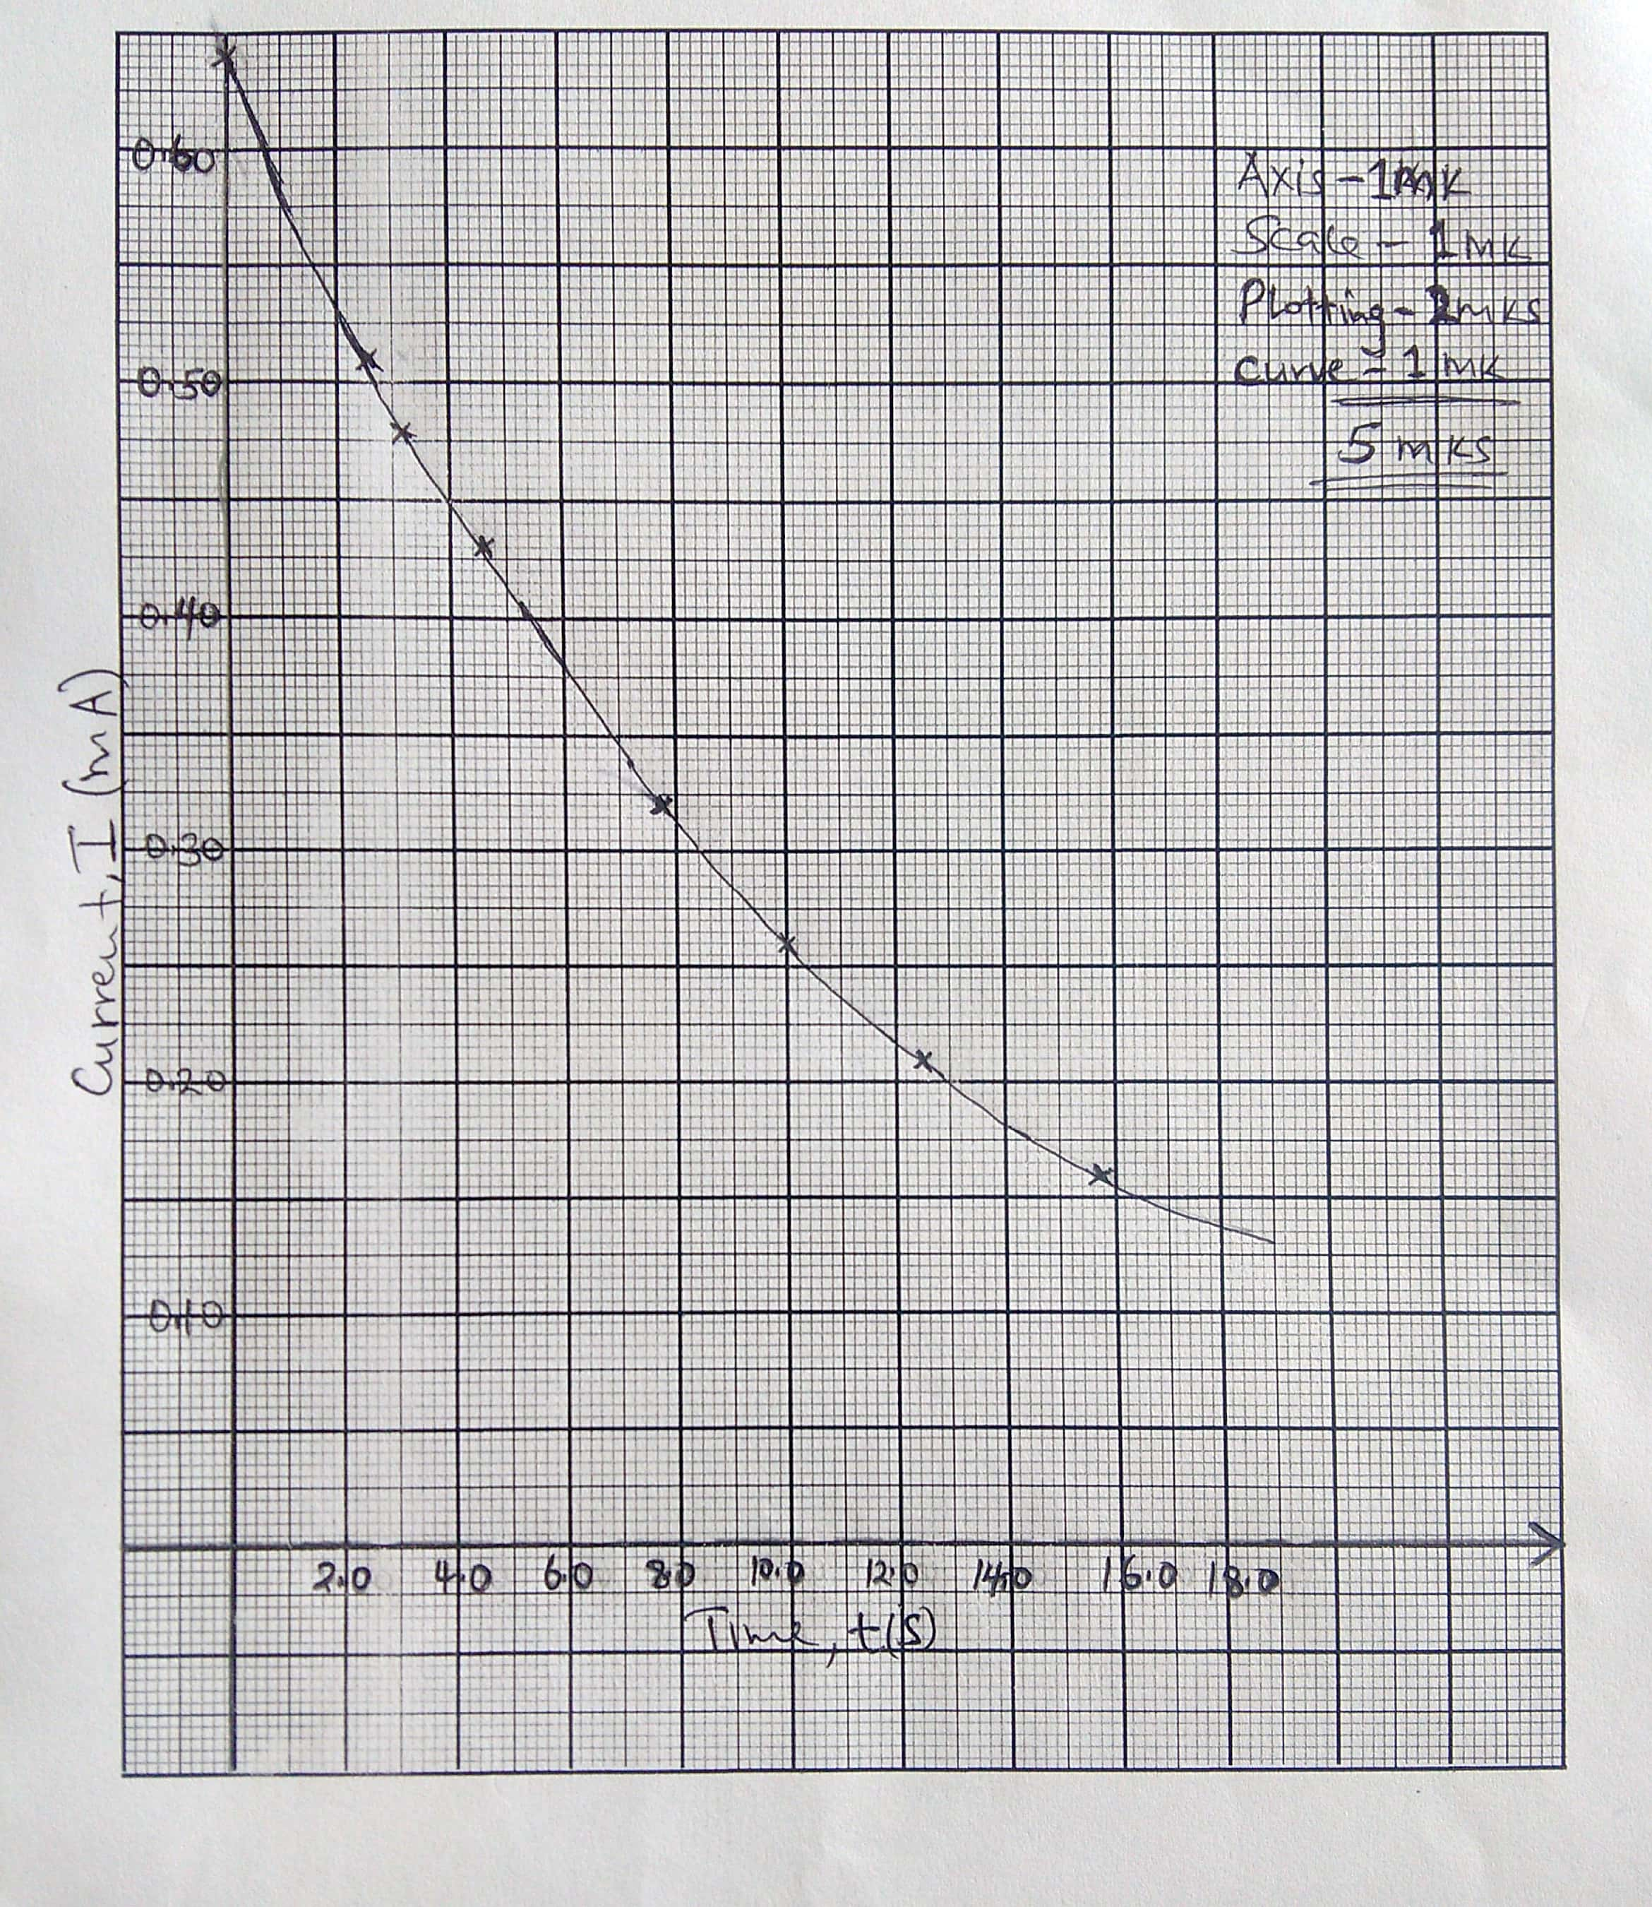

i) From your graph, find **W** the value of **I** when **t** = **7.00s** in **SI** units.(2marks)



j) Given that **A** = **10W**,determine the value of **A**. (1mark)



k) Determine the voltage across **R** at **t** = **7.00s** given that **R** = **4.7 KΩ** (2marks)



l) State the quantity represented by the area under the graph (1mark)

***Quantity of charge in the capacitor;***

**QUESTION TWO**

**PART A**

You are provided with the following

A convex lens

A lens holder

A candle

A white screen

A screen with cross wire

A meter rule

a) Set up the apparatus as shown in the **figure 2** below

Meter rule

Mirror holder

White screen

Convex lens

Candle

V

U

**Figure 2**

Cross wire

b) Starting with **U** = **22.5cm**, adjust the position of the screen to obtain a sharp image of the cross wire being illuminated by the candle. Record the value of **V** in the **table 2** below.

c) Repeat the procedure in (b) for **U** = **35.0cm** and **40.0cm**. complete the **table 2**

|  |  |  |  |
| --- | --- | --- | --- |
| **U (cm)** | **V (cm)** |  |  |
| **22.5** |  |  | **10.0** |
| **35.0** |  |  | **10.0** |
| **40.0** |  |  | **9.811** |
| *Each 1mk (1d.p must)* **(Max 3mks)** | *Each 1/2 mk*  *(***Max 11/2mks)** | *Each 1/2 mk*  *(***Max 11/2mks)** |

(6marks) **Table 2**

d) Determine the average value of **f** the focal length of the lens (3marks)



**PART B**

You are provided with the following:

A meter rule

A half meter rule

One stand, one clamp and one boss

Lump of Plasticine

A stop watch

Two pieces of thread

Proceed as follows

e) Suspend the half meter rule by the threads such that the distance between the meter rule and the half meter rule is **30cm** as shown in the **figure 3** below.

Threads

Plasticine

Meter rule

Stand

Clamp

Half meter rule

**Figure 3**

Direction of oscillation

30cm

X

X

f) Stick the plasticine at the center of the half meter rule. See the **figure 3** above. This plasticine should remain there throughout the experiment.

g) Set the distance between the threads **X** = **6cm** and ensure that the half meter rule lies horizontally.

h) Displace the rule slightly as shown in the **figure 3** above so that it performs oscillations in a horizontal plane about a vertical axis.

i) Measure and record in the table provide the time, **t**, for **10** oscillations. Determine the period **T**.

j) Repeat (b), (c), and (d) above for other values of **X** shown on the table. Complete the table.

|  |  |  |  |
| --- | --- | --- | --- |
| **X (cm)** | **6.0** | **8.0** | **10.0** |
| **X (m)** | **0.060** | **0.080** | **0.100** | *All correct 1mk* |
| **Time t, for 10 oscillations** | **37.75 ± 2.00** | **27.68 ± 2.00** | **22.38 ± 2.00** | *Each 1mk (2d.p must)* **(Max 3mks)** |
| **Periodic time T (s)** | **3.775** | **2.768** | **2.238** | *All correct 1mk* |
| **T2 (s2)** | **14.25** | **7.662** | **5.009** | *All correct 1mk (4d.p)* |
|  | **237.5** | **95.775** | **50.09** | *All correct 1mk (4d.p)* |

(7marks) **Table 3**

k) Find the average value of **S** (2marks)



l) Given that average value determine the value of constant **C**. (2marks)

