SCHOOL BASED FORM 4 EXAMINATION OCTOBER 2018
232/2 PHYSICS Paper 2 Marking Scheme

1. New object distance = 5 – 2 = 3cm
Distance between tip and its image = 3 + 3
= 6cm
2. a) Like poles repel, unlike poles attract.
b) Pole X is South pole

3. Convex mirror gives a wider field of view of the rear (behind) compared to plane mirror.

4. a) Period, T = 8.0 x 10⁻⁴S
Frequency =
= 1250
= 1.25 x 10³ Hz
b)

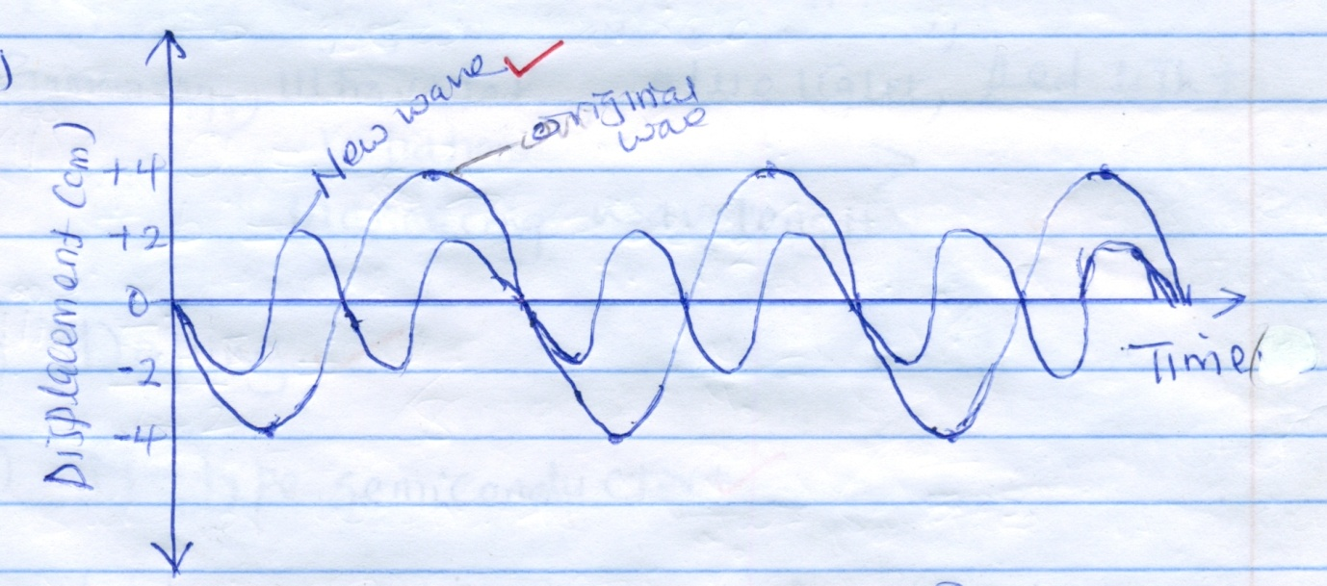

5. a) Primary cells cannot be recharged after use while secondary cells can be recharged after use.
b) Polarization is reduced by adding a depolarizer
or
Adding Manganses (VI) oxide

6.
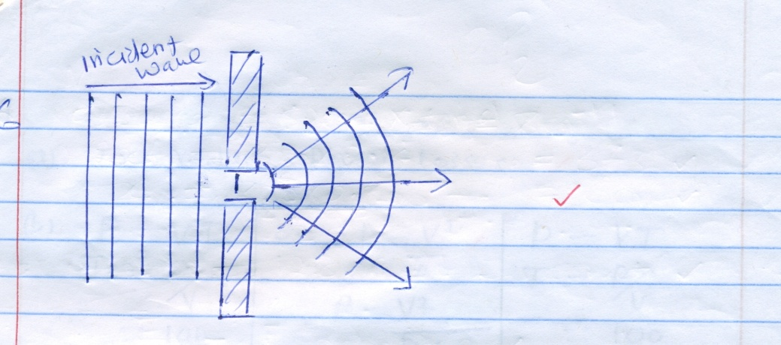

7. 2 Distance = Speed x time (2d = vt)
2x = 320 x 0.8
x = 320 x 0.8
2
x = 128m

8. Gamma rays, Ultra violet, Blue light, Red light
Radiation
Increasing wavelength

9. a) Doping

b) N – Type semiconductor

10. a)
N
S
N
S

Conductor

Force

b) Reduce the amount of current.
or
Reduce magnetic field strength.

11. a) To reduce power losses
b) $P=VI$
I = $\frac{P}{V}$
= $\frac{100}{20}$
= 5A

R = $\frac{V}{I}$
= $\frac{20}{5}$
= 4Ω
Or
P = $\frac{V2^{}}{R}$
= $\frac{V^{2}}{P}$
= $\frac{{20}^{2}}{100}$
= $\frac{400}{100}$
= 4Ω

I = $\frac{V}{I}$
= $\frac{20}{5}$
= 4Ω

Or
$P=VI$
I = $\frac{P}{V}$
= $\frac{100}{20}$
= 5A
P =$I^{2}R$
R = $\frac{P}{I^{2}}$
R = $\frac{100}{25}$
= 4Ω

12. a) The current flowing through a conductor is directly proportional to the potential difference
across the conductor provided Temperature and other physical conditions are kept constant.
b) Effective Resistance = $\frac{3 x 6}{3+6}$

= $\frac{18}{9}$
= 2Ω
V = IR
I = $\frac{V}{R}$ = $\frac{5}{2}$ = 2.5A

SECTION B (55 MARKS)
13. a) The direction of induced current is such as to oppose the change causing it.
b) i) Deflects to the right handside Because by Lenz’s law, end A of the solenoid produces a
South pole and there current is flowing in direction X to Z.
ii) - Decreasing the strength of the magnet
- Decreasing the number of turns in the solenoid.
- Decreasing the speed at which the solenoid moves.
Any
c) The core is made up of thin sheets of insulated soft iron plate (ie. Core is laminated) instead
of using a block of iron core
d) i) The galvanometer deflects in one direction and goes back to zero when switch is closed.
When the switch is open the galvanometer deflects in the opposite direction then to zero.
ii) The deflection would be smaller.
e) i) Step down transformer. Because the number of turns in the primary coils are more than the
number of turns in secondary coils.
ii) $\frac{N_{S}}{N_{P}}= \frac{V_{S}}{V_{P}}$ V_{S} = $\frac{50 x 120}{\begin{aligned}250 \\ \end{aligned}}$
$\frac{50}{250}= \frac{V_{S}}{120}$ = 24V
iii) Power in primary =V_{P}I_{P}
= 120 x 0.5
= 60W
Power in secondary = V_{S} x I_{S}
= 24 x 2
= 48V
Efficiency = $\frac{Power out }{Power inpout} x 100\%$
= $\frac{28 }{60} x 100\%$
= 80%

14. a) Like charges repel, unlike charges attract.
b) As the rod approaches the cap, the positive charges initially attracts the negative charges on the
leaf and plate before the leaf falls. As the rod is brought nearer, net positive charges are
induced on the leaf and plate, where they repel each other making the leaf rise again.
c) The milliameter record current as the capacitor is charging. When the capacitor is fully
charged, it offers an equal P.d in the opposite direction therefore no current flows.
d) i) 2 + 10
= 12μF

C_{T} = $\frac{3 x 12}{\begin{aligned}3+12 \\ \end{aligned}}$
= $\frac{36}{\begin{aligned}15 \\ \end{aligned}}$
= 2.4μF
ii) Q = CV
= 2.4 x 240
= 576 μC
= 5.76 x 10⁻⁴ C
iii) V = $\frac{Q}{\begin{aligned}C \\ \end{aligned}}$
= $\frac{576C}{\begin{aligned}12 F \\ \end{aligned}}$
= 48V
15. a) -The ray of light must be travelling from an optically denser medium to an optically rarer
medium.
- The angle of incidence must be greater than the critical angle. Any

b)

Normal
C

Refracted ray
c) η = $\frac{Real depth}{Apparent depth}$
Height = Real depth = n x Apparent depth
= 1.48 x 11.4
= 16.872cm

d) i) – The mirror absorbs some incident light while the prism does not.
- The mirror silvering peels off but this does not happen in prism.
- The mirror is thick and produces multiple images unlike prism.
Any
ii)

Object

Image
Eye

e) i) – Object distances, u, using a metre rule.
- A image distance, V, using a metre rule. any
ii) Extrapolate the graph to cut either $\frac{1}{V} or \frac{1}{u}$ axis or both.
At $\frac{1}{V}$intercept, $\frac{1}{u}$ = 0
- .: $\frac{1}{f}$ = $\frac{1}{V}$ , $\frac{1}{f}$ = value of $\frac{1}{V}$ intercet
f = $\frac{1}{Value of \frac{1}{V} intercest}$ = $\frac{1}{0.25}$
or f = 4cm
At $\frac{1}{u}$ intercept, $\frac{1}{V}$ = 0
.: $\frac{1}{u}$= $\frac{1}{f}$ f = $\frac{1}{0.25}$ = 4cm
f) i) – Too short eyeball
- Lens with too long focal length
ii) By wearing converging lens spectacles.

16. a) I – Copper is a good conductor of heat and therefore conducts heat produced.
II – To accelerate electrons from the cathode to the anode.
or
To give electrons sufficient kinetic energy.
ii) Decrease the amount of heating current in the filament.
iii) X-ray penetrate more in less dense material and penetrate less in denser materials.
b i) The emission of electrons from a metal surface when the metal surface is irradiated with
electromagnetic radiation.

b) I E = hf
= 6.63 x 10⁻³⁴ x 6.25 x 10¹⁴
= 4.14373 x 10⁻¹⁹ J
II Wo = Hfo
= 6.63 x 10⁻³⁴ x 5.5 x 10⁻¹⁴
= 3.6465 x 10⁻¹⁹ J
III – KE = hf - Wo
= (4.14375 – 3.6465) x 10⁻¹⁹
= 0.49725 x 10⁻¹⁹
= 4.972 x 10⁻²⁰ J

17. i) E – Filament
F – Y – Plate

ii) Thermionic emission

b) i) Alpha particles have higher charge (+2)
Compared to Beta particles (-1)
- Alpha particles are heavier compared to Beta particles.
Any
ii) a = 234
b = 84 – 2 = 82

iii) $\frac{5.25}{42}= \frac{1}{8}$

