NAME: ………………………………………………………………….…........ INDEX NO. …….……………..........................

CANDIDATE’S SIGNATURE: …………………………………............... DATE: ……………………..............……………

SCHOOL: ………………………………………………………..….…………………..…………………...........……………………

**121/2**

**MATHEMATICS (ALT A)**

**PAPER 2**

**JULY/AUGUST EXAM**

**2 ½ HOURS**

**JULY/AUGUST EXAM**

**FORM FOUR EVALUATION TEST**

**MATHEMATICS PAPER 2**

**2 ½ Hours**

**INSTRUCTIONS TO CANDIDATES**

1. *Write your Name and Index Number in the spaces provided at the top of this page.*
2. *Sign and write the date of examination in the spaces provided above.*
3. *This paper contains TWO sections: section I and section II*
4. *Answer all the questions in Section I and strictly any FIVE questions in section II.*
5. *All answers and working must be written on the question paper in the spaces provided below each question.*
6. *Show all the steps in your calculations, giving your answers at each stage in the spaces below each question.*
7. *Marks may be given for correct working even if the answer is wrong.*
8. *Non-programmable silent electronic calculators and KNEC mathematical tables may be used except where stated otherwise.*

**FOR EXAMINER’S USE ONLY:**

***Section I***

|  |  |  |  |  |  |  |  |  |  |  |  |  |  |  |  |  |
| --- | --- | --- | --- | --- | --- | --- | --- | --- | --- | --- | --- | --- | --- | --- | --- | --- |
| 1 | 2 | 3 | 4 | 5 | 6 | 7 | 8 | 9 | 10 | 11 | 12 | 13 | 14 | 15 | 16 | **TOTAL** |
|  |  |  |  |  |  |  |  |  |  |  |  |  |  |  |  |  |

***Section II*** ***Grand total***

|  |  |  |  |  |  |  |  |  |  |
| --- | --- | --- | --- | --- | --- | --- | --- | --- | --- |
| 17 | 18 | 19 | 20 | 21 | 22 | 23 | 24 |  |  |
|  |  |  |  |  |  |  |  |  |  |

**SECTION 1: (50 MARKS)**

***Answer ALL the Questions in this section in the spaces provided.***

1. Evaluate using logarithms. (4 marks)



1. Given the expression 9.7 ÷ 3.7, find to four significant figures the percentage error in its quotient. (3 marks)
2. Solve for Ө given that 2sinӨ = tan Ө for 00 ≤ Ө ≤ 3600. (3 marks)

1. Simplify, leaving the answer in the form a + b, where a, b and c are rational number (3 marks)
2. (i) Find the inverse of the matrix (2 marks)

(ii) Hence solve the simultaneous equations (2 marks)



1. The cost of maize flour and millet flour is Kshs 44 and Kshs 56 respectively. Calculate the ratio in which they were mixed if a profit of 20% was made by selling the mixture at Kshs. 54. (3marks)
2. The equation of a circle is given by 4x2 + 4y2 +12x – 16y -11 = 0. Determine the radius and the co-ordinates of the centre of the circle. (3 marks)
3. Solve the following linear inequalities and list the integral values of x. (3 marks)
$$\frac{1}{3}x+7≥-2x$$

$$0.5x+4>1.5x$$

4. The cash price of a music system is kshs. 30,000. It can be bought under hire purchase terms by paying a deposit of kshs. 10,000 and twelve monthly installments of Kshs. 3,200 per month. Determine the percentage rate of interest per month. (3 marks)
5. Evaluate $\int_{0}^{1}{\left(3x^{2}-6x+3\right)dx}$ (3 marks)
6. Make h the subject of the formula  (3 marks)
7. Solve for x in. (3 marks)
8. The average of the first and fourth terms of a GP is 185. Given that the first term is 27, find the common ratio. (3 marks)
9. The equation 3x2 – 8px + 12 = 0 has real roots. Find the value of P. (3 marks)
10. (a) Expand ${(2-x)}^{7}$ up to the fifth term. (2 marks)

(b) Use your expansion in (a) above to evaluate ${(1.98)}^{7}$ to four significant figures. (2 marks)

1. In the figure below O is the centre of the circle diameter AB. <AXP = 900, AX = 4cm and PX = 10cm. Calculate the radius of the semi-circle. (3 marks)

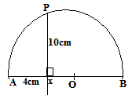

**SECTION II (50 MARKS)**

***(Answer any five questions in this section)***

1. The table below shows the distribution of ages in years of 50 adults who attended a clinic:-

|  |  |  |  |  |  |  |
| --- | --- | --- | --- | --- | --- | --- |
| Age | 21-30 | 31-40 | 41-50 | 51-60 | 61-70 | 71-80 |
| Frequency | 15 | 11 | 17 | 4 | 2 | 1 |

1. State the median class (1 mark)
2. Using a working mean of 45.5, calculate

(i) The mean age (3 marks)

(ii) The standard deviation (3 marks)

(iii) Calculate the 6th decile. (3 marks)

1. (a) Complete the table given below by filling the blank spaces. (2 marks)

|  |  |  |  |  |  |  |  |  |  |  |  |  |  |
| --- | --- | --- | --- | --- | --- | --- | --- | --- | --- | --- | --- | --- | --- |
| X | 0o | 15o | 30o | 45o | 60o | 75o | 90o | 105o | 120o | 135o | 150o | 165o | 180o |
| 2sin(2x+30)o | 1.00 | 1.73 | 2.00 | 1.73 |  | 0 | -1.00 | -1.73 |  |  |  | 0 | 1.00 |
| 4cos2x | 4.00 |  | 2.00 | 0 | -2.00 |  | -4.00 | -3.46 |  | 0 | 2.00 |  | 4.00 |

(b) On the grid provided draw on the same axes, the graph of and  for. On x- axis, 1cm rep 150 and y- axis 1cm rep 1 unit (5 marks)

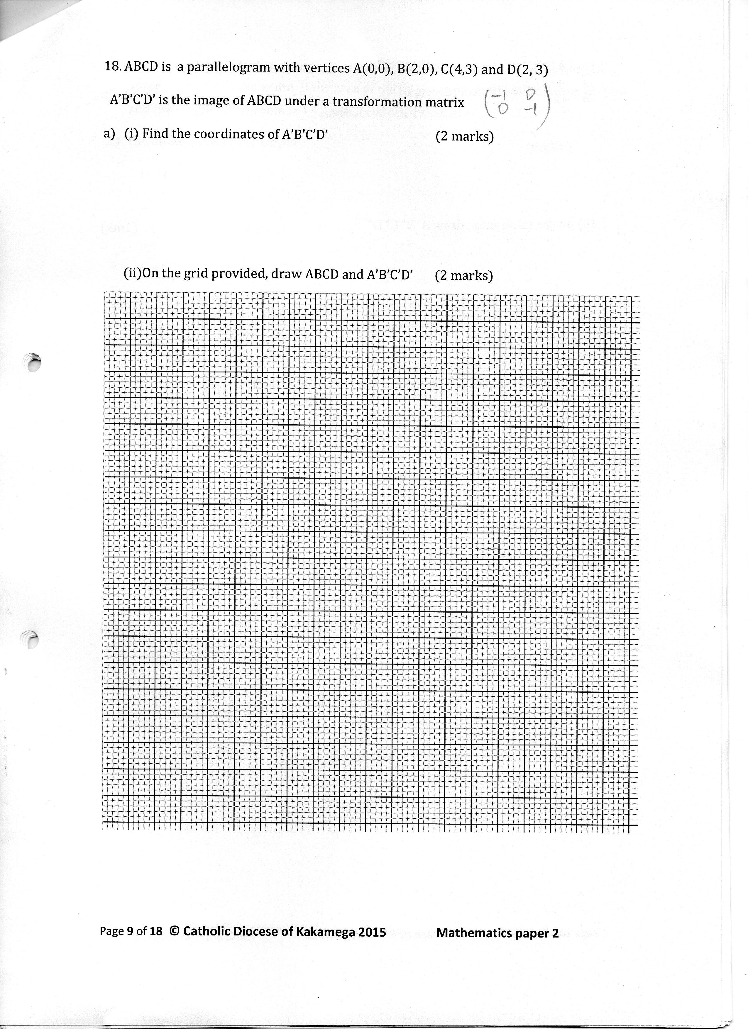

(c) From your graph(i) State the amplitude of  (1 mark)

(ii) Find the period of  (1 marks)

iii) Use your graph to solve  (1 mark)

1. OPQ is a triangle in which  X is a point on OP such that OP: XP = 3: 2 and Y is another point on PQ such that PY: YQ = 1: 2. Lines OY and XQ intersect at T.
2. Express the following vectors in terms of 

~

~

(i) PQ (1 mark)

~

(ii) OY (1 mark)

~

(iii) QX (1 mark)

~

1. If OT = k OY and QT = h QX express OT in two different ways. Hence or otherwise find the values of h and k. (6 marks)

~

~

~

~

~

1. Determine the ratio OT: TY. (1 mark)
2. Using a ruler and a pair of compass only;
3. Construct a triangle PQR such that PR=7.5cm, PQ=3.0cm and <QPR=60° (3 marks)
4. Construct the locus T of points which are equidistant from a point L and passes through the vertices P, Q and R. (2 marks)
5. Locate the locus S on T such that it is equidistant from sides PQ and QR of the triangle (2 marks)
6. Locate the locus of points G enclosed by PQ and QS such that QG <2cm. (2marks)
7. Measure SL. (1 mark)
8. The figure shows a right pyramid mounted onto a rectangular block. The length AB=8cm, BC = 6cm, CH = 3cm and VC = 15cm

B

V

H

G

F

E

D

C

A

Given that M is the centre of the plane ABCD and P is a point on MV such that MP = $\frac{1}{5}$ MV, Calculate:-

1. The length of EG. (1 mark)
2. The height MV of the pyramidal section to 2 decimal places. (2 marks)
3. The angle between the plane BPC and the pyramidal base ABCD. (3 marks)
4. The angle between the line GV and the plane EFGH. (2 marks)
5. The volume of the solid to four significant figures. (2 marks)
6. Triangle ABC is such that A(-5, 1), B(-1, 1) and C(-3, 4). Triangle A′B′C′.is the image of ∆ABC under transformation $T=\left(\begin{matrix}0 & 1 \\ -1 & 0\end{matrix}\right)$
7. Determine the co-ordinates of ∆ A′B′C′. (2 marks)
8. On the grid provided draw ∆ABC and ∆ A′B′C′. (2 marks)
9. Describe the transformation T fully. (1 mark)
10. ∆ A′′B′′C′′ is a reflection of the ∆ A′B′C′ on the line y = -x. Construct ∆ A′′B′′C′′. State the co-ordinates (3 marks)
11. Determine a single matrix that maps ∆ A′′B′′C′′ onto ∆ABC. (2 marks)
12. Every evening before the end of preps, Kulecho either reads a novel or solves a mathematical problem. The probability that he reads a novel is $\frac{4}{5}$. If she read a novel, there is a probability of $\frac{3}{4}$ that he will fall asleep. If he solves a mathematical problem, there is a probability of $\frac{1}{4}$ that he will fall asleep. Sometimes the teacher on duty enters Kulecho’s classroom. When Kulecho is asked whether he had been asleep, there is a probability of only $\frac{1}{5}$ that he will admit that he had been asleep and a probability of $\frac{3}{5}$ that he will claim to have been asleep when he had not been asleep.
13. Draw a tree diagram to represent this information. (2 marks)
14. Use the tree diagram to find the probability that;
15. He sleeps and admits (2 marks)

1. He sleeps and does not admit (2 marks)
2. He does not sleep and says that she has not been asleep (2 marks)
3. He does not sleep but claims that she had been asleep (2 marks)
4. The diagram below, not drawn to scale shows part of the curve and the line y = 8-2x. The line intersects the curve at points C and D. Lines AC and BD are parallel to the y-axis.

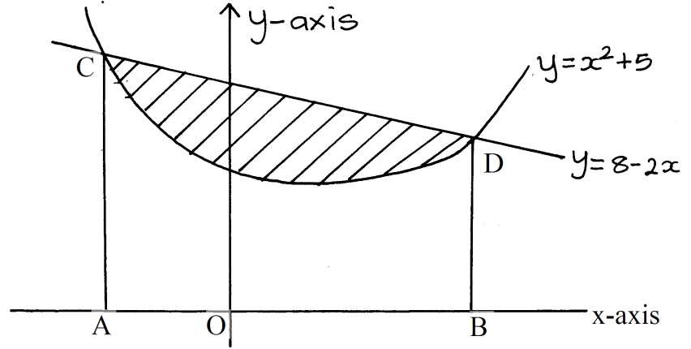

(a) Determine the coordinates of C and D. (4 marks)

(b) Use integration to calculate the area bounded by the curve and the x-axis between the points C and D. (3 marks)

(c) Calculate the area enclosed by the lines CD, CA, BD and the x-axis. (2 marks)

d) Calculate the area of the shaded region. (1 mark)