451/2
COMPUTER STUDIES
PAPER 2

MARKING SCHEME.

EXPENSES 1 = 1mk ( for printing

KIBOS HOLDINGS COMPANY LIMITED
P.O BOX 23625 BOMET.

 |  | First Quarter Second Quarter
 | January | February | March | April | May | June
Production | 15642 | 14687 | 18741 | 19457 | 15412 | 15441
Transportation | 1564 | 1469 | 1874 | 1946 | 1541 | 1544
Warehousing | 1125 | 1056 | 1347 | 1398 | 1107 | 1109
Promotion | 2564 | 2407 | 3071 | 3188 | 2525 | 2530
Salary | 4525 | 4248 | 5420 | 5626 | 4456 | 4465

Bold + centered + underlined each
1mk = 3mks

Bold + centered + underlined @ 1mk = 3mks

Boarders = 2mks
Correct alignment = 2mks
All entries correct = 7mks
One wrong entries = 5mks
Two wrong entries = 3mks
Turee or wrong entries = 3mks
Wrong entries=0
b) i) Worksheet correctly copied to sheet 2 = 2mks
ii) = 2mks for tithe “Total”
= 2mks for correct formula for total production cost.
- 

KIBOS HOLDINGS COMPANY LIMITED
P.O BOX 23625 BOMET.
 |  | First Quarter | Second Quarter
 | January | February | March | April | May | June | Total  2mks  2mks  1mks  1mks  1mks  4mks
Production | 15642 | 14687 | 18741 | 19457 | 15412 | 15441 | 99380
Transportation | 1564 | 1469 | 1874 | 1946 | 1541 | 1544 | 9938
Warehousing | 1125 | 1056 | 1347 | 1398 | 1107 | 1109 | 7142
Promotion | 2564 | 2407 | 3071 | 3188 | 2525 | 2530 | 16285
Salary | 4525 | 4248 | 5420 | 5626 | 4456 | 4465 | 28740
Total Expenses  any 4 correct 4mks | 25420 | 23867 | 30453 | 31615 | 25041 | 25089 | 161485
Percentage of Total Expenses4mks | 15.7414 | 14.7797 | 18.8581 | 19.5777 | 15.5067 | 15.53364
4mks (any 4 correct)
c) ii) = Sum (E5: E9)  = 2mks
or
= E5 + E6 + E7 + E8 + E9  = 2mks

d) i) = Sum ($ H $ 5: $ H $ 9) = 4mks
or
=$ H $5 + $H$6 + $ H $7 + $H $8  = 4mks

iv) = ( F9 / $ H10) * 100 =  2mks
or
= (F9 / H10) * 100 = = 2mks

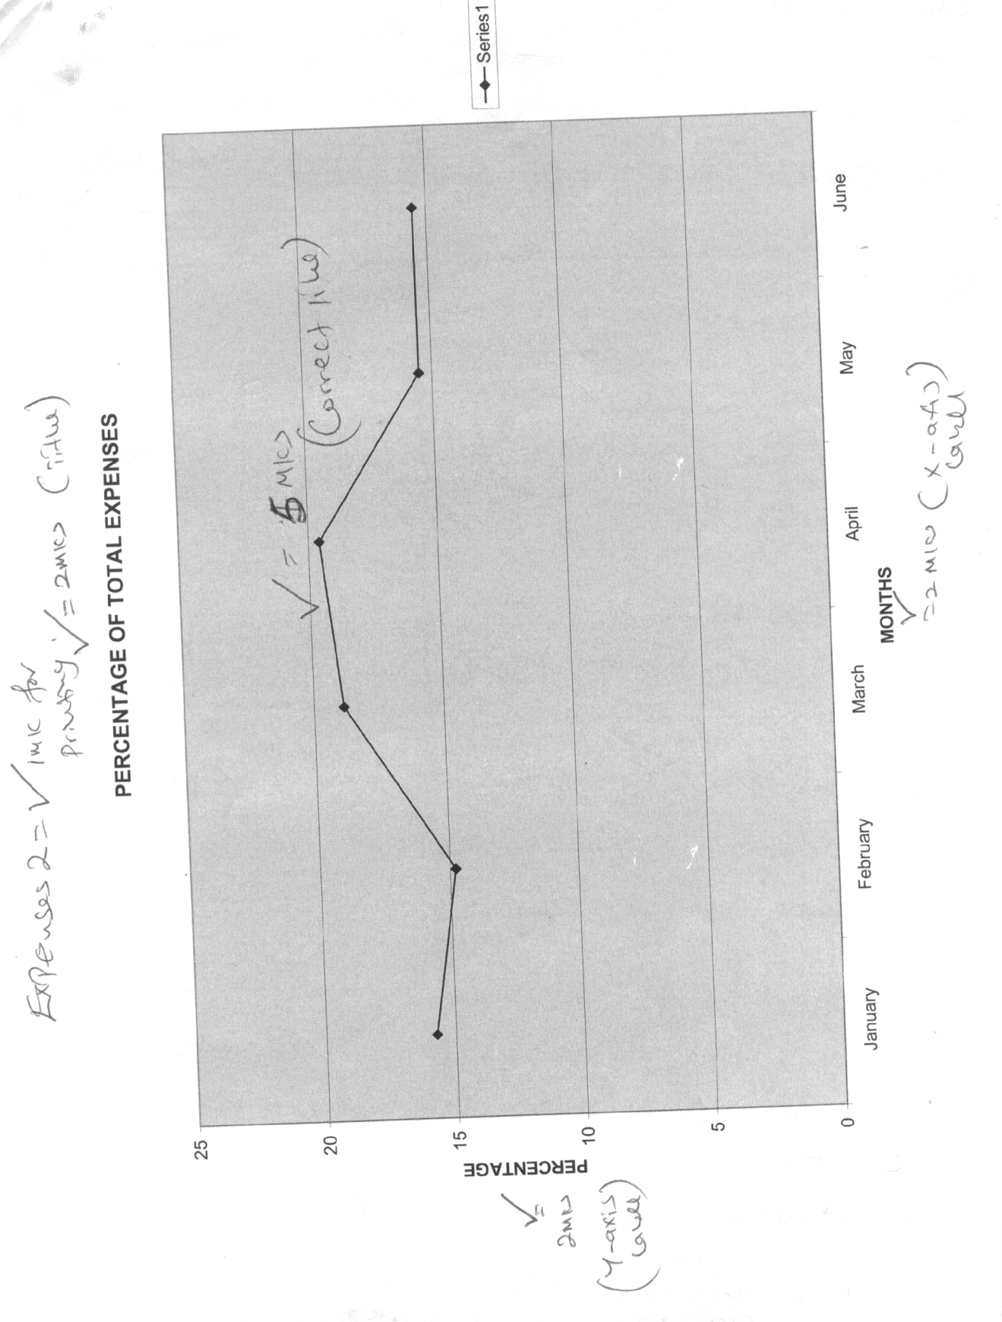

2. a) i) Correct tapes size i.e. A$  2mks
ii) Correct margin 2mks
- Correct margin setting 87m, 81m & 97m  = 2mks
- Correct space between columns (6mm) =  2mks
- Correct key in of text
No mistake  =8 mks
One mistake  =6mks
Two mistakes  = 4mks
Three mistakes  = 2mks
Four any more  = 0mks
- i) Reverse title  = 2mks
  - Bold million headly = 2mks
  - Italicized & centered mission statement  = 2mks @
  - Centered address at bottom of column 3 = 2mks
  - Clipart appropriately placed  = 2mks
  - Work saved as sample 2 =  2mks

- i) Main title and sub-title in bold  = 2mks
ii) Main the underlines  = 2mks
- Courses highlighted using bullets =  2mks

- Tooter
- Mailing coupon.
- Mailing Coupon
i) Bolden and centered  2mks
ii) Capton included  2mks
- Work saved  2mks
- Printed sample 1,Sample 2,Sample 3 @ 2mks  6mks

