Name: ……………………………………………………Adm. No: ………………Class:……………..

INSTRUCTIONS TO CANDIDATES:-
- Write your name, index number and class in the spaces provided above.
- This paper consists of two sections; A and B
- Answer all the questions in section A and B in the spaces provided
- All working must be clearly shown.
- Mathematical tables and electronic calculators may be used
- This paper consists of 10 printed pages. Candidates should check to ascertain that all pages are
printed as indicated and that no questions are missing.
- Candidates should answer the questions in English.
- Take g=10N/kg

For Examiner’s Use Only:
Section | Question | Maximum  Score | Candidate’s  Score
A | 1 – 11 | 25
 | 12 | 16
 | 13 | 14
B | 14 | 13
 | 15 | 12
Total Score |  | 80

SECTION A: 25 mks
- A Circuit consists of a battery, metal wire, ammeter and a switch connected in series. The switch is closed and the ammeter reading noted. The metal wire is now heated.
- State the observation made on the ammeter reading. (1mk)

- Give one reason for the above observation made. (1mk)

- 5 images are formed when two mirrors are inclined at an angle between them. Determine the angle of inclination. (2mks)

- A current carrying conductor AB is a magnetic field as shown in the figure below.
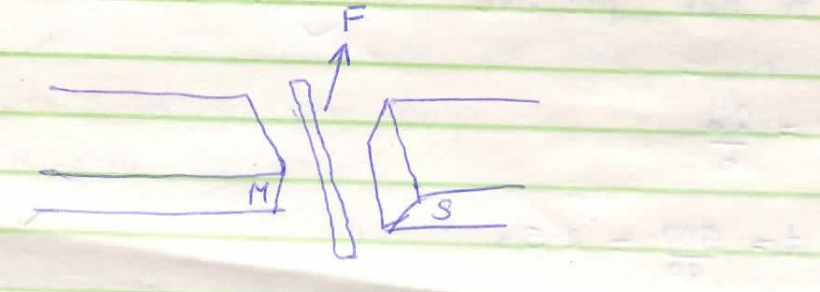

- Indicate the direction of the force F acting on the conductor. (1mk)

- State two factors that determine the direction of the force F. (2mks)

- The figure 1 below shows the image behind a mirror M

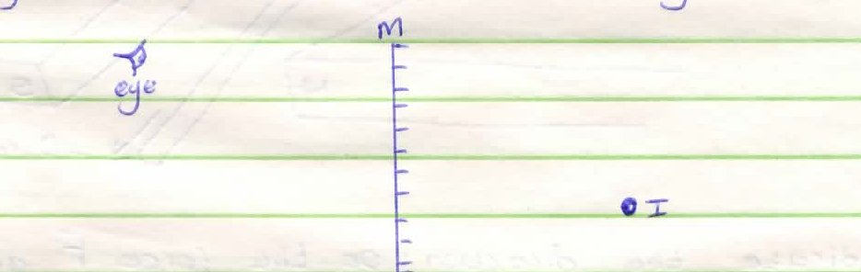

By ray diagram construction, locate the position of the object. (2mks)

- A negatively charged rod is brought near the cap of a leaf electroscope. The cap is then earthed momentarily by touching with a finger. Finally the rod is withdrawn. State and explain the observation mode. (2mks)

- A student stands at a distance 400m from a wall and claps two pieces of wood. After the first clap, the student claps whenever an echo is heard from the wall. Another student starts a stopwatch at the first clap and stops it after the twentieth clap. The stopwatch records a time of 50 seconds. Find the speed of sound. (2mks)

- In the fig. 4 shown below (not drawn on scale) sketch the path of a ray till it emerges from the prism.
(1mk)
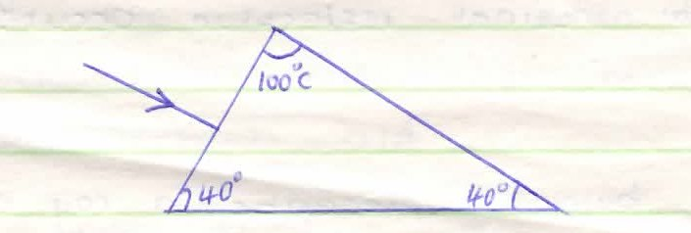

- Describe the changes that can be observed during discharging process of lead-acid accumulator. (2mks)

- The figure below shows a current carrying conductor placed perpendicularly between the poles of a magnet.

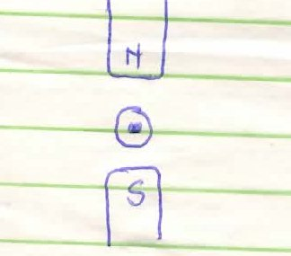

- Show on the diagram the magnetic field pattern. (1mk)

- The direction of the net force on the conductor. (1mk)

- Using domain theory, describe how a nail can be magnetized through hammering. (2mks)

- (i) Define focal plane. (1mk)

(ii) State two properties of images formed by convex mirrors. (2mks)

SECTION B (55 MARKS)
- Some plain water waves were produced in a ripple tank. They pass from a region of deep water into a region of shallow water. The figure shows what the waves look like from above
Boundary

Waves
Move
This way

Deep Water Shallow water

- State what happens at the boundary to:
    - The frequency of the waves (1 mark)

    - The speed of the waves (1 mark)

    - The wave length of the waves (1 mark)

- The waves have a speed of 0.12m/s [in the deep water. Wave crests are 0.08m apart to the deep water. Calculate the frequency of the sources producing the waves. (3 marks)

- State two differences between a stationary wave and a progressive wave. (2 marks)

- The wave shown in the figure below has a velocity of 200ms⁻¹
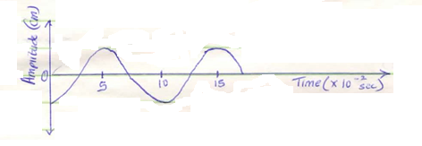
Determine:
- The period T of the wave. (2mks)

- The frequency of the wave. (2mks)

- The wavelength of the wave. (2mks)

- State two difference between electromagnetic waves and mechanical waves. (2 marks)

- (a) State one application of a capacitor. (1 mrk)

(b)The figure shows four capacitors connected to a battery of 12volts

12V

^{8µF}
^{5µF}
^{2µF}

^{3.2µF}
Calculate
- Effective capacitance (3mks)

- Charge on 3.2µF (3 marks)

- P.d across 5 µF (2 marks)

- The energy stored by 2 µF (2 marks)

- State any two factors that affect capacitance of a conductor. (2 marks)

- Why is repulsion the surest way for polarity of a magnet. (1 mark)

- (a) State Ohm’s law. (1mk)

(b) Three resistors 1Ω, 3Ω and 5Ω are connected together in a circuit. Draw a circuit diagram to show an arrangement that would give minimum resistance and determine that resistance. (3mks)

- The cell in a figure below has an e.m.f. of 1.8V abd negligible internal resistance.

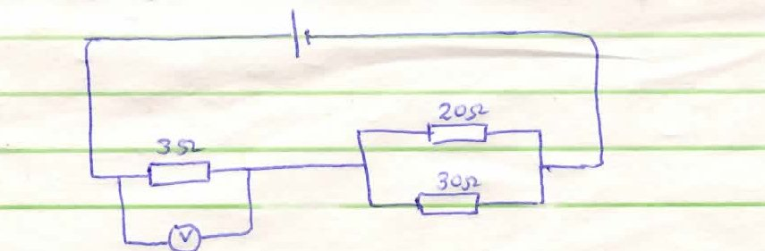
Determine:
- Total resistance in a circuit. (3mks)

- The current in the circuit. (3mks)

- Reading of the voltmeter. (3mks)

- (a) State Snell’s law. (1mk)

(b) A coin is placed beneath a transparent block of thickness 10cm and refractive index 1.56. Calculate the vertical displacement of the coin. (3mks)

(c) The speed of green light in a prism is 1.94 x 10⁸ms⁻¹
(i) Determine the refractive index of the prism material. (Speed of light in air = 3.0 x 10⁸ms⁻¹). (3mks)

(ii) Determine the critical angle of the prism material. (3mks)

(d) State two advantages of using optical fibres in communication. (2mks)

