MAKING SCHEME
TERM III
PHYSICS FORM ONE

- Physics is the study of matter and its relation to energy

- Mechanics

Electricity and magnetism
Thermodynamics
Geometric optics
Waves
Atomic physics

- (a) Force is a pull or a push on a body D1 unit Newton (N)

(b) In (a) the cohesive forces between water molecules are stronger than between water and wax. In (b) adhesive forces between the water molecules and glass molecules are stronger.

(c) Soap lowers the surface tension of water

- In the thick glass, heat is distributed unevenly causing unequal expansion and contraction which leads to breakage. In the thin glass heat is evenly transmitted hence uniform contraction and expansion .

- The initial fall of the level of the water is due to the expansion of the glass flask, which gets heated first. The water starts expanding when heat finally reaches it, and it rises up the tube.

- (a) Force acting normally (perpendiculary) per unit area.
S1 unit Nm⁻² or Pa or N/m².

- (i) Pressure is greater at the bottom than at the top. This is because pressure
increases with depth.

(ii) A sharp panga has a smaller area of the edge than a blunt panga, hence it exerts more pressure during cutting than a blunt one.

- (i) Pmax = F
Amin

Amin = 0.15 x 0.05
= 0.0075m²

Pmax = 25
0.0075

= 3333.3N/m²

(ii) Pmin = F
Amax
Amax = 0.25 x 0.15

= 0.0375m²

(ii) Pmin = 25
0.0375
= 666.67N/m²

- (a) Anything that occupies space and has mass

(b) (i) to illuminate the smoke cell
(ii) to focus light into the smoke cell
(iii) to observe the movement of the smoke particles
(c) Bright specks in continuous random motion
The motion is due to constant collisions between the smoke particles and the invisible air particles which are always in random motion.
(d) The motion of the particles increase

- (a) Mass per unit volume
S1 unit Kg/m³ or Kgm⁻³
(b) volume = Mass
Density

= 3600 = 2000cm³
1.8

(c) Mass of water = 70 – 20
= 50g
Volume of water = 50cm³ (P = 1g/cm³)
Volume of bottle = 50cm³
Mass of liquid = 55 – 20
= 35g

Density of liquid = 35
50
= 0.7g/cm³ or
700Kg/m³

- Thickness of sheets = 1000 x 0.05
= 50mm
Thickness of covers = 0.10 x 2
= 0.2mm
Thickness of book = 50 x 0.2
= 50.2mm

- Volume of water drops = 55 x 0.12
= 6.6cm²

Final water level in burette = 30 + 6.6
= 36.6cm³

- (a) The degree of hotness or coldness of a body D1 unit is Kelvin (K)

(b) (i) T = 0 – 273
= 0 – 273
= -273⁰C

(ii) T = 0167 – 273
= -106⁰C

(c) - be seen easily (visible)/opaque)
- expand or contract uniformly
- not stick to the inside of the tube (should not we the inside of the tube)
- have a wide range of temperature (high boiling point and low freezing
point)

(d) - Its temperature range is about 350C - 430C, which makes it suitable since the temperature of a healthy person is about 370C.
- The constriction. It prevents the mercury from flowing back to the bulb before the temperature is read.
(e) It will break since the temperature of boiling water is much above the maximum this thermometer can measure.
12. (a) The behavior of water in that it contracts when its temperature is raised from 0⁰C to 4⁰C
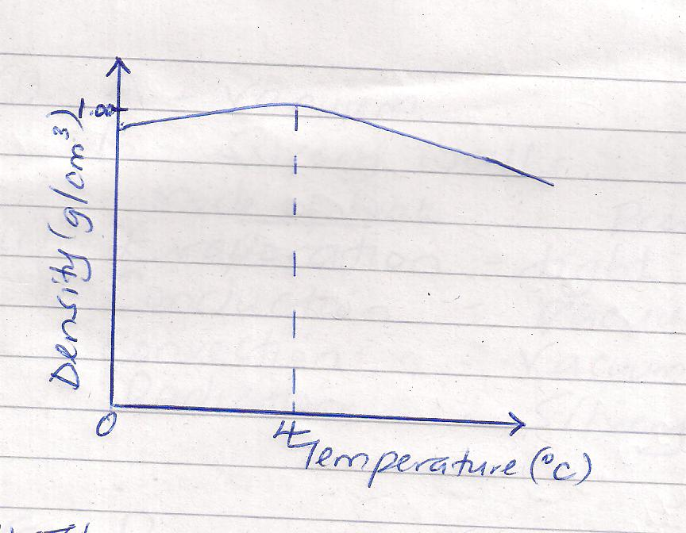
(b)

(c) (i) The temperature of water does not drop to zero. At 4⁰C water has a maximum
density hence it sinks, ice being lighter than water floats on the surface and this prevents further loss of heat.

- When water freezes in the pipes it expands and this is what causes bursting

- (a) Pressure applied at one part in a liquid transmitted equally to all other parts of the
enclosed liquid

(b) F1 = F2
A1 A2

F1 = F2 A1
A2
= 20000 X 2
1000
= 40N

(c) - Be incompressible
- Have low freezing point and high boiling point
- should not corrode the parts of the brake system

- (a) Mass Weight
Quantity of matter in a body Pull of gravity on a body
Measured in kilograms Measured in Newtons
Same everywhere Changes from place to place
Magnitude only Both magnitude and direction

(b) W = mg
= 70 x 1.7
= 119N

(c) g = W
M
= 30
7.5

= 4N/Kg

(d) A scalar quantity has magnitude (size) only but no direction while a vector quantity has both magnitude and direction.

