Name: ………………………………………………. Adm. No ……Class…………

TIME : 2 ½ HOURS

FORM 1 END TERM III

INSTRUCTIONS TO CANDIDATES
- Write your NAME, ADMISSION NUMBER and CLASS in the space provided above.

- Answer ALL the questions in the spaces provided.

- ALL working MUST be clearly shown

- Candidates should check the question paper to ascertain that all the pages are printed as indicated and that no questions are missing.

- Candidates should answer questions in ENGLISH .

- Calculators SHOULD NOT be used

KNEC Mathematical tables may be used where necessary.

Where necessary, take
g = 10N/kg
Density of water = 1000kg/m³

- What do you understand by the term Physics (1mk)

- The study of physics is divided into a number of branches: list 3 branches under which we study physics (3mks)

- (a) Define the term force and state its SI unit (2mks)

(b) The figure below shows water drops on two surfaces. In (a) the glass surface is smeared with wax while in (b) the glass surface is clean
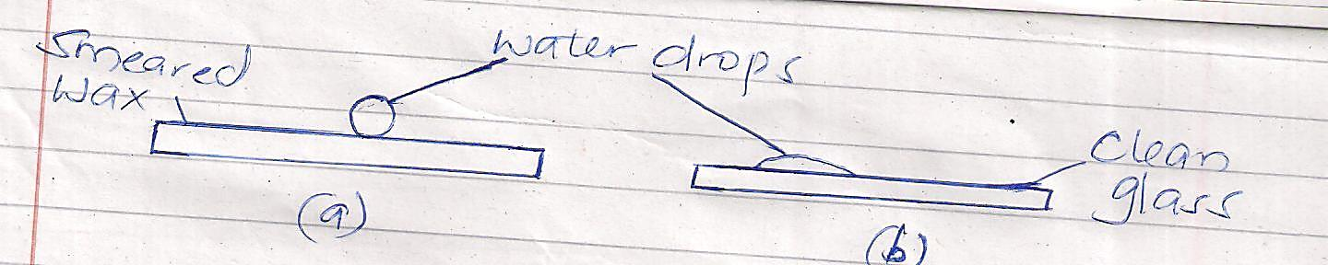

Explain the difference in the shapes of the drops (2mks)

(c) A metal pin was observed to float on the surface of pure water. However the pin sunk when drops of soap solution were carefully added to the water. Explain this observation (2mks)

- Explain why a thick glass is more likely to break when hot water is poured on it than thin glass. (2mks)

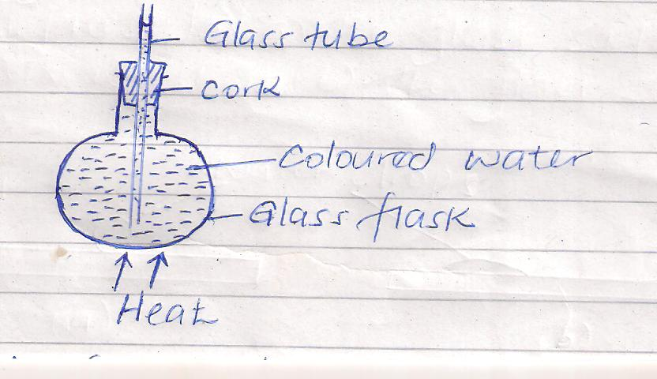
- The figure below shows a flask filled with coloured water. The rubber cork is pushed until the water rises a short distance in the glass tube

When the flask is heated it is noted that the level of water first drops before it starts to rise. Explain this observation (3mks)

- (a) Define the term pressure and state its SI units (2mks)

(b) Explain each of the following
(i) Water dams are constructed with thicker walls at the bottom that at the top (2mks)

(ii) It is easier to cut through a log of wood with a sharp panga than a blunt one (1mk)

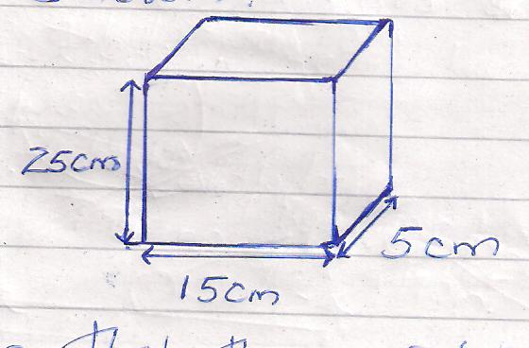
(c) A block of wood of dimensions 25cm by 15cm by 5cm rests on a flat surface as shown

Given that the weight of the block is 25N.
Determine:
(i) The maximum pressure it exerts on the surface (3mks)

(ii) The minimum pressure it exerts on the surface (3mks)

- (a) Define matter (1mk)

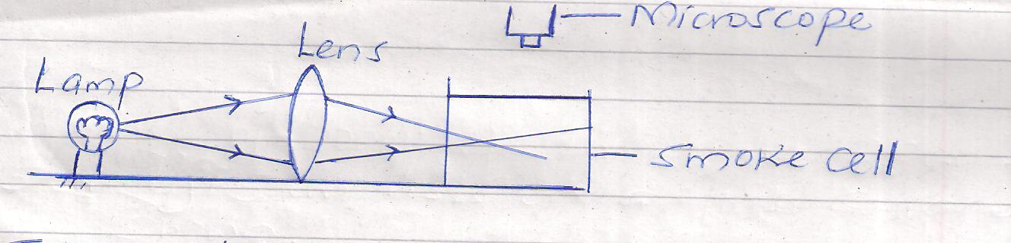
(b) The following set up was used to observe Brownian motion

Explain the role of the following:
(i) Lamp (1mk)

(ii) Lens (1mk)

- Microscope (1mk)

(c) State and explain the observation made in the smoke cell (3mks)

(d) What will be the effect of increasing the temperature of the smoke cell on the observations made above (1mk)

- (a) Define the term density and state its SI unit (2mks)

(b) The density of concentrated sulphuric acid is 1.8gcm⁻³. Calculate the volume of 3.6Kg of the acid. (3mks)

(c) The mass of a density bottle is 20.0g when empty, 70.0g when full of water and 55.0g when full of a second liquid. Calculate the density of the liquid (4mks)

- A text book has 1000 sheets bound between two covers each of thickness 0.10mm. Each sheet of paper is 0.05mm thick. Determine the thickness of the book. (2mks)

- The water level in a burette is 30cm³. If 55 drops of water fall from the burette and the average volume of one drop is 0.12cm³, what is the final water level in the burette
(2mks)

- (a) Define the term temperature and state its SI units (2mks)

(b) Convert each of the following from Kelvin to ⁰C (2mks)
(i) OK

(ii) 167K

(c) State three properties of a good thermometric liquid (3mks)

(d) State and explain the two special features of a clinical thermometer (4mks)

(e) Give a reason why a clinical thermometer should never be sterilized using boiling water (1mk)

- (a) What do you understand by anomalous expansion of water (1mk)

(b) Sketch a graph of variation of density of water with temperature when water is
heated from 0⁰C to 10⁰C (2mks)

(c) Explain the following;
(i) Aquatic animals are able to survive under layers of ice even if the surface is completely frozen (2mks)

(ii) Water pipes are liable to burst during winter (2mks)

- (a) State the Pascal’s principle of transmission of pressure in liquids (1mk)

(b) The figure below shows a hydraulic machine
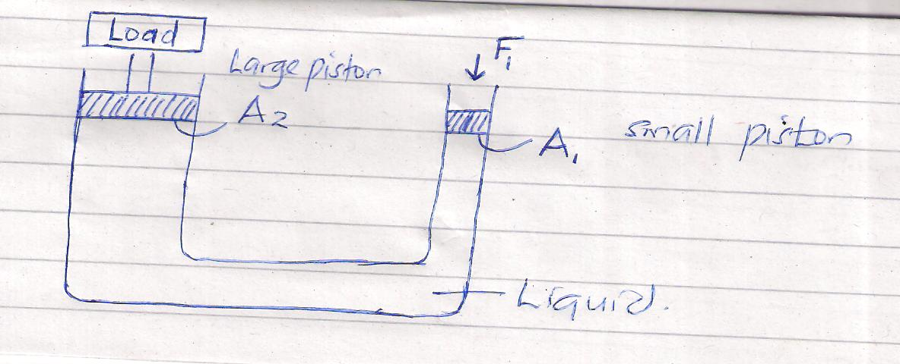

If the area of the small piston is 2cm² and the large piston is 1000cm². Determine the force on the small piston that would be required to lift a load of mass 2000Kg. (3mks)

(c) Give one property of a liquid that can be used in a hydraulic machine (1mk)

- (a) Give three differences between mass and weight (3mks)
MASS WEIGHT

(b) A man has a mass of 70Kg. Calculate his weight on the moon where the gravitational field strength is 1.7N/Kg (2mks)

(c) A mass of 7.5Kg has weight of 30N on a certain planet. Calculate the acceleration due to gravity on this planet (2mks)

(d) Differentiate between a Scalar quantity and a vector quantity (2mks)

