FORM 3
GEOGRAPHY PAPER 1 MARKING SCHEME

SECTION A: (25 MARKS)
SECTION A
- a) Forces that shape the surface of the earth centripetal – pulls the poles towards each other and causes flattening
- Centrifugal flinging force that causes the bulge at the equator
- Gravitational – pulls towards the centre causing the rounding effect
2 x 1 = 2 marks
b) Characteristics of the crust
- Average thickness 16 – 24km
- Made up of two parts. the outer and inner crust
- The outer crust made of Silica and aluminium (SIAL)
- The inner crust made of SIMA
- SIAL density - 2.7 gms / cc
- SIMA average density 2.3 - 3.0 gm/cc
- Sial mainly forms the continental crust while Sima forms the oceanic crust.
Max. 3 x 1 = 3 marks
- a) A coast and a shore (2 mks)
- A coast is a strip of land that is bordering the sea while a shore is the point along the coast that lies between the lowest water tide and the highest point reached by waves.

b) Conditions necessary for the formation of a spit
- relatively shallow and sheltered water
- Availability of a lot of load
- A long one ward shore drift must occur
- A gently sloping shoreline
- A change in the angle of the coastline for deposition to occur
Max 3 x 1 = 3 marks
3.a) Ideal conditions for an artesian well
- the aquifer must outcrop in a region which is a source of water
- the aquifer must did from a region of water intake to form a broad syncline
- the aquifer must lie between impermeable rocks so as to retain water
- the mouth of the well must be lower than the intake area to ensure water comes out on its own. ( max 3 x 1 = 3 marks)
b) Water may reach the surface through
- through spring / wells / seepage
- through capillary action / trangiration (2 marks )
4. (a) A lake is an accumulation of water in a wide hollow or depression / it is an extensive hollow in the earth’s surface which contains water(2 mks).

(b) Why most Rift Valley lakes are alkaline
-Most lakes have no outlets
-The area experiences volcanic eruptions.
-Most rivers that drain into them are salty
-High rate evaporation in the region. (3x1=3mks)
5. (a) Natural causes of climatic change in the world today.
(i) Variation in the earth’s orbital characteristics
(ii) Variation in solar output
(iii) Variation in CO₂ in atmosphere. (4x 1=4mks)
(b) Effects of climate change
Causes increase in atmospheric
-Cases changes in rainfall pattern e.g. flooding , drought
-Causes change in season as pattern /air masses
SECTION B
6 a)i)man made featres found in grid square3628. (2 marks)
- Murram road
- School
- Main Tracks (Motorable)
- Settlement/sega mission
ii)Distance 7.3 km (1mk)
ii) magnetic declination when the map was taken (1 mk)
2 ⁰21’
b)i) Bearing and direction of Odiado Hill from Air photo Principal point atgrid square2539. (2 marks)

1± 150⁰N
ii)Citingevidencefrom themap give twoeconomic activities carried out in thearea covered
- (Crop) Farming – cotton store grid square 2731
- Trading – presence of markets
Mention 1 mk Evidence I mk 2x 2. (4 marks)
c )i)Types of vegetation shown in the map (3 mks)
- Thicket
- Scrub
- Papyrus swamp
- Riverine trees
- Tree swamp
- Woodland
- Scattered trees
ii) There liefofthe area covered bythemap. (5 marks)
- There are many river valleys
- The main relief features are hills
- There are many hills
- The highest point is 1568 m
- The lowest point is 1160 m
- The north west part of the map is gentle evidenced by widely spaced contours and swamps
- The north East part of the map is gentle evidenced by widely spaced contours and swamps
- The South west part of the map is steep evidenced by closely packed contours
- The South East part of the map is gentle evidenced by widely spaced contours and swamps
- The land slope from north to south
iii) Methods of representing relief in the map (2 Mks)
- Countour lines
- Form lines
- Trigonometrical stations
d) i) Longitudinal extent extent of the area covered by the map ( 2mks)
From 34⁰05’to 34⁰15’
ii) Types of scales represented by the map ( 2mks)
- Linear scale
- Representative scale
iii) Drainage features shown in the map (2 mks)
- Seasonal swamp
- Rivers
- Dam

7. (a) A rock is an aggregate of mineral particles forming solid part of the earth’s crust (2mks)
(b)-Formed from weathered igneous and metamorphic rocks.
-The rock particles are transported
-Particles are deposited in lowland areas in layers
-The particles are compressed and compacted into hard rocks. (5x1 = 5mks)

(c)
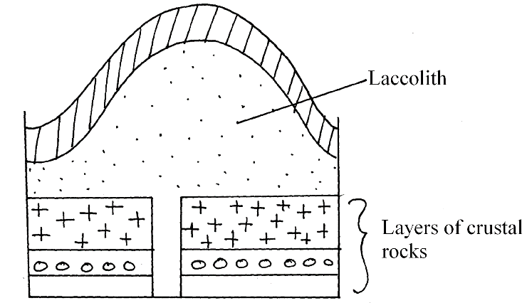

Diagram 1mk
Description 4mks
5mks
(i)It is a dome or mushroom shaped igneous intrusion with a flat floor which lies between the bedding planes of a rock stoats
-Laccolith is formed by viscous magma which is pushed from the interior into the earth’s crust by high pressure through a vent.
-The magma cools and solidifies near the earth’s surface
- Since the magma does not flow easily it accumulates around the vent and pushes the overlying rock into a dome shape.
(ii)
-Hard crystalline rock
-Made up of one or two mineral components
-Black or dark brown in colour
-Large crystals or coarse texture
-Shiny in appearance (3 x 1=3mks)
(a) Tools carried during field study
-hammer
-Camera
-Polythenes (3 x 1 = 3mks) any relevant
(b) Preparation of field study
-Read extensively different types of rocks
-Prepare a working schedule
-obtain permit from the relevant authorities
-Select suitable methods of data collection /recording
-Conducting previsit
-Hold discussion in class.
-Obtain necessary materials and equipment
-Obtain the map of the area (3x1 =3mks)
(c) importance of coral rocks
-Used as building materials and blocks
-Fascinating rock features attract tourists
-Coral limestone is a raw material for cement manufacture. (3x1 = 3mks)
(a) (i) River rejuvenation is the renewal of the river’s ability to erode (extra power to erode) (2mk)
(ii) (a) The process- River capture (1mk)
(b) Part J – Pirate River
K- Misfit stream 2mks

(c) Head ward erosion at point M (2mks)
(iii) Ways in which a river transports its load
-Suspension: is where insoluble materials are carried in within the River water downstream.
-Traction: Is where the large piece of material like sand pebbles are dragged along the river bed as it is transported downstream
-Saltation: Is where the river load especially light ones bounce over river bed/ materials are series of hopes and jumps / the materials are air borne at some stage and fall back to river bed.
-Solution : Is where soluble materials are carried downstream after dissolving in water.

(iv) THE HYDROLOGICAL CYCLE

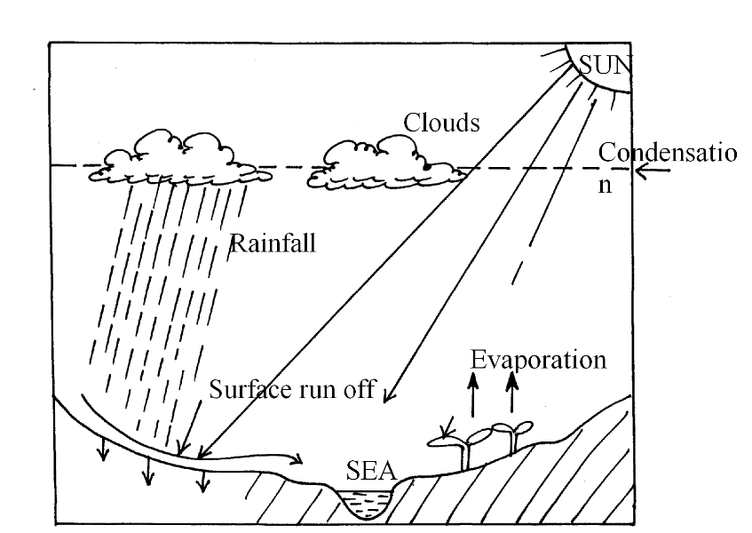
8ticks (8mks)

(v) Significance of Rivers to human Activities
-River provide water for domestic and industrial use.
-Rivers are used for irrigation and decrease food production.
-Some rivers have waterfalls that are used to generate Hydro – Electric power
-Some rivers are fishing grounds
-Rivers are habitats of aquatic life
-Rivers form fertile agricultural soils when they deposit alluvium soils in flood plains
-Act as tourist attraction sites to earn foreign exchange
Any 1 x 4 = (4mks)

8 i) Faulting is process whereby the crustal rocks or rocks of the earth crust fractures or cracks.
Process of breaking or fracturing of the rocks of the earth crust due to compression or tension forces (2 marks)

(ii)Three types of features associated with faulting are:
  - Fault scarps
  - Fault steps
  - Block mountains/horsts/fault blocks
  - Tilt block any 3 x 1 = 3 mark

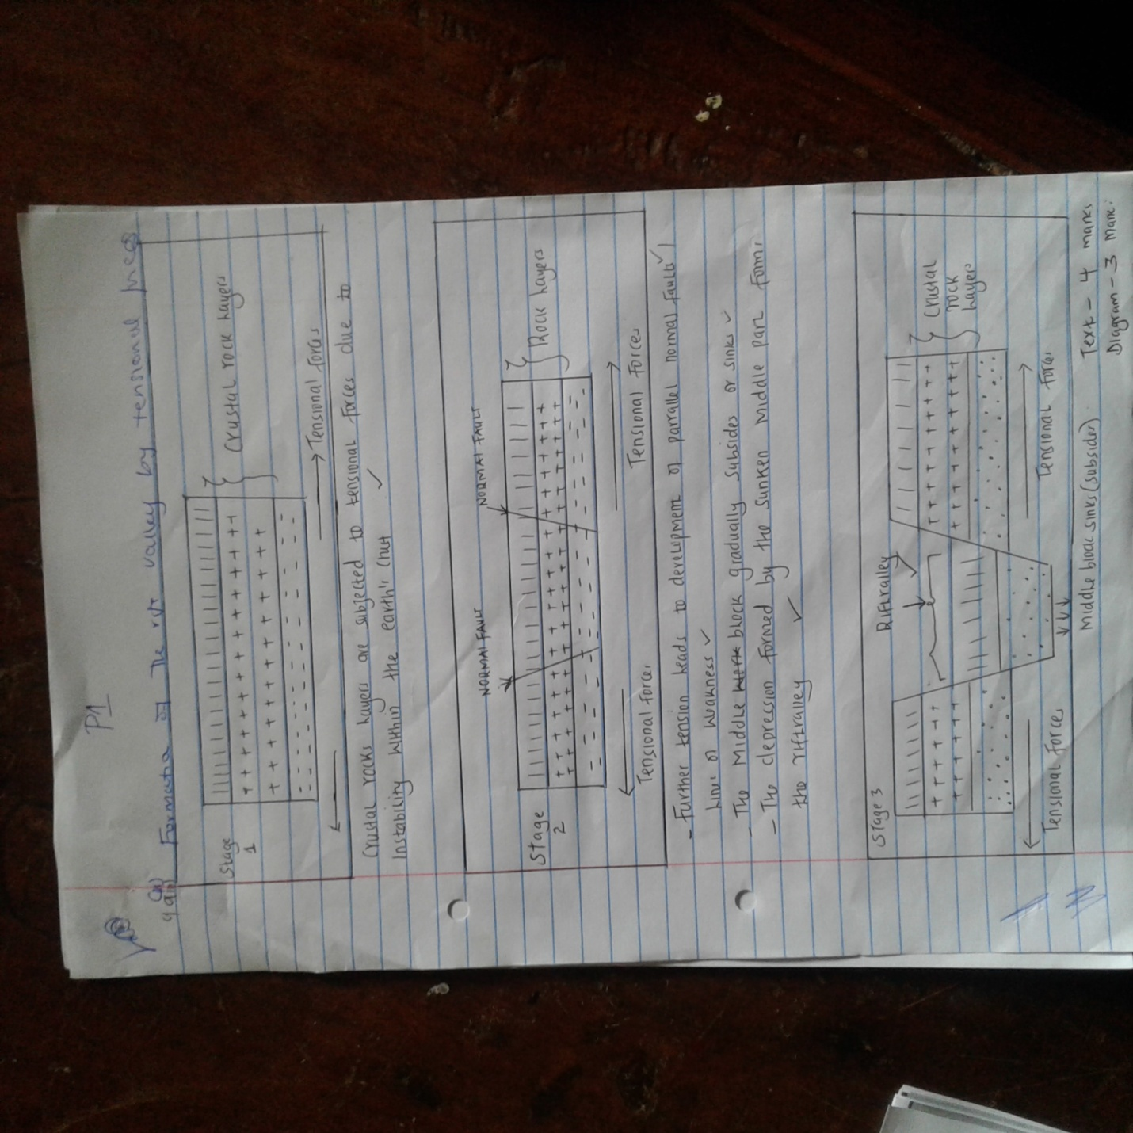

10. What is weathering? (2mks)
- Weathering is the breaking down / disintegration and decomposition of rocks at or near the
earth’s surface in situ. (2 mks)

(b) Give five processes involved in physical weathering (5mks)
- Pressure release / off-loading / sheeting.
- Block disintegration.
- Exfoliation.
- Frost action.
- Crystallization.
- Shaking / wetting and drying.
- Granular disintegration. (any 5 x 1 = 5 mks)
(c)(i) Apart from plants, give factors that influence the rate of weathering. (4mks)
- Nature of the rock.
- Climate / temperature / rainfall.
- Human activities / animals.
- Time taken.
- Nature of slope. (any 4 x 1 = 4 mks)
(ii) Explain three ways in which plants cause weathering. (6 mks)
- As plants grow, their roots penetrate into cracks / joints causing them to widen and eventually
rock disintegrates.
- Plants absorb mineral from rocks and this weaken them causing them to disintegrate.
- As plants rot on rocks, they release organic acids which then react with some minerals in the
rocks leading to disintegration of the rocks. (any 3 x 2 = 6 mks)
(d) Explain four effects of weathering. (8mks)
- Weathering leads to the formation of soil important to man for agriculture.
- Weathered rocks offer beautiful sceneries for tourist attractions.
- Weathering breaks rocks making mining easier. Weathering also produces minerals such
as bauxite.
- Weathering reduces sizes of rocks providing suitable materials for construction e.g. rock blocks
and sand.
- Weathered crust of the earth is important to engineering, for it is necessary to establish how
deep it is and remove so as to construct buildings on firm foundation.

