BUSINESS STUDIES
Paper 2
2 ½ hours

Instructions to Candidates
- Write your name, Admission Number and class in the spaces provided above.
- This paper consists of six questions.
- Answer any FIVE questions.
- Write your answers in the answer booklet provided
All questions carry equal marks.
Candidates should check the question paper to ascertain that all the pages are printed as indicated and that no questions are missing.
(i) Candidates should answer the questions in English.
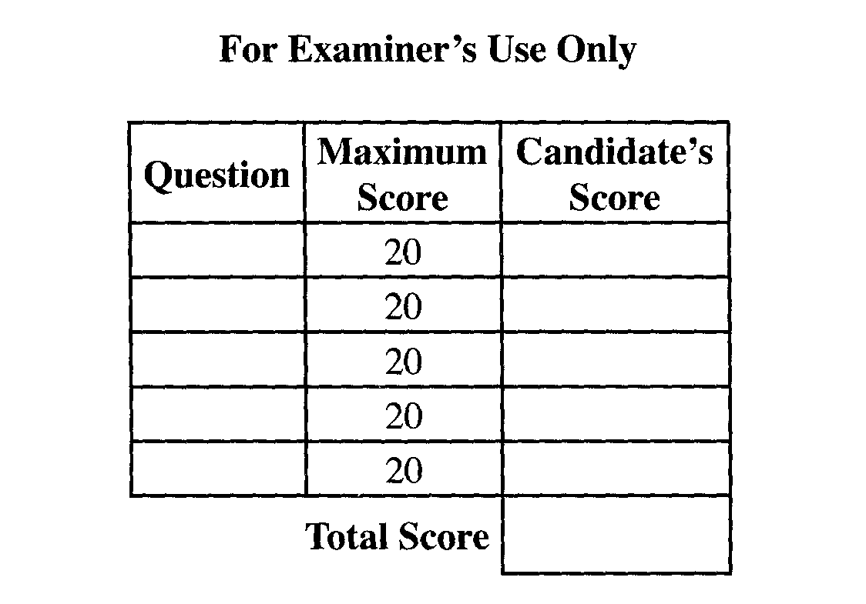
ATTEMPT ANY 5 QUESTIONS
- (a) Explain five measures that the African continent may use to solve the widespread unemployment cases. (10mks)
(b) Explain five functions of the stock exchange market. (10mks)
- (a) Highlight five circumstances under which the wholesaler can be eliminated in the distribution of goods
and services. (10mks)
(b) The following are the assets and liabilities of classic furniture Enterprises as at 1st July, 2012.

Kshs.
Furniture for sale 560,000
Office furniture 150,000
Creditor 155,000
Drawing 40,000
Debtor 85,500
Premises 250,000
Cash at Bank 130,000
Net profit 60,000
Cash in hand 5,500
Bank loan 600,000
Prepaid insurance 20,000
Capital 426,000
Required.
Prepare the balance sheet of the business as at 1st July showing subtotals for:
- Fixed assets
- Current assets
- Long term liabilities
- Current liabilities

- (a) The following diagram shows a shift in the supply curve. Explain briefly five factors that would cause
such a shift. (10mks)

Price S I

S O

S I

S O

Quantity

(b) Explain five characteristic of economic resources. (10mks)

- (a) The following balances were obtained from the books of Baraka for the period ended 12th January 2011
Drawings 5,000
Salaries 2,000
Capital 50,000
Purchases 12,000
Postage 500
Sales 15,000
Computer 10,000
Rent 2,000
Bank 15,000
Cash 18,500
Required
- Prepare a trial Balance of Baraka Traders as at 12th January 2011. (12mks)

(b) Bodaboda services (motor cycles) have become a popular means of transport in many parts of the country. Explain four factors that have led to this trend. (8mks)

5(a) Kenya Power and Lighting Company is a monopoly in the provision of electricity in Kenya. Explain five challenges of having such a firm in the economy. (10mks)

(b) Explain five benefits of indirect production. (10mks)

6(a) Explain five factors that should be considered when choosing methods of product promotion. (10mks)
(b) Explain five importances of National Income statistics. (10mks)

