Name ………………………………………………… Candidate’s signature ………………
Date …………………………………………………..
231/2
Biology
Time: 2hrs.

Term 3
Biology
Paper 231/2
Time: 2 hrs

Instructions to candidates
- Write your name, index number in the spaces provided above.
- Sign and write the date of examination in the spaces provided above.
- This paper consists of two sections A and B.
- Answer all the questions in section A in the spaces provided.
- In section B answer question 6 (compulsory) and either question 7 or 8 in the spaces provided after question 9.
- Check to ascertain that all pages are printed and that no questions are missing.

FOR EXAMINER’S USE ONLY

SECTION | QUESTIONS | MAXIMUM SCORE | CANDIDATES SCORE
 | 1 | 8
 | 2 | 8
 | 3 | 8
 | 4 | 8
 | 5 | 8
 | 6 | 20
 | 7 | 20
 | 8 | 20
Total score |  | 80
SECTION A 40 MARKS

Answer all questions in this section in the spaces provided

Q1. The food web represents a feeding relationship in an ecosystem.

Hawk
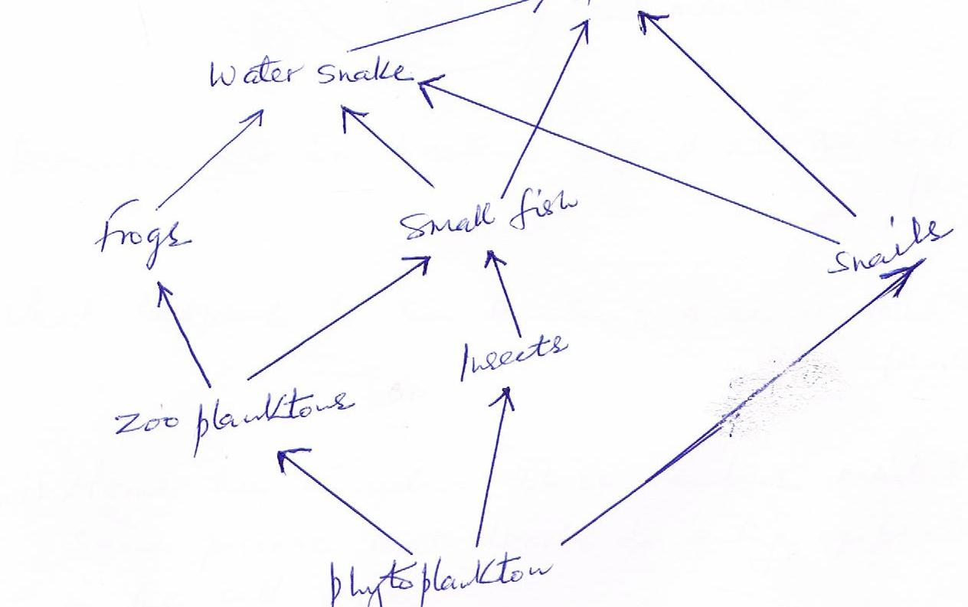

- Name two organisms which are both secondary and tertiary consumers (2mks)

- State the short term effect of immigration of insects in the ecosystem. (2mks)

- Which organism has the least biomass in the food web? Give reasons (2mks)

- Explain the disadvantages of using synthetic pesticides over biological control in agriculture (2mk)
Q2. The diagram shows a white blood cell

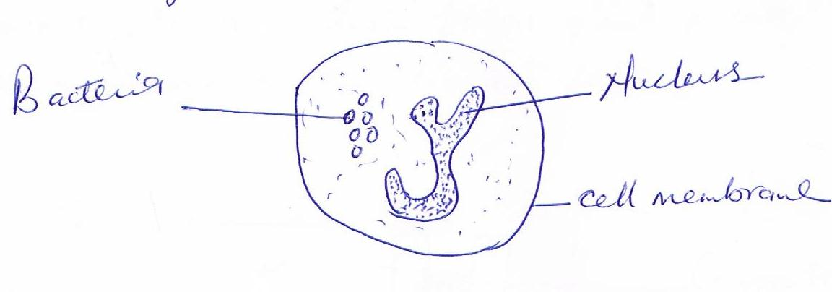

- Describe how the bacteria entered into the cell (2mks).

- What happens to the bacteria once in the cell? (2mks)

- (i) Name the kingdom whose members exhibit the same process that leads to entry of bacteria in the cell (1mk)

(ii) besides the process described in (a) above, state two ways by which white blood cells protect the body. (2mks).

(iii) State where white blood cells (lymphocytes) are made. (1mk)

Q3. A group of students set up an experiment to investigate a certain physiological process. The set up is as shown in the diagram below:

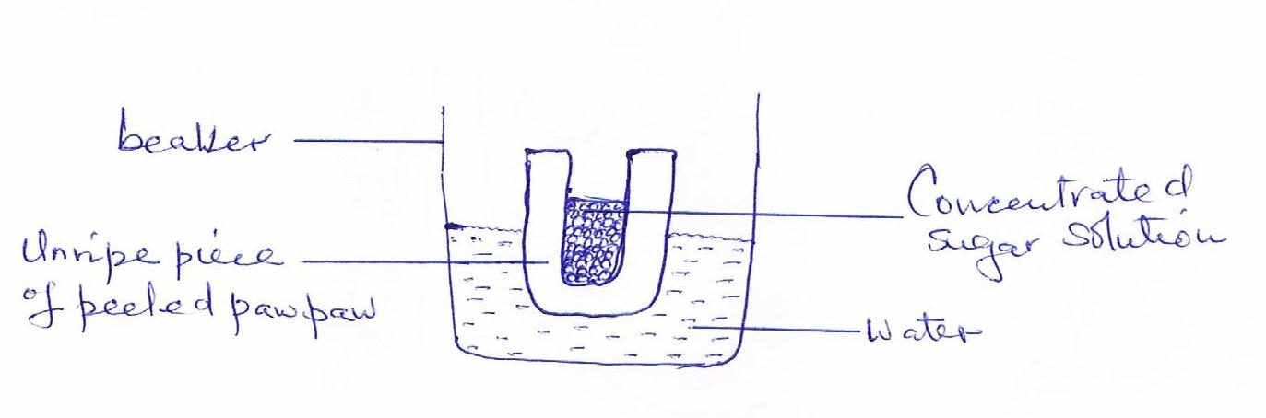

- After sometime, the students observed that the level of the sugar solution had risen. What physiological process was being investigated? (1mk)

- Account for the rise in the level of sugar solution in the experiment. (3mks)

- (i) Suggest the results that the students would obtain if they repeated the experiment
Using a piece of boiled paw paw. ( 3mks)

(ii) Give a reason for your answer in (c) (i) above (1mk)

Q4. The graph shows relationship between body size and surface area to volume ratio of
Organisms. Three animal species A, B and C are marked on the graph.

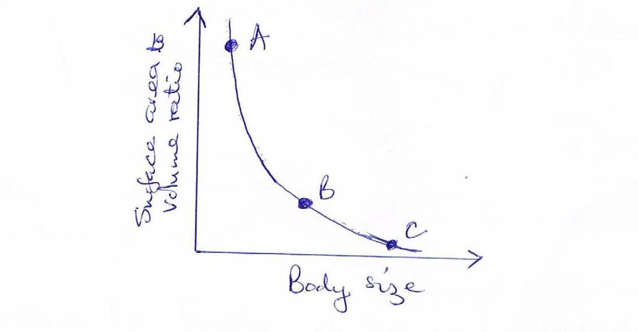
- Which of the three animals is likely to have the simplest transport system? Give a reason for your answer (2mks).

- Give the formula used to calculate surface area to volume ratio of an organism. (1mk).

- State two disadvantages of small surface area to volume ratio in organisms. (2mks).

- Showing your working, calculate the surface area to volume ratio of the following organisms X and Y.

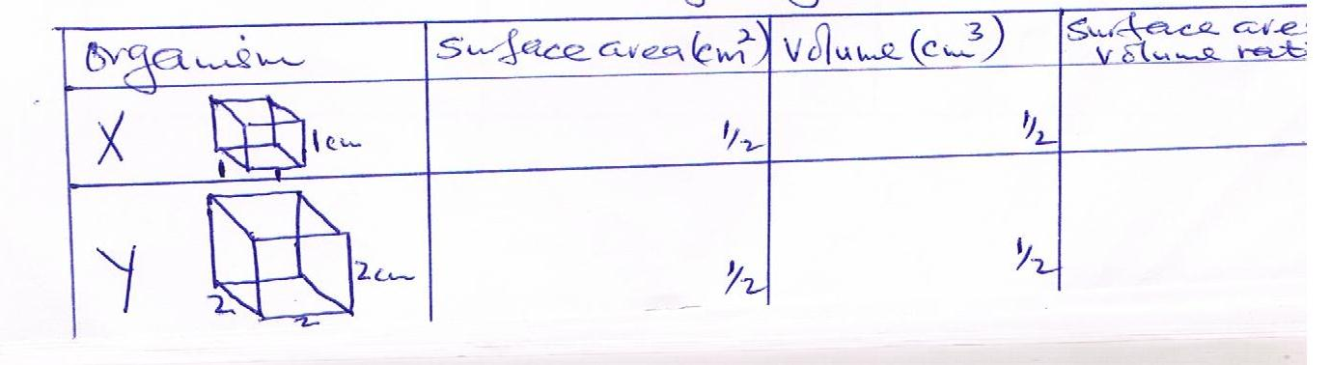

Q5. The diagram represents a plant cell.

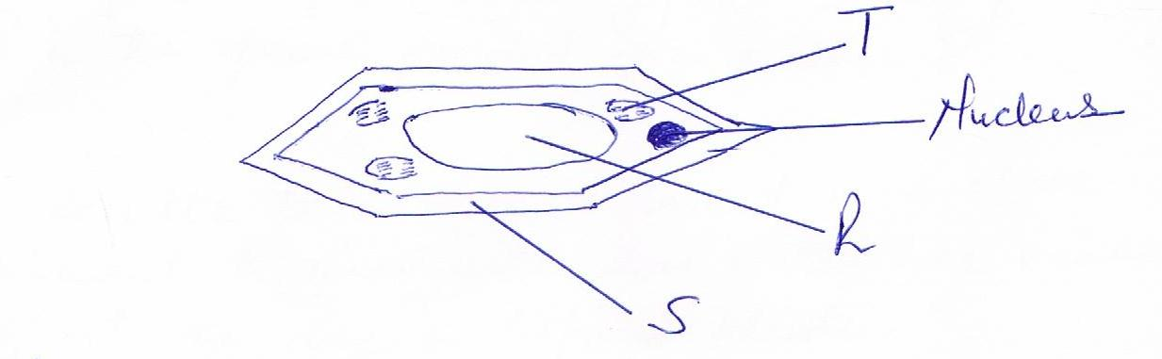
- Name a carbohydrate which forms the structure labeled S (1mk)

- (i) State the function of the part labeled R (2mks)

- Name two cell organelles present in the diagram but absent in animal cells (2mks)

- Complete the following table.

Eye – piece lens magnification | Objective lens magnification | Total magnification
X10 | X5
 | X40 | X600
(2mks)

SECTION B (40 MARKS)

Answer question 6 (compulsory) and either question 7or 8 in the spaces provided after question 8.

Q6. The results below were obtained in a class experiment to investigate how water loss varies
Throughout the day in tropical plants.

Time in day (hrs) | 2.00am | 6.00am | 8.00am | 10.00am | 12.00am | 1.00pm | 2.00pm | 3.00pm | 4.00pm | 6.00pm | 8.00pm | 12.00 midnight
Water loss  ^{gm-2 h -1} | 14 | 35 | 135 | 275 | 315 | 285 | 245 | 175 | 75 | 16 | 16

- ) Plot a graph of amount of water lost against time. (6mks)

(ii) At what time of the day was 210 mg^{-2 h -1} of water lost? (1mks)

- Account for the amount of water lost between

(i) 2.00 a.m and 6.00 a.m (2mks)

(ii) 6.00 a.m and 1.00 p.m (2mks)

(ii) 1.00 p.m and 6.00 p.m (2mks)

- (i) Which set of apparatus was used in the experiment? (1mks)

(ii) State the effect of putting an electric fan near the apparatus during the experiment. Give a reason for your answer (2mks)

- In a related ecological study two habitats each of 25 meters square were studied for five hours. Habitat A was an open pond while B was a forested area. More water was found to be lost in habitat B than A. explain (2 mks)

- In a related ecological study two habitats each of 25 meters square were studied for five hours. Habitat A was an open pond while B was a forested area. More water was found to be lost in habitat B than A. explain (2 mks)

7. (a) Giving examples,describe how various fruits and seeds are suited to different methods
dispersal. (17mks)

(b) state the differences between a seed and a fruit.(3mks)

8. Describe how the ileum is adapted to its functions. (20mks)

